Ysgol Bryn Gwalia
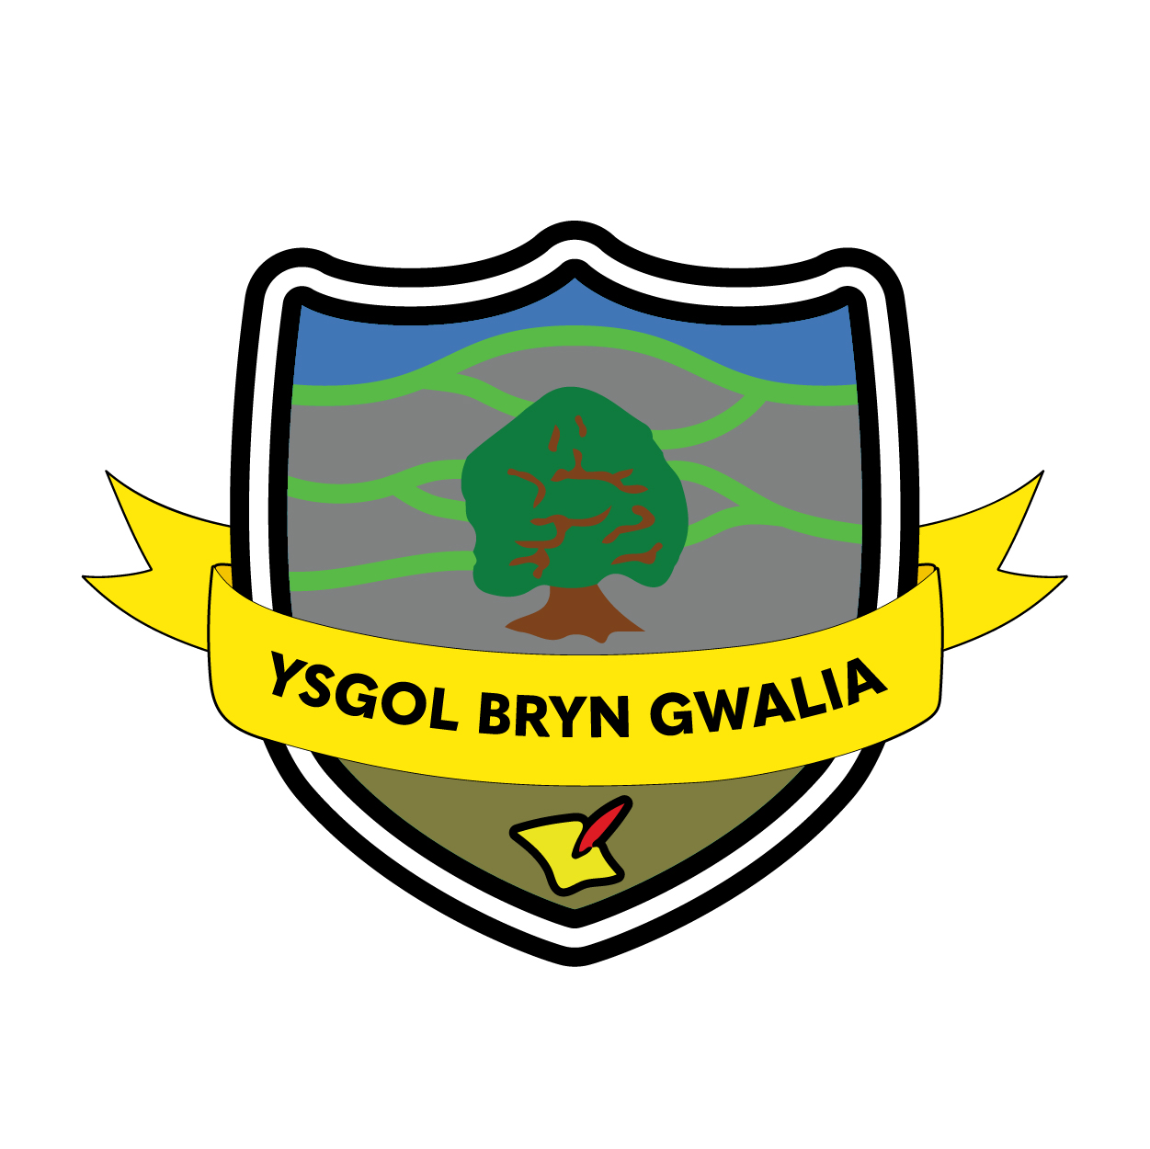

Accessibility Plan
Last Review Date | February 2025
Date to be reviewed by Senior Management Team | April 2028
Date Adopted by Governing Body | April 2025
Head Teacher – Mrs Lorraine Dalton | 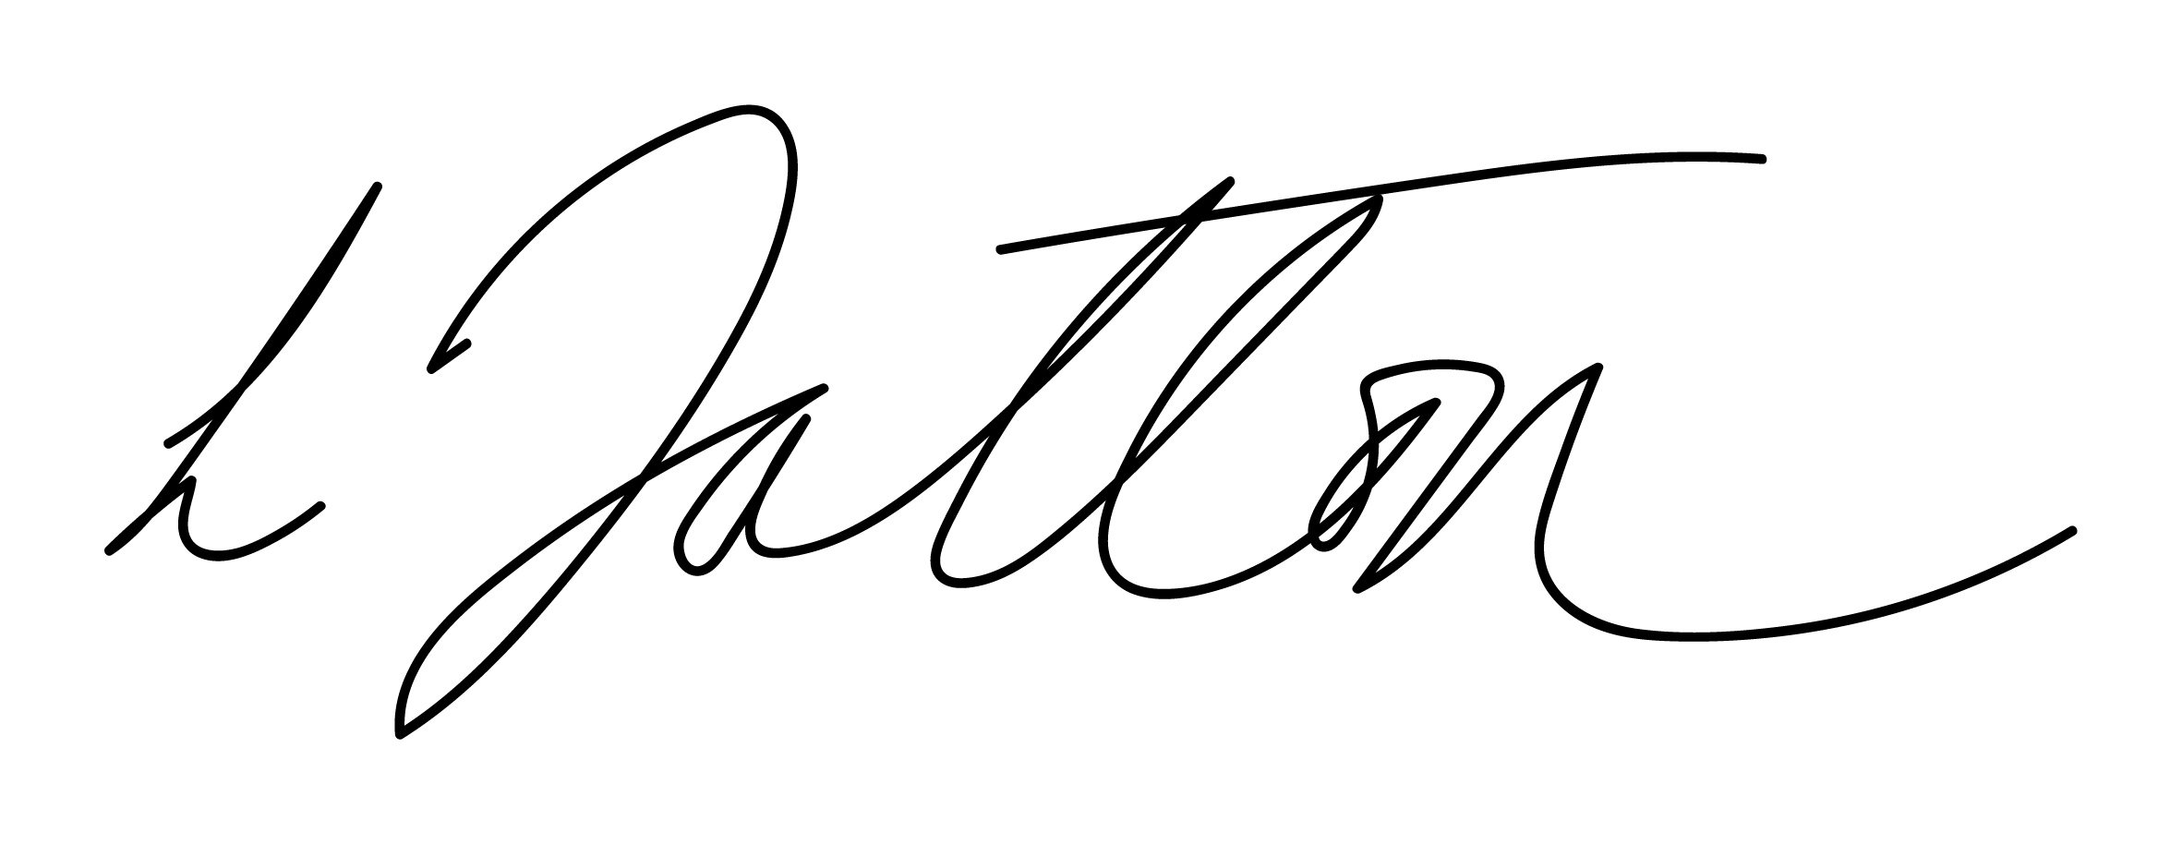
Chair of Governors – Mrs Janiene Davies | 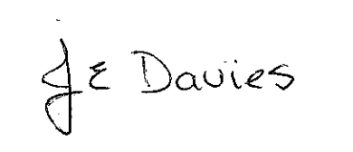



Introduction
The purpose of this plan is to show how Ysgol Bryn Gwalia intends, over time, to increase the accessibility of our school for all pupils

Definition of Disability
A person has a disability if he or she has a physical or mental impairment that has a substantial and long-term adverse effect on his or her ability to carry out normal day- to -day activities. (Equalities Act 2010).

Legal background
From September 2010, the Equality Act 2010 outlawed discrimination by schools and Local Authorities against either current or prospective disabled pupils in their access to education. It is a requirement that the school’s accessibility plan is resourced, implemented and reviewed and revised as necessary.

The Governors of Ysgol Bryn Gwalia’s aim, over time, to increase the accessibility of provision for all pupils, staff and visitors to the school. The following areas will form the basis of the Accessibility Plan with relevant actions to:

- Increase access to the curriculum, incorporating after school and out of school activities and including educational visits
- Improve access to the physical environment of the school
- Improve the delivery of written information to pupils, staff, parents, and visitors with disabilities

Ysgol Bryn Gwalia aims to treat all stakeholders, including pupils, prospective pupils, staff, governors and other members of the school community favourably and, wherever possible, takes reasonable steps to avoid placing anyone at a substantial disadvantage. The school aims to work closely with disabled pupils, their families and any relevant outside agencies in order to remove or minimise any potential barriers to learning, which puts them at a disadvantage, but allows them to learn, achieve and participate fully in school life. The school is active in promoting positive attitudes to disabled people in the school and in planning to increase access to education for all disabled pupils.

As part of the school’s continued communication with parents, carers and other stakeholders we continually look at ways to improve accessibility through data collection, questionnaires and parental/carer discussions.

Contextual Information
The school is a one storey building which has accessible facilities and toilets. Wheelchair access is available into the main building from a number of ramped access points. There is accessible parking on site. All areas of the school grounds are accessible to wheelchair users.

Reporting and Monitoring
The school prospectus and the Annual Report to parents/carers will also make reference to this Accessibility Plan. The school will work in partnership with the Local Authority in developing and implementing this plan and will adopt in principle the Local Authority Accessibility Strategy. This plan will be monitored through the Health & Safety Committee of the Governing Body

Targets | Strategies | Success Criteria | Timeframe | RAG
To regularly discuss this plan at Governing Body meetings and the Health & Safety Committee. | Clerk to add agenda item for Governing Body Meetings.  Agenda item for Health & Safety Committee Meetings. | - Legislative compliance.  - An up to date Accessibility Plan which is regularly reviewed. | Annually
To improve staff awareness of accessibility issues. | Review staff professional learning needs.  Provide training for members of school community as appropriate | - All staff aware of the needs of pupils and stakeholders.  - An inclusive and compassionate school that is open and accessible to all. | Annually
To ensure recognition of the Accessibility Plan in any relevant school policies or documentation. | Review school policies and documentation as per the policy review cycle.  Make any amendments to raise the profile of the Accessibility Plan within these documents. | - Legislative compliance.  - An up to date Accessibility Plan which is regularly reviewed. | On-going as per policy cycle
To ensure that all areas of the school buildings and grounds are accessible for all pupils and adults and continue to improve access to the school’s physical environment. | Audit of accessibility of school buildings and grounds by Senior Management and Health & Safety Committee.  Prioritise actions and implement as budget allows.  Engage with the Local Authority to repair damaged yard to improve access. | - A safer school site that has improved accessibility. | March 2021
To ensure that floor markings on ramped access into school are appropriate and maintained annually. | Caretaker and Senior Management Team to conduct regular inspections to ensure floor markings are appropriate and highly visible. | - All markings on ramped access into buildings are highly visible | February 2021 and reviewed annually
To ensure that the playing surfaces around the large trees is repaired to ensure complete accessibility to the site. | Headteacher to engage with the Local Authority regarding the completion of this work urgently. | - A safer school site that has improved accessibility. | February 2021 and reviewed annually
To continue to ensure that all pupils are able to access all out-of-school activities eg. clubs, educational and residential visits etc. | Regularly review out-of-school provision to ensure compliance with legislation and accessibility requirements. | - Legal compliance.  - An accessible out of school offering. | Annually
Continue to ensure that all fire escape routes are suitable for all. | Request advice from the Local Authority to ensure continued compliance. | - Safe access and exit points for all. | March 2021 and annually
To ensure that all staff are aware of, and able to use, ALN resources effectively. | INSET from the ALNCo and Local Authority as required.  Seek any relevant and new resources as required.  Access professional learning relating to the Equalities Act. | - Barriers to learning will be reduced or removed enabling pupils to achieve their full potential | April 2021
To ensure that all parents/carers and other members of school community can access information. | Written information will be provided in alternative formats as necessary.  Accessible and easy to read school website. | - Written information will be provided in alternative formats as necessary.  - Website accessible to all stakeholders. | April 2021
Improve signage and external access for the visually impaired. | Replace bulbs as soon as possible.  Ensure all signage is clear and easy to follow.  Explore alternative formats where possible. | - Barriers to access will be reduced or removed. | May 2021

Evaluation & Review
This plan will be reviewed by the Senior Management Team and Governing Body and adopted by the Governing Body as per the schedule on the front page.

