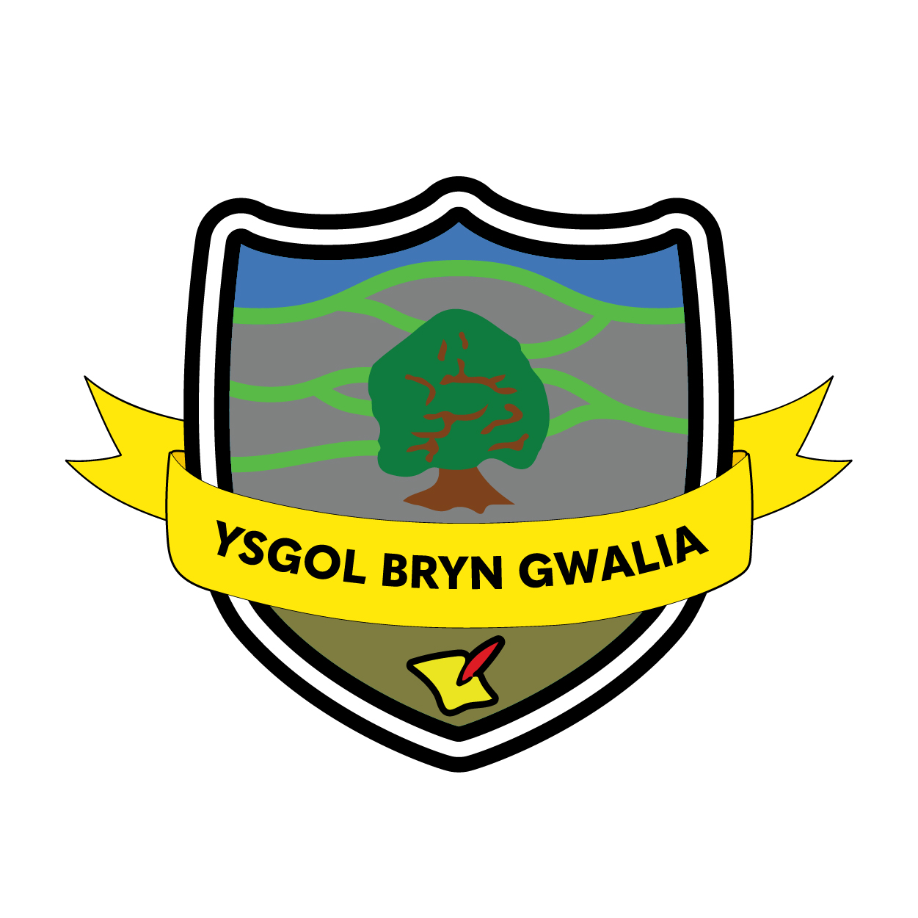
Ysgol Bryn Gwalia

School Development plan
2024/2027


Context of the School
Ysgol Bryn Gwalia is situated in the centre the market town of Mold. There are currently 134 pupils aged 3-11 on roll. Most pupils come from homes where English is the main language of communication and nearly all pupils learn Welsh as a second language.
Pupils come from a variety of backgrounds and have a wide range of attainment when they start at the school. 51% of the pupils are entitled to free school meals and 14% of pupils have Additional Learning Needs. There are currently 8.2 EAL learners on roll.
The Head Teacher has been in post since January 2021. The SLT comprises the Headteacher, Deputy Head teacher and a Foundation Phase lead.

National Priorities
We take account of the Welsh Government National Priorities for education in Wales which provides as aspirational vision for the entire sector. Namely:
- Learning for life
- Breaking down barriers - Attendance
- A positive educational experience for everyone
- High quality teaching and leadership
- Community based learning
- Cymraeg belongs to us all

Grant Funding
Our school receives grant funding from Welsh Government through several funding streams including, Education Improvement Grant (EIG), Pupil Development Grant (PDG), Professional Learning Grant (PLG), Recruit, Recover and Raise Standards Grant (RRRS) and Additional Learning Needs Implementation Grant (ALNI). These grant funding streams are referenced throughout this plan and also in the Grant Planning Dashboard which is available on the school website and agreed by the Local Authority. The Headteacher is an Associate of the National Academy of Education Leadership which offer a grant of 20,000 over 2 years. A grant of £15,000 has also been gained for Welsh language development.

Our Vision, Purpose and Values
Our vision of Growing Together, aiming high, ensures that collaboration and working together to ensure progress is at the heart of what we do. This vision and our core values of kindness, honesty, resilience and nurture drive us forward as we implement the Curriculum for Wales and ensure the very best for all of our pupils, families and wider community.

Who has input into this plan?

Learners – As part of the self evaluation process, pupils are asked to feedback on their experiences of being a pupil at the School. We have feedback sheets, surveys and The school council represent the school on their ideas and thoughts on improvement. The School Council will create a child friendly SDP and present to the school.
Staff – Staff have direct input into the Self evaluation and School Development Plan. We work on the Schools as a learning organisation model of sharing feedback around school improvement.
Parents/Guardians – Questionnaires and surveys are regularly used to gather feedback from Parents. We also hold workshops and open evenings to discuss ways of improving as part of the self evaluation process.
Stakeholders – We work with many other partners from Local Authority to External Agencies to improve the school where we can. Governors assist with School monitoring and self evaluation, ensuring accountability at all times.

All information gathered is collated and used to assist us to identify areas to celebrate, next steps and areas for improvement. We use the National Framework for Evaluation, Improvement and Accountability to support rapid and ongoing self-evaluation as well as our school monitoring and quality assurance cycle.

How will we know if we are achieving our aims?
We measure and evaluate the progress we are making to achieve the key outcomes set out in this plan. We do this using monitoring and quality assurance activities that include:
- Monitoring and Quality Assurance calendar which ensures a rigorous approach to monitoring improvement,
- Regular staff meetings (teaching and non-teaching staff),
- Monitoring of planning and evaluations of learning,
- Target setting for each child (through Pupil Progress Reviews),
- Monitoring and tracking of pupils’ learning, well-being and potential at termly Pupil Progress Reviews,
- Regular lesson observations, learning walks, listening to learners and work review activity to support school improvement,
- Analysis of assessment data from on-entry baseline, observations, ongoing class assessments and standardised assessments
- Welsh Government and inhouse develop questionnaires to staff, parents, children and partners and analysis of results to inform improvements.
- Monitoring and moderation of standards of pupil work, targets, displays and evaluations,
- Peer learning visits, coaching and mentoring activities,
- Liaison with external partners who provide support for pupils and staff. (Inclusion Services etc) to ensure best provision for pupils.

Each year, we also work to update and develop our Self Evaluation Framework using the National Framework for Evaluation, Improvement and Accountability.

2024 – 2025 | 2025 – 2026 | 2025 - 2026
- Refine provision to ensure that there are consistent opportunities for pupils to apply their literacy, numeracy and digital skills in relevant, real life situations.  - Develop music provision and outcomes for pupils across the school.  - To improve reading comprehension.  - Continue to narrow the gap for disadvantaged and vulnerable learners incorporating Trauma informed approaches.  - To improve Welsh language across the school and gain Silver award.  - Review the use of the Religion, Values and Ethics Framework and the consistency across the school using this has created.  - To review independent learning  - Maintain and improve attendance levels  . | - To monitor narrowing the gap  - Continued replacement of the ICT hardware of the school utilising Hwb funding.  - Curriculum review as the Curriculum for Wales is further implemented.  - To review outdoor learning opportunities for Nursery – Year 2.  - Revisit cluster transition arrangements and the cluster transition plan | - Ensure equity for all learners  - Continued replacement of the ICT hardware of the school utilising Hwb funding  - Work with other providers to ensure all learners have the best posiible learning experiences  - Achievement of the Cymraeg Campus Gold Award.
Ongoing Priorities:
- Promotion of Welsh language skills across the school – to achieve the Silver award in Campus Cymraeg.
- Strengthening collaborative working with other schools, settings and wider partners.
- Narrowing the Gap for learners who are efsm

Progress since last inspection

Recommendation | Actions
1 Refine provision to ensure that there are consistent opportunities for pupils to apply their literacy, numeracy and digital skills in relevant, real-life situations | To organise topics across the school that relate to age of pupils and progress with maturity
 | To ensure coverage of LNF and DCF across the curriculum
 | To focus on Cynefin, Wales and further afield in each topic
 | To develop Changemakers in the community, ensuring coverage of real-life situations.
 | To ensure financial education is embedded in the curriculum to ensure coverage of real-life situations

3. Evaluation of Last Year’s Priorities for 2023-24

Priority 1: To raise the standard of reading and spelling and writing across the school

The school has worked hard over the past year to incorporate Accelerated reading across the Juniors. This has had good impact, however data shows that there is a disparity between efsm and non efsm pupils. Using the EEF it is clear that phonics needs to be addressed to ensure those learners that have missed much of their early years due to the pandemic have a secure knowledge, which will improve reading and spelling. DCF can be used well to enhance these skills and as a creative lead school we will use this as a focus. The marking and feedback policy is embedded and gives time for pupils to respond to feedback. However, more time is needed to address drafting and re drafting work. Parental engagement is also key to improving reading at home. There is a need for more books within school, especially a reading scheme in Foundation learning.
- 61% (57/93) at reading age or above (54/93) 58% in Autumn. Although 68% of pupils made progress with reading there is a gap between efsm and non efsm. 68% (36/53) efsm pupils made progress whilst 82.5% (33/40) non efsm pupils made progress
- 55% (51/93) at spelling age or above. Although 68%(63/93) made progress with spelling there is a gap between efsm and non efsm. 57% (30/53)efsm made progress whilst 82.5% (33/40) non efsm made progress

Summary of end point:
- School continues with Accelerated reader as well as additional reading sessions effectively to improve a culture of reading.
Carefully selected Interventions to improve reading have been sourced.
^{Reading –}
- 64% now at reading age and above 3% increase 2023 -61% (57/93) at reading age or above (54/93) 58% in Autumn
- 61% now at spelling age and above 6% increase -2023 55% (51/93) at spelling age or above
- 77% of pupils made progress with reading 2023 -68% of pupils made progress with reading
- 71% efsm made progress 2023 -68% (36/53) efsm pupils made progress
- 86% non efsm made progress 2023 -82.5% (33/40) non efsm pupils made progress
- School has a wider stock of books in the library which enables most pupils .
- More Apps for reading and spelling have been added to iPads and pupils use these to enhance learning well.
- Phonics screening taken place
Spelling -
- 61% at spelling age or above 2023 –55% (51/93) at spelling age or above
- 78% made progress with spelling 2023 -68%(63/93) made progress with spelling
- 72% maintained or made progress 2023 -57% (30/53)efsm made progress
- 86% non efsm maintained or made progress 2023 -82.5% (33/40) non efsm made progress

Genre mapping and writing toolkit has supported extended writing
- Across the school, most pupils develop their writing skills appropriately. The youngest pupils make marks using a variety of writing tools effectively. As they move through the school, younger pupils begin to write familiar words independently and use these successfully to write simple sentences. For example, Years 1 and 2 pupils write in complete sentences when they write letters to a troll. Most pupils present their work with care and develop their spelling, punctuation and handwriting successfully. By the time they reach Year 6, pupils organise their writing into lively, interesting paragraphs, selecting words for effect. They make adventurous choices with their vocabulary, such as when adding more complex words to add impact to their poetry – Estyn 2023

Next Steps:
- Continue with phonics intervention
- Talk boost training for KS2
- Class novels and reading time
- Research based project for next academic year to look at improved reading for FSM pupils
- Regular library visits
- Improve inference and deduction through guided reading sessions
- Continue to use LNF data to improve targets

Judgement on progress | Very good | Strong | Satisfactory | Limited progress
Priority 2: To improve consistency in teaching and learning opportunities in Mathematics and Numeracy

Summary of start point:
- From the National test data it is clear that the children in Year 2 and 3 fell well below expected benchmark in both Procedural and Reasoning. There needs to be a focus on using a consistent approach and using practical sessions as well as written mathematics. Again, there is a huge gap between the efsm pupils falling below expected level and the non efsm pupils. As a school we need a consistent approach to teaching numeracy and applying this across the curriculum including using DCF in order to do so.

Summary of end point:
2023 data
- 64% of Year 2 were below 85 (expected level) with 46% of Year 2 below in Procedural – other classes ave 25%
- 56% of Year 3 were below expected level and 31% below expected level in Reasoning – other classes ave 25%

69% efsm above 85 in procedural
89% non efsm above 85
Proc maths | 96+
fsm | non efsm
53% | 48% | concern low scores
Reas
fsm | non efsm
40% | 62%
- Year 2 – 57% non efsm below expected/ 67% efsm below expected Year 3 – 0% non efsm below 85/ 38% efsm below 85
- Year 3 - 33% non efsm below expected/ 50% efsm below expected Year 4 – 50% non efsm below 85/ 33% efsm below 85
- Visits to see good practice for numeracy working walls and numeracy areas in classes.- impacted other classes
- GwE in to support - KS attending GwE cluster group
- Interventions evaluated
- Every class has manipulatives out for pupils to use.
- Working walls to support pupils

Next Steps:
- Continue to use manipulatives with maths
- Use real life authentic tasks in maths
- Use group work in maths to problem solve
- Further develop financial education across the school
- Staff meetings to look at progress
- World of work week

Judgement on progress | Very good | Strong | Satisfactory | Limited progress
Priority 3: Further refine Assessment and Progression across the curriculum
Summary of start point:
- Foundation learning staff felt that there was not a robust enough system for gathering data, although older year teachers felt there was. This shows there needs to be a clear tracker and assessment record in place across the whole school. School had started to look at Taith as staff felt insecure on the tracking of pupil coverage and assessment. Staff felt it would support them with planning as a medium-term plan. WMS are mapped out over a 2-year cycle giving a long-term plan. More detailed weekly planning and evaluation needs embedding in case of staff absences. Staff felt that they needed to know expectations or non-negotiables for each progress step in every area of learning. This would give a clear map of progression throughout the school
Summary of end point:
- Purposeful tracker in place
- Evaluate the impact on performance of pupils
- Pupil progress reports in place
- Report data to Governors
- Staff meetings to discuss progress
- Reports completed with pupil voice
- Reports completed with pupil voice - 100% parents liked new layout/ liked hearing pupil voice/felt teacher comments were useful. 100% parents felt that they were kept informed of pupil progress

Next Steps
- This needs further work next year as we look at what Estyn defines as ‘Independent learning’. Headteacher visited a school where a Case Study has been produced for example of good practice.
- We will look at progress in Peer support, working with Bryn Coch and Rhos Helyg, focus on progression
- Pupils complete their reviews and LD to push for Literacy and Numeracy targets in place from testing as part of this from LNF data
- We will need to develop outdoor learning further next year including growing the vegetable garden in order to supply our food bank.
- Ensure that teachers are confident on progress across all AoLE’s
- Strategic Plan for Parent sharing sessions across the year
- Ensure progression is evident across school in the use of everyday Welsh

Next Steps
- Staff meeting to discuss progress
- Develop the Quadrant to show barriers to learning
- Achieve Silver Cymraeg Campus

Judgement on progress | Very good | Strong | Satisfactory | Limited progress
Priority 4: Supporting vulnerable and disadvantaged pupils and the wider community

Summary of start point:
- Data shows that our non efsm pupils are making less progress than our non efsm pupils.
- Parent engagement needs to be improved.
- Concerns regarding potential high number of ACES within school.

Summary of end point:
- 3 staff trained at Trauma Informed schools Diploma level
- Hope Hut up and running
- Regular Parent groups up and running
- ALNCo has new PCP documents in place and systems to allow timely provision to support
- Dosbarth Derwen provision in place as additional resource
- Still a gap between fsm and non efsm progress. However, last year we were concerned with number below 85. New data shows progress here. Efsm have shown strong progress in language after interventions
- Parent questionnaires:
1.My child likes this school
80% all the time 20% some of the time
2.The School helped my child settle in well when they started
100% agree
3. I believe my child is safe in school
100% agree
4. The school offers my child a range of interesting learning experiences, including educational trips and visits
100% agree
5.My child receives the additional support they need
80% agree 10% disagree 10% not applicable
6.The school keeps me well informed about my child's progress
100% agree
7.The school seeks my views as a parent/carer
100% agree
8.The school considers my feedback and, if needed, responds to it
100% agree
9.If I share problems or issues with the school, leaders respond and deal with them appropriately
90% agree 10% N/A
10.The school shares important information with me in a timely and clear way
100%
11. I would recommend this school to another parent/carer
90% agree 10% no
(10 replies 10% = 1 parent) .

Next Steps
- Track pupil ACES and add data to Quadrant to see if trauma intervention is needed
- Continue to improve standard of learning for pupils who are vulnerable and disadvantaged

Judgement on progress | Very good | Strong | Satisfactory | Limited progress

School Improvement Priority
Priority 1: Refine provision to ensure that there are consistent opportunities for pupils to apply their literacy, numeracy and digital skills in relevant, real-life situations Reading and mpove Reading and Spelling
Lead Person: EL/KS Team: CC/DC/BS
Link Governor: Jennie D
Current position (Evidence from monitoring – reason/rationale for priority)
The school curriculum is broad and balanced and teachers provide a progressive range of activities to develop pupils’ literacy, numeracy and digital skills. However, across the school, opportunities for pupils to apply their skills in relevant, real-life situations are inconsistent .
Areas to Develop (Capture areas to develop from monitoring in clear areas for improvement - what needs to improve based on monitoring above?)
- Ensure that Topics are relevant – re visit to ensure real-life situations can be applied
- Use of LNF and DCF tracker to ensure progression of skills
- Focus on Cynefin within topics and the wider world
- Develop pupils as Changemakers within the community
- To ensure that Financial Education is embedded to ensure coverage of real life situations

Desired Outcomes (What will each of the areas to develop listed above look like once achieved?)
- Ensure that topics are relevant to age
- LNF/DCF skills are developed
- Pupil can apply knowledge to local areas
- Pupils develop a sense of Cynefin and independence in learning
- Develop numeracy skills as well as Financial Education knowledge through real-life situations

Activity | Lead person | Timescale | Staff development | Cost | Monitoring | Success Criteria | Date Completed/rag rating
Specific Action to be taken to achieve desired outcomes | Who takes responsibility? | Completion date | Support needed? | How much? Source (PDG etc)? | Who/when? | What will have improved?
Map topics that provide real-life situations relevant to age | All staff | Sept 2024 | GwE | none | EL/KS/LD/AG  Learning walk – Oct 23 | Topics that are relevant to age
Focus on Cynefin within topics and the wider world | All staff | July 2025 | Staff meeting | £200 for any projects | EL/KS/LD/AG  Learning walk – Oct 23 | To apply knowledge to local area
Develop integral skills | All staff | July 2025 | LD re cap on integral skills | none | EL  Monitor in staff meeting before end Autumn term | Improve pupil skills towards 4 purposes
To provide further opportunities for skills to be used across the curriculum - Establish ‘topic weeks’ such as Wellbeing week/Expressive Arts/ People, places, planets and FE week once per half term | All staff  KS | By Oct Half term | Staff meeting to map | £200 for resources EIG | KS/LD  Learning walk with GwE – Spring 24 | Opportunity to apply skills to real- life situations
Further development of cross curricular skills across the curriculum needed. LNF/ DCF tracker to support this | LD/KS | By Oct half term | GwE | none | KS/LA  Monitor during pupil progress meetings | Development of skills
Timetable meetings for Councils | All staff | September 16 2024 | LD calendar | £300 PDG | JJW/LD | Active pupil voice
Develop Hope Hut further | LD/KS | Oct half term | Neighbourly  Greggs | £200 PDG | LD/KS | Improve community collaboration and develop integrsal skills
Further embed opportunities for Financial Education | KS | Oct half term | Young Enterprise | £500 (Young enterprise schools grant) | Monitoring by creative lead schools continuous  KS to monitor end of Autumn term  Evaluate end of Spring term | Develop numeracy and Financial education as well as integral skills
Monitor progression of areas regularly | LD/KS  All staff LW | End of Autumn term | Staff meeting  LW | Visits to schools  £200 EIG | LD/EL/KS/AG to monitor at end of Autumn term and Spring Term | Ensure progression
SDP monitoring Programme
Priority 1: Refine provision to ensure that there are consistent opportunities for pupils to apply their literacy, numeracy and digital skills in relevant, real-life situations
Lead Person:
Linked Governor:

Milestones (what will be actioned term by term?)
Autumn | Spring | Summer
- Change the topic map to ensure opportunities for real-life authentic experiences  - Incorporate Cynefin  - Incorporate FE  - Trackers for LNF and DCF sourced  - Recap Taith – not in use  - Incorporate integral skills  - Plan for experience weeks  - Timetable council meetings for term  - Staff meetings to look at progression  - Assemblies mapped out  - Contact companies for support with Hope Hut  - Class assemblies for parents  - Floor books to show journey of topic | - All staff to monitor their areas through learning walks and completing impact forms  - Develop RVE to incorporate real life experiences#  - Review trackers for DCF and LNF  - Display of integral skills  - Class assemblies for parents | - Review the impact of real-life authentic experiences
Impact
Progress judgement – Autumn | Progress judgement – Spring | Progress judgement – Summer
The school’s improvement priority clearly focuses on:
- Ensuring topics are relevant and real-life based
- Embedding financial education
- Using Cynefin (sense of place/identity) and Changemaker principles
- Implementing topic weeks and integral skills to support pupil independence and application of learning
This reflects a shift toward inquiry-based, contextual, and cross-curricular learning – key features of the Curriculum for Wales.
Evaluation:
- The action plan indicates a clear intent and strategic structure to promote inquiry through topic-based and real-world contexts.
- Emphasis on pupil voice (school councils, Hope Hut) and cross-curricular experiences (topic weeks) strongly supports learner agency, another pillar of inquiry-based approaches.
- Use of learning walks and staff meetings for progression monitoring reflects a commitment to embed and sustain inquiry over time.

Alignment with SHRN Data
The SHRN report provides student-level insights into health, well-being, engagement, and school climate, which are essential to evaluating the effectiveness of an inquiry curriculum.

Areas of Strong Alignment:
- Pupil Involvement in Planning:
  - 91% of Bryn Gwalia learners in Years 5/6 agree they have a say in planning activities (vs 73% Wales average).
  - 96% say they help plan school projects – strongly aligned with the inquiry priority on “Changemakers” and community-linked learning.
- Emotional Well-being & School Belonging:
  - High rates of trust in teachers (92%), sense of belonging (85%), and access to supportive adults (98%) reflect a nurturing environment, crucial for successful inquiry learning.
- Application of Skills in Real Life:
  - While SHRN doesn’t directly assess inquiry learning, indicators like active travel (62%), community involvement (Hope Hut), and high engagement in planning suggest learners see school as relevant to their lives, which is a key goal of real-life inquiry.
Strong progress has been made towards this priority. The action plan ensured that there was clear intent and strategic structure to promote inquiry through topic-based and real-world contexts. Emphasis on pupil voice and cross-curricular experiences during topic weeks has strongly supported learner agency, another pillar of inquiry-based approaches. Use of learning walks an dstaff meetings to monitor progression has highlighted a commitment by staff to embed and sustain inquiry over time.
LD and KS attended the National Curriculum development course by WG. Sadly due to illness it was not possible to complete second part.

New curriculum rationale developed : https://eur02.safelinks.protection.outlook.com/?url=https%3A%2F%2Fnew.express.adobe.com%2Fwebpage%2FvcdMTRonIxBL8&data=05%7C02%7CGwheaD%40Hwbcymru.net%7C3238bb3f746a4b620cd408dd9391493e%7C4f3f0e52b734416494091b601d147993%7C0%7C0%7C638828974393760994%7CUnknown%7CTWFpbGZsb3d8eyJFbXB0eU1hcGkiOnRydWUsIlYiOiIwLjAuMDAwMCIsIlAiOiJXaW4zMiIsIkFOIjoiTWFpbCIsIldUIjoyfQ%3D%3D%7C0%7C%7C%7C&sdata=3EepFnYkVJrqQQARroVm0Atfj1wOBUdN9gCV637RukI%3D&reserved=0
Louise Allen attended a course in Cardiff on inquiry approach an developed a planning booklet for staff to use.

School Improvement Priority
- Priority 2: Develop music provision and outcomes for pupils across the schoold
- ing and mpove Reading and Spelling
Lead Person: KE Team: CH/LA/KE
Link Governor: JW
Current position (Evidence from monitoring – reason/rationale for priority)
From evaluation of expressive arts it is clear to see that while art is a big part of school there is a lack of opportunity for pupils to develop their musical skills.
Procedural

Areas to Develop (Capture areas to develop from monitoring in clear areas for improvement - what needs to improve based on monitoring above?)
- Develop composition of music
- Develop performance of music
- Develop digital music skills

Desired Outcomes (What will each of the areas to develop listed above look like once achieved?)
- To inspire pupils to compose and perform music.
- Confident digital skills within music

Activity | Lead person | Timescale | Staff development | Cost | Monitoring | Success Criteria | Date Completed/rag rating
Specific Action to be taken to achieve desired outcomes | Who takes responsibility? | Completion date | Support needed? | How much? Source (PDG etc)? | Who/when? | What will have improved?
Work with Cluster SPP group for music | LA/CH | Summer 2025 | Supply | £300 EIG | Cluster heads | Provision for musical development  Standard of music
Map out opportunities for music skills within topics | KE/LA/CH | By half term Oct | Resources | £200 EIG | LD/KS monitoring through the year | Consistency of music across the curriculum
Research evidence based research projects that have improved music in schools | LA & CH | Summer 2025 | Supply | As above £300 PDev Grant | LD/KS  Cluster heads | Provision for musical development  Standard of music
Explore use of digital Apps to improve music | LA | Summer 2025 | Supply | As above £100 PDev Grant | KS | Provision for digital musical development  Standard and usage of digital music
Audit musical equipment | LA/CH/KE | By half term Oct | None – staff to support | None – staff meeting | KE | Provision for musical development  Standard of music
Expressive arts lead to monitor | KE | Termly | Leadership development | None – staff meeting | LD/KS | Ensure that there is provision in place and consistency in delivery of music whole school
Incorporate performing into Urdd | LD/CH/KE | By Spring term | Singing teacher – to develop | none | LD/CH | Team compete in the Urdd in singing | Continue next year
Improve performing through singing across the school | KE/LD | By Half term | N/A | N/A | LD/KS | Improved performing by pupils
Raise awareness of different genres of music across the school and appraisal style | CH/LA | By Half term | N/A

SDP monitoring Programme
Priority 2: Develop music provision and outcomes for pupils across the schoold
Lead Person:
Linked Governor: BL

Milestones (what will be actioned term by term?)
Autumn | Spring | Summer
- Visits to see good practice for in classes.  - Evaluate skills and knowledge of pupils and staff  - GwE in to support  - SPP group set up  - Purchase resources  - Choirs set up  - Music skills used across the curriculum – evidenced on planning  - Attend prof dev and Charanga training  - Apps installed for music  - Singing assemblies fortnightly  - Artist of the week set up | - Staff meetings to look at progress in music across the curriculum  - Dydd music Cymru - Feb  - Compete in the Urdd  - Learning walks to evaluate the use of Music across the school  - Peer observation of good practice  - Governor to meet lead | - Monitor music provision  - Celebration day  - Evaluate the impact on performance of pupils and staff – questionnaire  - Governor meet with lead to analyse performance  - Report data to Governors
Impact
Progress judgement – Autumn | Progress judgement – Spring | Progress judgement – Summer
In the Autumn term the SPP team met at Ysgol Bryn with Ruth Jones from GwE.  During this meeting the cluster of school agreed that a lack of subject and resources were our biggest hurdle across the schools.  Headteachers arranged an evening training session with Chranga Cymru at Ysgol Bryn Gwalia.  All teachers across the 3 schools trialed and explored the resources on the Chranga website with their class. | After receiving the Chranga training and exploring the website the SPP met and fed back that most teachers had not found the resource useful and does not fit well into the new curriculum for Wales.  The SPP group researched evidence and research projects that have improved music in schools and found the BBC teach website very useful and appropriate for all years and fits well into our topics and the Welsh curriculum.  We developed a bank of resources for each year group and ideas of music activities and a document mapping progression of skills and vocabulary across the progression steps.  This will be fed back to the staff of each school individually in the Summer term. | Due to other school priorities: Cymraeg campus, school of sanctuary and trauma informed training the bank of resources and progression document has not yet been shared with the staff.  LA and CH have trialed the BBC Teach resources for music with their own classes and found good impact on teaching and learning of music for the summer term.  LA and CH will feedback to staff and use their trialing to improve the resource bank further. This work will continue next year on target 3 of the new SDP with a wider focus on expressive arts not just music.

School Improvement Priority
Priority 3: To improve reading and spelling, particularly in year 3 & 4, as well as comprehension across school.
and mpove Reading and Spelling
Lead Person: LD Team: JJW, KE
Link Governor: JD
Current position (Evidence from monitoring – reason/rationale for priority)
Year 3 | At or above | fsm at or above | nonfsm at or above | efsm prog | nonefsm prog | Class maint or made progress
Reading | 54% | 56% | 50% | 71% | 67% | 79%
Spelling | 48% | 53% | 55% | 68% | 67% | 54%
Year 4 | At or above | fsm at or above | nonfsm at or above | efsm prog | nonefsm prog | Class maint or made progress
Reading | 53% | 53% | 50% | 80% | 100% | 88%
Spelling | 18% | 12% | 50% | 58% | 50% | 71%
From WG comprehension test: (note Above Year is end of 24)
Year 3 | At or above
Reading | 61%
Year 4 | At or above
Reading | 34%
Year 5 | At or above
Reading | 37%
Year 6 | At or above
Reading | 67%
Areas to Develop (Capture areas to develop from monitoring in clear areas for improvement - what needs to improve based on monitoring above?)
- Improve reading and spelling in Year 4 & 5
- Develop pupils’ comprehension of reading across the school

Desired Outcomes (What will each of the areas to develop listed above look like once achieved?)

- Increase reading and spelling scores in Years 4 & 5
- Develop pupils inference and deduction through guided reading

Activity | Lead person | Timescale | Staff development | Cost | Monitoring | Success Criteria | Date Completed/rag rating
Specific Action to be taken to achieve desired outcomes | Who takes responsibility? | Completion date | Support needed? | How much? Source (PDG etc)? | Who/when? | What will have improved?
Daily accelerated reading sessionsTime | EL | Termly | None – trained staff | none | LD/KS - termly | Reading and comprehension ability
Regular use of library – local and school | All staff – EL to lead | Half termly | None | None | EL | Reading for pleasure
Class novel with regular analysis | EL | Half termly | None | £100 EIG | EL | Desire for reading for pleasure
Phonics screening and sessions | EL | Weekly | Phonics screening kit | £100 EIG | EL | Phonics recognition
Buddy reading | EL/LD/KS | Weekly – Friday morning | None – see previous SPP | N/A | LD/KS | Relationships  Confidence building
Guided reading sessions | All staff | Weekly | Staff meeting - LD | None | LD/KS | Improved inference and deduction
Interventions in place – Spelling Shed/Comprehension/Ed Shed? | AG/LD/JJW/KS | Summer 2025 | Staff training in staff meeting | £400 resources | EL | Improved reading

SDP monitoring Programme
Priority 3: To improve reading and spelling in year 3 & 4, as well as comprehension across school.
Lead Person: LD/KS
Linked Governor: JDavies

Milestones (what will be actioned term by term?)
Autumn | Spring | Summer
- Phonics assessment  - Interventions in place – groups in Year 4 & 5 to DD  - Timetabled sessions for Acc reader and interventions  - Buddy reading set up  - Visits to school library timetables  - Visits to Mold library timetabled  - Guided reading planned for each class  - Monitoring and pupil progress meetings | - Literacy test  - Staff meetings to look at progress in Reading and Spelling across the curriculum  - Learning walks to evaluate the use working walls across the school  - Peer observation of good practice  - Governor to meet lead | - Monitoring through learning walks  - Evaluate data  - Pupil progress meetings
Impact
58% at or above reading across school - down on 64% last year. However, Year 4 at or above RA is now 60% was 54% Up 6% Year 5 now 47%, down 5% on last year – However Year 5 up 19% higher on LNF reading
66% at or above spelling age - up 5% on lasr year. Year 4 now at 62% was 48%. Up 14% Year 5 spelling now 47% up 24%

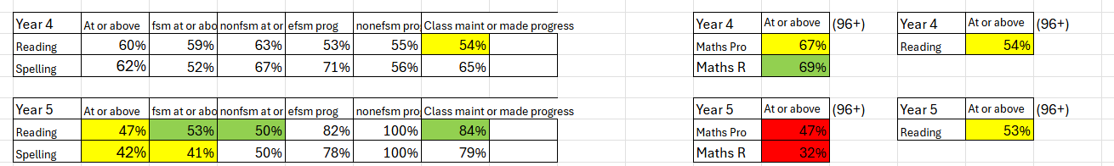
Progress judgement – Autumn | Progress judgement – Spring | Progress judgement – Summer

School Improvement Priority
Priority 4: Supporting vulnerable and disadvantaged pupils and the wider community
and mpove Reading and Spelling
Lead Person: LD Team: All staff
Link Governor: KGJ
Current position (Evidence
Whole school
Narrowing the gap
Reading - at age or above
fsm | non efsm
48% | 84% | concern re narrowing gap
Spelling - at age or above
48% | 88%
Procedural math at or above 96+
fsm | non efsm
53% | 48% | concern low scores generally
Reasoning
fsm | non efsm
40% | 62%

Reading progress
71% efsm made progress
86% non efsm made progress
Spelling progress
72% efsm made progress
86% non efsm made progress

Year 1 | At or above | fsm at or above | nonfsm at or above | efsm prog | nonefsm prog | Class maint or made progress
Reading | 35% | 29% | 38% | 57% | 57% | 57%
Spelling | 79% | 57% | 100% | 86% | 86% | 86%
Year 2 | At or above | fsm at or above | nonfsm at or above | efsm prog | nonefsm prog | Class maint or made progress
Reading | 69% | 69% | 100% | 71% | 100% | 85%
Spelling | 92% | 86% | 100% | 100% | 100% | 100%
Year 3 | At or above | fsm at or above | nonfsm at or above | efsm prog | nonefsm prog | Class maint or made progress
Reading | 54% | 56% | 50% | 59% | 71% | 63%
Spelling | 48% | 53% | 55% | 59% | 57% | 58%
Year 4 | At or above | fsm at or above | nonfsm at or above | efsm prog | nonefsm prog | Class maint or made progress
Reading | 53% | 53% | 50% | 73% | 50% | 71%
Spelling | 18% | 12% | 50% | 60% | 50% | 59%
Year 5 | At or above | fsm at or above | nonfsm at or above | efsm prog | nonefsm prog | Class maint or made progress
Reading | 89% | 66% | 100% | 100% | 100% | 100%
Spelling | 83% | 60% | 92% | 83% | 100% | 94%
Year 6 | At or above | fsm at or above | nonfsm at or above | efsm prog | nonefsm prog | Class maint or made progress
Reading | 80% | 67% | 100% | 83% | 100% | 93%
Spelling | 71% | 33% | 100% | 83% | 89% | 87%

Despite there still being a gap there has been good progress through work on narrowing the gap – therefore we continue this target.
from monitoring – reason/rationale for priority)

Areas to Develop (Capture areas to develop from monitoring in clear areas for improvement - what needs to improve based on monitoring above?)
- Re look at how we track our disadvantaged families by adding ACES onto tracker and using Trauma informed approaches
- Targeted interventions for pupils
- All staff to be trained in trauma informed approaches
- Continue with parent groups to support learning and nurture
- Continue to narrow the gap for disadvantaged pupils
- Continue to develop digital skills to engage disadvantaged learners

Desired Outcomes (What will each of the areas to develop listed above look like once achieved?)
- Vulnerable and disadvantaged gap is narrowed in all areas.
- Families are more engaged with learning
- Families are supported well with food, uniform and trips.

Activity | Lead person | Timescale | Staff development | Cost | Monitoring | Success Criteria | Date Completed/rag rating
Specific Action to be taken to achieve desired outcomes | Who takes responsibility? | Completion date | Support needed? | How much? Source (PDG etc)? | Who/when? | What will have improved?
Track pupils who are vulnerable or disadvantaged as well as 4 or more ACES | LD/KS | By October half term | Time to add data and present to staff | Staff meeting | LD/KS | Provision and nurture for pupils with 4 or more ACES | Established as part of Pupil progress meeting
Develop further the food and uniform store | LD/KS | By 16th October | Contact agencies | none | LD/KS | Sustainable provision for parents to use | Gained grants from Flintshire and Mold Council
Regular Parent groups to help with learning | LD/KS | Ongoing | External agency involvement  Improve facilities | £50 sundries  £800 JJW to offer TISK parent group | LD | Consistently providing adult learning across the year  To reduce the Gap  Parental engagement | 5 + plus different groups this year
Continue to engage parents with school events | LD/KS | Termly in place | Staff to timetable events | none | LD/KS | Parental engagement improved
All staff trained in Trauma informed approaches | LD/KS/JJW | November 4th | Trauma informed training | £1500 | JJW/LD | Pupil wellbeing | November 24
Continue with evidence based practice to support classes | KS | By October half term | Grants for projects – GwE? | £500 | KS | Reduced the Gap | Padlet
Dosbarth Derwen to support vulnerable and disadvantaged pupils | JJW | Ongoing | ALNCo | none | LD/KS | Pupils with trauma feel safe and ready to learn – quadrant to check

SDP monitoring Programme
Priority 4: Supporting vulnerable and disadvantaged pupils and the wider community
Lead Person: LD/KS/JJW
Linked Governor: KGJ
Milestones (what will be actioned term by term?)
Autumn | Spring | Summer
- Tracker in place with ACES  - All staff attend Trauma informed training  - Staff to work on projects in teams as part of their PM  - Staff use the Mike Gershwin site and choose area to implement  - Visit to schools to look at best practice  - Parent groups planned  - PTA in place  - Set up the food and uniform hub  - Greggs breakfast club support  - Interventions in place  - Governor to meet lead  - Staff meetings to discuss progress | - Pupil progress meetings to look evaluate progress  - Evaluate interventions  - Staff meet to evaluate progress of evidence based project  - Peer observation of good practice  - Governor to meet lead  - Report to Governors on progress  - Staff meetings to discuss progress  - Visit abroad | - Pupil progress meetings  - Evaluate the impact on performance of pupils  - Governor meet with lead to analyse data- Autumn  - Report data to Governors  - Staff meetings to discuss progress  - Parent questionnaires
Impact
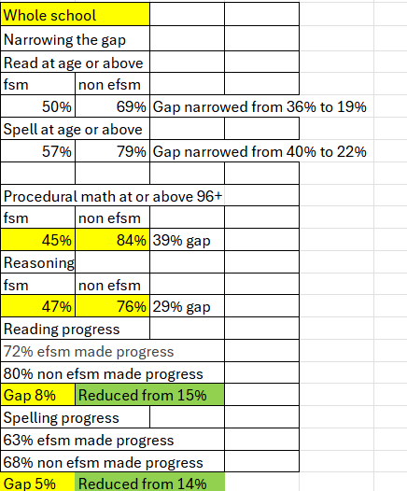
Number of pupils attending breakfast club has risen from
Parents feel welcomed to school and events are well attended
Nearly all parents that answered the questionnaire felt their child was safe at school and that issues were dealt with.
Attendance - Current whole school attendance is 90.5%. 2 families with very poor attendance is having a significant impact on overall attendance. There is a 2.6% variance between the attendance of efsm (88.78%) and non fsm (91.38%) learners. Late attendances are more noticeably high for efsm learners. Unauthorised absences are higher for efsm than non fsm learners in nearly all classes. 6 families are a real concern with persistent absences. 1 family has been issued with a fixed penalty notice. Attendance is monitored closely by the EWO and Head Teacher and the school works very closely with families. Letters are sent out immediately and followed up with an appointment at school.
Progress judgement – Autumn | Progress judgement – Spring | Progress judgement – Summer

