Ysgol Bryn Gwalia
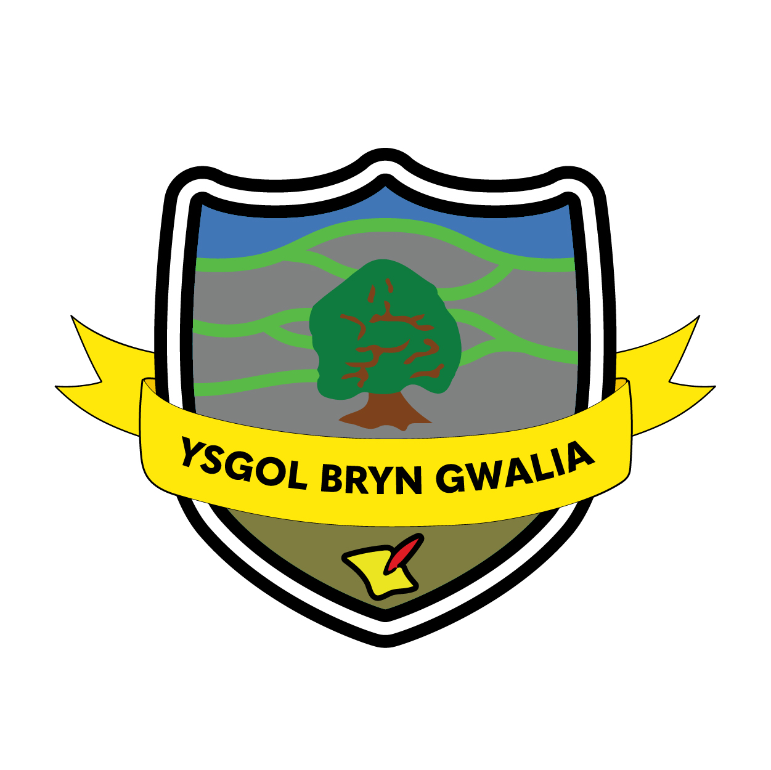

Acceptable Use of ICT Policy

Last Review Date | June 2025
Date to be reviewed by Senior Management Team | July 2028
Date Adopted by Governing Body | July 2025
Head Teacher – Mrs Lorraine Dalton | 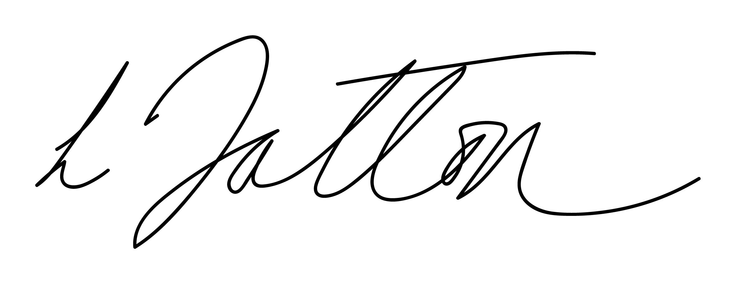
Chair of Governors – Mrs Janiene Davies | 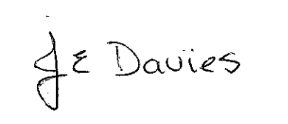


Introduction
Information Communication Technology (ICT) plays an important role in the lives of all pupils, young people and adults and is an essential resource to support teaching and learning. At Ysgol Bryn Gwalia we recognise the need to build in the use of these technologies in order to arm our pupils with the skills necessary to access life-long learning and employment.
E-Safety is concerned with ensuring the safety of our pupils, parents/guardians/carers and staff when using any means of electronic communication which can include:
- Websites and the Learning Platform (Hwb+)
- Email and Instant Messaging
- Social Networking and Chat Rooms
- Blogs, Wikis and Podcasting
- Video Broadcasting
- Music Downloading
- Gaming
- Mobile/Smart phones with text, video or web functionality
- Portable data storage including laptops and memory sticks (such as USB drives)
The purpose of internet in school is to:
  - Enhance teaching and learning and enrich the curriculum
  - Raise educational standards and promote pupil achievement
  - Support the professional work of staff and enhance the school’s management functions.
Internet access is an entitlement for students who show a responsible and mature approach to its use. Pupils use the internet widely outside school and need to learn how to evaluate internet information and to take care of their own safety and security.

Aims
At Ysgol Bryn Gwalia we understand our responsibility through this policy is to:
- Provide appropriate and safe access to modern information and communication technologies
- Educate our pupils and staff in e-safety issues and how to use the technologies safely, both in school and in the wider world.
- Ensure the responsible use of ICT by all staff and pupils.

Roles and Responsibilities
The e-safety co-ordinator – Mrs Louise Allen and Mrs Kate Sturdy
The e-safety and ICT coordinators will update the staff and Governors when necessary so that they have an understanding of the issues relating to e-safety.

Guidelines
Staff:
- Are given access to the school e-safety policy and made aware of its importance.
- Receive regular information and training on e-safety issues, through the e-safety and ICT coordinators at staff meetings.
- Are made aware of individual responsibilities relating to the safeguarding of pupils within the context of e-safety.
- Know what to do in the event of misuse of technology by any member of the school community.
- Receive information on the school’s Acceptable Use Agreement as part of their induction and sign an agreement annually.
- Are encouraged to incorporate e-safety activities and awareness within their lessons.
- Are reminded to be vigilant when transporting sensitive school data on portable devices such as laptops and memory sticks.
- Must be respectful of copyright, property rights and privacy issues of any information downloaded.
- Should be aware that internet traffic is monitored and can be traced to the individual user.
- Must recognise that discretion and professional conduct is essential.
- May be issued with a laptop/iPAD, which remains the property of the school. Users of such equipment must adhere to school policy regarding appropriate use with regard to internet access, data protection and use of software, both in and out of school.
- Will be trained and given advice on how to effectively use the school’s website and Learning Platform.

Parents/guardians/carers:
- Are asked to read through and sign the Acceptable Use Agreement on the Parental Consent Form when their child joins the school.
- Are required to make a decision as to whether they consent to images of their child being taken and used on the school’s website or Learning Platform.
- Are provided with information through the school’s website, Learning Platform and newsletter which contain useful information and links to sites such as Thinkuknow, Childline and CEOP.
- Are informed about what the Learning Platform is and how it can enhance the learning of each child.

Community use of the Internet:
- Organisations using the school’s ICT facilities must adhere to the e-safety policy.
- All users must have signed a copy of the Acceptable Use Agreement prior to first use.

Teaching and Learning
- The school will provide opportunities within a range of curriculum areas to teach e-safety. This may include work done by the Schools Police Liaison Officer
- Educating pupils on the dangers of technologies that may be encountered outside school is done informally when opportunities arise and as part of the e-safety curriculum.
- Pupils must be made aware of the impact of online bullying and know how to seek help if these issues affect them. Pupils are also made aware of where to seek advice or help if they experience problems when using the Internet and related technologies; i.e. parent/carer, teacher/trusted member of staff, or an organisation such as Childline/CEOP. (Child Exploitation and Online Protection Centre)
- The school’s internet access is designed expressly for pupil use and will include filtering appropriate to the age of pupils. This is controlled by Wrexham LA.
- Pupils will be taught what internet use is acceptable and what is not and given clear objectives for its use.
- Pupils will be educated in the effective use of the internet in research, including the skills of knowledge location, retrieval and evaluation.
- E-safety rules will be displayed in all classrooms and the ICT suite and discussed with the pupils at the start of each term.
- Specific lessons on e-safety and cyber bullying will be taught by class teachers at the beginning of every year and at relevant points throughout e.g. during PSHE lessons/circle times/anti-bullying week etc.
- Pupils will be informed that network and internet use will be monitored.
- The school will ensure that the use of internet derived materials by staff and pupils complies with copyright law.
- Pupils should be taught to be critically aware of the materials they read and shown how to validate information before accepting its accuracy.
- All pupils will be given training on how to effectively use the Learning Platform, HWB+.

Managing Systems and the Internet
Filtering and monitoring:
- The school will work with the Local Authority and the Internet Service Provider to ensure systems to protect pupils are reviewed and improved.
- If pupils or staff discover an unsuitable site, it must be reported to the e-safety/ ICT Coordinator so that it may reported to the appropriate officer.
- The e-safety/ ICT coordinators will ensure that regular checks are made to ensure that the filtering methods selected are appropriate, effective and reasonable.

System security:
The Internet is an open communication medium, available to all, at all times. Anyone can view information, send messages, discuss ideas and publish material, which makes it both an invaluable resource for education, business and social interaction, as well as a potential risk to young and vulnerable people.
- The school’s ICT system’s capacity and security will be reviewed regularly.
- Security strategies will be discussed with Flintshire ICT advisors.
- Adult users are provided with an individual network, email and Hwb+ login username and password.
- All pupils are provided with an individual network login and Hwb+ login username and password.
- Pupils are not allowed to deliberately access on-line materials or files of their peers, teachers or others on the school network.
- Staff are aware of their individual responsibilities to protect the security and confidentiality of the school network and systems.

Authorising Internet access
The school will take all reasonable precautions to ensure that users access only appropriate material. However, due to the international scale and linked nature of Internet content, it is not possible to guarantee that unsuitable material will never appear on a school computer.
- Pupil instruction in responsible and safe use should precede any internet access and all pupils must sign up to the Acceptable Use Agreement for pupils and abide by the school’s e-safety rules. These e-safety rules will also be displayed clearly in all networked rooms.
- Pupil access to the internet will be supervised by an adult at all times.
- All parents/guardians/carers will be asked to sign the Acceptable Use Agreement acknowledging that their child will have access to the Internet in school and that they will follow the school’s e-Safety rules and constraints detailed in the school’s e-Safety policy.
- All staff must read and agree in writing to adhere to the Acceptable Use Agreement for Staff before using any school ICT resource.
E-mail
- Pupils may only use approved email accounts on the school system.
- Pupils must immediately tell a teacher if they receive an offensive email.
- Pupils must not reveal personal details of themselves or others in email communication, or arrange to meet anyone without specific permission.
- Emails sent to an external organisation should be written carefully and authorised before sending, in the same way as a letter written on school headed paper.
- The forwarding of chain letters is not permitted.
- Staff are advised to use school based email accounts, not personal accounts, when contacting parents/guardians/carers.
Social networking and personal publishing
- The LA will block / filter access to social networking sites.
- Newsgroups will be blocked unless a specific use is appropriate.
- Pupils and parents/guardians/carers will be advised that the use of some social network spaces outside school is inappropriate for primary aged pupils. However, we accept that some pupils will still use them; they will be advised never to give out personal details of any kind, which may identify them or their location.
- Pupils are advised to set and maintain profiles on such sites to maximum privacy and deny access to unknown individuals.
- Our pupils are asked to report any incidents of cyber bullying to the school.
- School staff must not add current school pupils as ‘friends’ if they use these sites.

Published content and the school web site
The contact details on the Website should be the school address, email and telephone number. Staff or pupils’ personal information will not be published. The headteacher will take overall editorial responsibility and ensure that content is accurate and appropriate.

Publishing pupils’ images and work:
- Parents/guardians/carers are asked to read and sign the Using Images of Pupils section of the Parental Consent Form when their child joins the school.
- Parents/guardians/carers/carers may withdraw permission, in writing, at any time.
- Photographs that include pupils will be selected carefully and will not enable individual pupils to be clearly identified.
- Pupils’ full names will not be used anywhere on the School Website, particularly in association with photographs. Only pupils’ initials/first names will appear alongside individual pupils’ avatars on the Learning Platform where avatars are in use.
- Pupil’s work can only be published by outside agencies with written permission from the pupil and parents/guardians/carers – see permission sheet.
- Pupils will be allowed to upload photographs of groups or group activities onto their homepage, but not individual pictures of themselves.

Photographs taken by parents/guardians/carers/carers for personal use
In the event of parents/guardians/carers/carers wanting to take photographs for their own personal use, at events such as school performances and assemblies, the school will demonstrate its protective ethos by announcing that photographs taken are for private retention and are not for publication in any manner, including use on personal websites and social networking sites. These images should only be viewed by members of the school community and close family.

Portable devices
- The use of portable media such as memory sticks and CD ROMS will be monitored closely as potential sources of computer virus and inappropriate material.
- Pupils are not allowed to bring personal/portable mobile devices/phones to school or on school residentials. Any phones/personal/portable mobile devices that are brought to school will be sent to the school office and kept there until the end of the day and those taken on a school residential will be retained by the leader in charge until the end of the visit. The sending of abusive or inappropriate text messages is forbidden.
- Staff will use a school phone where contact with pupils is required.
- Staff will not use personal equipment or non-school personal electronic accounts when contacting pupils.
- Staff are advised to keep personal electronic devices such as mobile phones out of sight.
- Staff are advice to password protect personal electronic devices used on school premises such as mobile phones and laptops.

Protecting personal data
The school will collect personal information about pupils and families fairly and will let them know how the school and Wrexham will use it. The school will use information about pupils to further curriculum, professional and managerial activities in accordance with the business of the school and will contact the parents/guardians/carers or guardians, if it is necessary, to pass information beyond the school or local authority. For other members of the community the school will tell you in advance if it is necessary to pass the information on to anyone else other than the school and local authority.
The school will hold personal information on its systems for as long as a child remains a member of the school community and remove it in the event of them leaving or until it is no longer required for the legitimate function of the school. We will ensure that all personal information supplied is held securely, in accordance with the policies and practices of Wrexham and as defined by the Data Protection Act 1998.
Parents/guardians/carers and pupils have the right to view the personal information that the school holds about its pupils and to have any inaccuracies corrected.

Handling e-Safety complaints
- Complaints of Internet misuse will be dealt with by a senior member of staff and reported to the e-Safety coordinator.
- Deliberate access to inappropriate materials by any user will lead to the incident being logged by the e-Safety coordinator and recorded in the e-Safety incident logbook.
- Any complaint about staff misuse must be referred to the Headteacher.
- Complaints of a child protection nature must be dealt with in accordance with school child protection procedures.
- Pupils and parents/guardians/carers will be informed of the complaints procedure.

Ysgol Bryn Gwalia
Acceptable Use Agreement

For Staff

The computer system is owned by the school and is made available to staff to enhance their professional activities including teaching, research, administration and management. The school’s Internet Access Policy has been drawn up to protect all parties – the pupils (and their parents/guardians/carers), the staff, guest and community users and the school.

Any infringement of this agreement, may result in disciplinary action.

- The school reserves the right to examine or delete any files that may be held on its computer system or to monitor any Internet sites visited.
- Staff requesting Internet access should sign a copy of this Acceptable Internet Use Statement and return it to the Head Teacher.
- Internet activity should be appropriate to staff professional activity or the pupil’s education.
- Any photographs taken of pupils during school activities should be for school use only – sharing of photographs without permission is not permitted.
- Access should only be made via the authorised account and password, which should not be made available to any other person. (Passwords may be shared with Teacher Training Students provided they have signed the appropriate agreements).
- Activity that threatens the integrity of the school ICT systems, or activity that attacks or corrupts other systems, is forbidden.
- Users are responsible for all e-mail sent and for contacts made that may result in e-mail being received.
- Use for personal financial gain, gambling, political purposes or advertising is forbidden.
- Copyright of materials must be respected.
- Posting anonymous messages and forwarding chain letters is forbidden.
- As e-mail can be forwarded or inadvertently be sent to the wrong person, the same professional levels of language and content should be applied as for letters or other media.
- Use of the network to access inappropriate materials such as pornographic, racist or offensive material is forbidden.
- No staff member should use ‘work’, the school name or its pupils/parents/guardians/carers (or any other comments which may relate back to Ysgol Bryn Gwalia) on personal social media sites such as ‘Facebook’. Although social media sites may be have high privacy settings, once comments are published they are in the public domain.

Name
Date |  | Signed

Ysgol Bryn Gwalia E-safety Rules

- We ask permission before using the internet

- We check sites are appropriate when researching
- We only contact people our teacher has approved

- We only communicate with people in ways that are polite and friendly- we never send anything by text or e-mail that we wouldn’t say face to face.

- We never give personal details such as phone numbers, adresses etc

- We never arrange to meet anyone we don’t know

- We never open e-mails sent by people we don’t know

- We never use internet chat rooms

- When sending e-mails, we always use correct punctuation and don’t use ‘text speak’


- We always tell a parent or teacher if there is anything we are unhappy with

Ysgol Bryn Gwalia
Acceptable Use Agreement

For Guest and Community Users

The computer system is owned by the school and is made available to Guest and Community users for learning and research activities. The school’s Internet Access Policy has been drawn up to protect all parties – the pupils, the staff, guest and community users and the school.

- The school reserves the right to examine or delete any files that may be held on its computer system or to monitor any Internet sites visited.
- Users requesting Internet access should sign a copy of this Acceptable Internet Use Statement and return it to the Head Teacher for approval.
- Internet access should be appropriate to learning or research activities.
- Access should only be made via the authorised account and password, which should not be made available to any other person.
- Activity that threatens the integrity of the school ICT systems, or activity that attacks or corrupts other systems, is forbidden.
- Users are responsible for all e-mail sent and for contacts made that may result in e-mail being received.
- Use for personal financial gain, gambling, political purposes or advertising is forbidden.
- Copyright of materials must be respected.
- Posting anonymous messages and forwarding chain letters is forbidden.
- As e-mail can be forwarded or inadvertently be sent to the wrong person, the same levels of language and content should be applied as for letters or other media that would be suitable for viewing by a child.
- Use of the network to access inappropriate materials such as pornographic, racist or offensive material is forbidden.
- Staff should not use ‘work’, the school or its pupils (or any other comments which may relate to Ysgol Bryn Gwalia) on personal social media sites such as ‘Facebook’.

Name
Date |  | Signed

