Ysgol Bryn Gwalia


Adults Causing Distress Policy
Last Review Date | July 2025
Date to be reviewed by Senior Management Team | July 2028
Date Adopted by Governing Body | July 2025
Head Teacher – Mrs Lorraine Dalton | 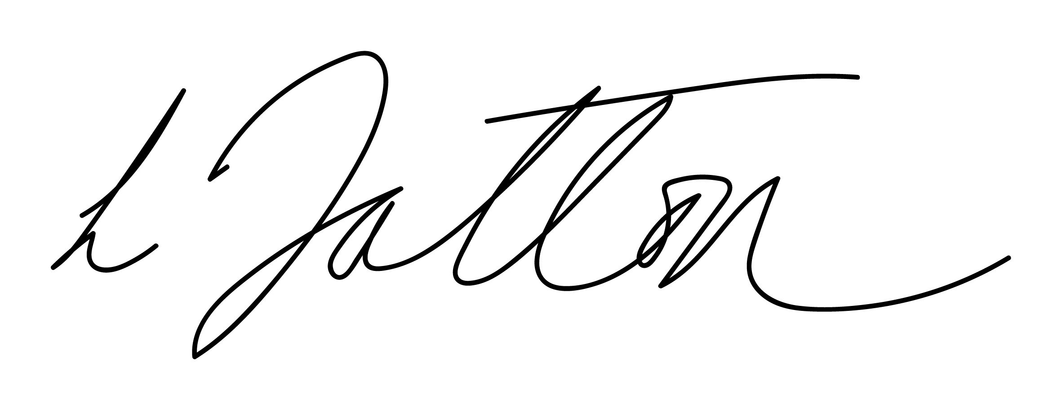
Chair of Governors – Mrs Janiene Davies | 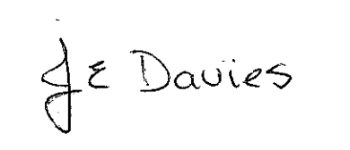


Introduction
The Governing Body of Ysgol Bryn Gwalia encourages close links with parents/carers and the wider school community. It believes that pupils benefit when the relationship between home and school is a positive one. The Governing Body also believes that our staff and pupils have the right to work in a safe environment, free from any abuse or harm caused by others.

We expect all adults to treat our staff, pupils, parents and visitors with courtesy and respect at all times. In a small number of cases the actions of some adults become unacceptable because they involve abuse of our staff, pupils, parents, visitors and/or our processes or place excessive or unreasonable demands on the school or school staff.

We do not view an action as unacceptable, just because a person is forceful or determined. However, we do consider actions that result in unreasonable demands and/or abusive behaviour to be unacceptable.

The Governing Body expects and requires its members of staff to behave professionally in difficult situations and attempt to defuse situations where possible, seeking the involvement as appropriate of other colleagues. All members of staff have the right to work without fear of violence and abuse.

We expect parents/carers and other visitors to behave in a reasonable way towards members of school staff. This policy outlines the steps that will be taken where behaviour is unacceptable or where the demands of parents/carers or visitors placed on the school or school staff are excessive or unreasonable.

There are a range of actions we consider to be unacceptable, which can be best grouped as follows:

- Aggressive or abusive behaviour;
- Unreasonable demands and/or unreasonable levels of contact.

Aggressive or abusive behaviour
We understand that people can become angry when they feel that matters about which they feel strongly are not being dealt with as they wish. If that anger escalates into aggression or abuse towards our staff, pupils, parents/carers or visitors, we consider that unacceptable.

Aggressive or abusive behaviour includes language (whether verbal or written) that may cause staff, pupils, parents/carers or visitors to feel afraid, threatened or abused and may include threats, personal verbal abuse, derogatory remarks and rudeness. We also consider inflammatory statements, remarks of a discriminatory nature and unsubstantiated allegations, to be abusive behaviour. Where an adult is aggressive or abusive, we may decide to:

- Advise the adult that we consider their actions offensive, unnecessary and unhelpful and ask them to stop;
- End telephone calls / appointments / meetings;
- Terminate all direct contact with the adult;
- Notify the police. This will always be the case if physical violence is used or threatened;
- Take any other action that we consider appropriate to the circumstances, including banning the parent/carer from the school premises.

In imposing a ban the following steps will be taken:

1. The parent/carer will be informed, in writing, that she/he is banned from the premises, subject to review, and what will happen if the ban is breached, eg. that police involvement.
2. Where an assault has led to a ban, a statement indicating that the matter has been reported to the Local Authority and the police will be included.
3. The chair of the Governing Body and Local Authority will be informed of the ban
4. Where appropriate, arrangements for pupils being delivered to, and collected from the school gate will be clarified.

Unreasonable demands and / or unreasonable levels of contact
A demand becomes unacceptable when it starts to impact excessively on the work of our staff, or when dealing with the matter takes up an excessive amount of time and in so doing, disadvantages other members of the school community, staff, pupils, parents/carers or visitors.

Where an adult is unreasonably demanding, repeatedly contacts us in person, by phone, or email or contacts various staff about the same issue, raises the same issue repeatedly, or sends us large numbers of documents about which the relevance is not clear, we may decide to:
- Limit contact to telephone calls from the person at set times on set days;
- Restrict contact to a nominated member of staff who will deal with future calls or correspondence;
- See the person by appointment only;
- Restrict contact to written correspondence only;
- Refuse to deal with further correspondence and return any documents;
- Advise the person that further irrelevant documentation will be destroyed;
- Take any other action that we consider appropriate to the circumstances.

Taking action
Before we take any action, we will give the adult involved the opportunity to modify their behaviour. If the behaviour continues, we will take action as set out in this document. Adults causing distress will be told in writing why a decision has been made, what the alternative arrangements will be and the length of time that these restrictions will be in place.

Evaluation & Review
This policy will be reviewed by the Senior Management Team and Governing Body and adopted by the Governing Body as per the schedule on the front page.

