Ysgol Bryn Gwalia
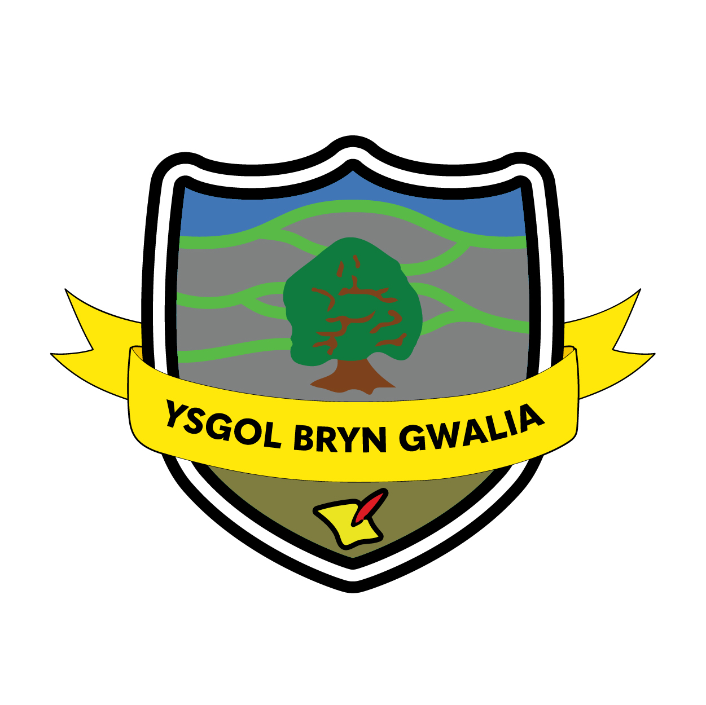

CCTV Policy
Last Review Date | January 2025
Date to be reviewed by Senior Management Team | July 2028
Date Adopted by Governing Body | July 2025
Head Teacher – Mrs Lorraine Dalton | 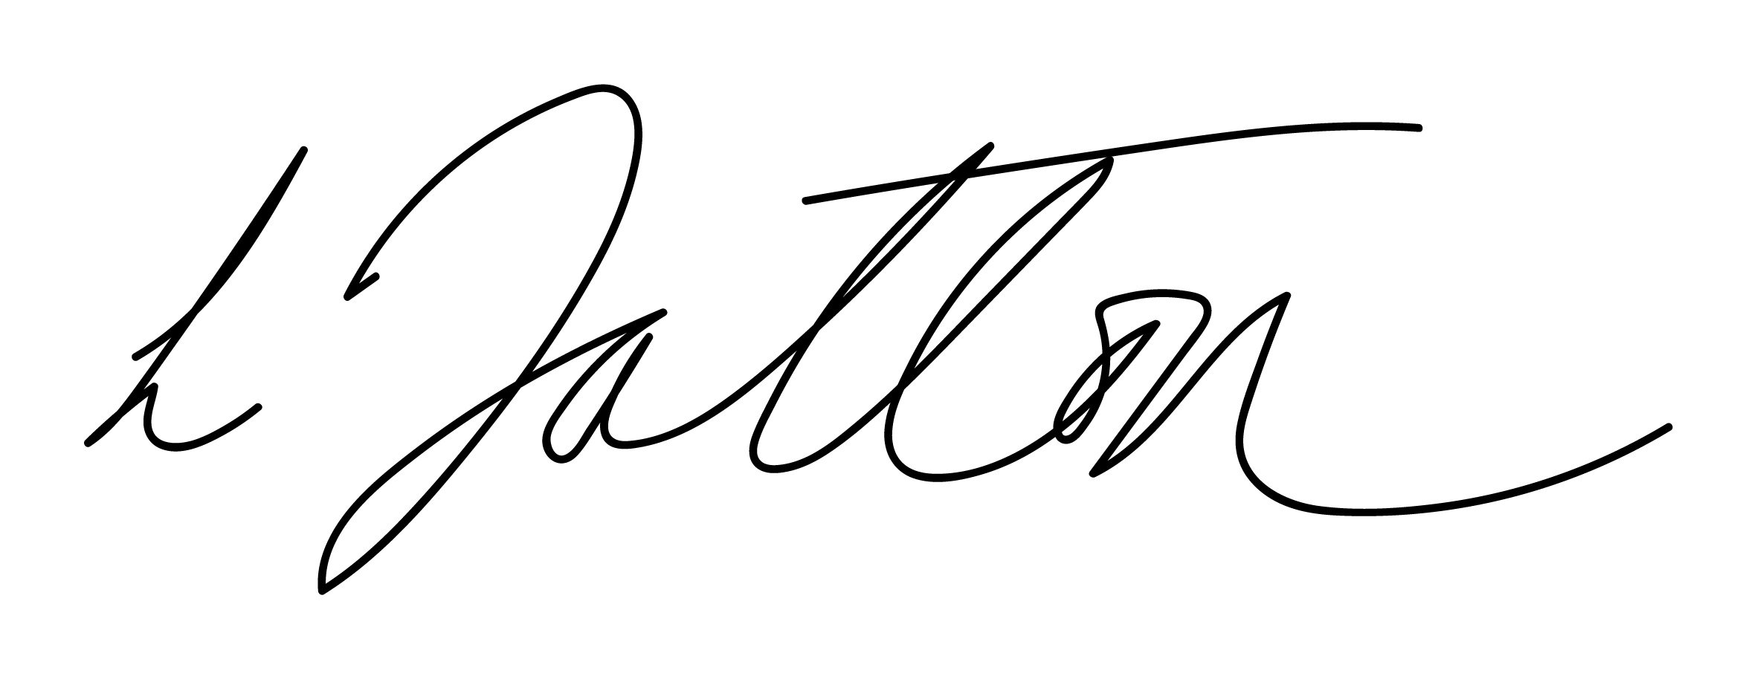
Chair of Governors – Mrs Janiene Davies



Introduction
Ysgol Bryn Gwalia uses closed circuit television (CCTV) images to reduce crime and monitor the school buildings and grounds in order to provide a safe and secure environment for pupils, staff and visitors, and to prevent the loss or damage to school property.

The system comprises a number of fixed cameras located on the outside of the building, covering entrances, play areas and school grounds. The system does not have sound recording capability.

The CCTV system is owned and operated by the school, the deployment of which is determined by the school’s leadership team. The CCTV is maintained centrally from the school offices by the School Business Manager and the Head teacher acting as the Data Controlling Office

The introduction of, or changes to, CCTV monitoring will be subject to consultation with staff and the school community. The school’s CCTV Scheme is registered with the Information Commissioner under the terms of the Data Protection Act 2018. The use of CCTV, and the associated images and any sound recordings is covered by the Data Protection Act 2018. This policy outlines the school’s use of CCTV and how it complies with the Act.

All authorised operators and employees with access to images are aware of the procedures that need to be followed when accessing the recorded images and sound. All operators are trained by the school data controller in their responsibilities under the CCTV Code of Practice. All employees are aware of the restrictions in relation to access to, and disclosure of, recorded images and sound.

Statement of Intent
The school complies with Information Commissioner’s Office (ICO) CCTV Code of Practice to ensure it is used responsibly and safeguards both trust and confidence in its continued use. The Code of Practice is published at:
https://ico.org.uk/media/for-organisations/documents/1542/cctv-code-of-practice.pdf

In areas where CCTV is used, the school will ensure that there are prominent signs placed at both the entrance of the CCTV zone and within the controlled area.
The planning and design has endeavoured to ensure that the Scheme will give maximum effectiveness and efficiency but it is not possible to guarantee that the system will cover or detect every single incident taking place in the areas of coverage.

Siting the Cameras
Cameras will be sited so they only capture images relevant to the purposes for which they are installed (described above) and care will be taken to ensure that reasonable privacy expectations are not violated. The School will ensure that the location of equipment is carefully considered to ensure that images captured comply with the Data Protection Act 2018.

The school will make every effort to position cameras so that their coverage is restricted to the outdoor school premises. CCTV will not normally be used within school;. Members of staff should have access to details of where CCTV cameras are situated, with the exception of cameras placed for the purpose of covert monitoring.

Covert Monitoring
This will only take place in exceptional circumstances under the direction/advice of the police, safeguarding agencies and the Local Authority Legal department

Storage and Retention of CCTV images
Recorded data will not be retained for longer than 6 months. While retained, the integrity of the recordings will be maintained to ensure their evidential value and to protect the rights of the people whose images have been recorded.
All retained data will be stored securely.

Access to CCTV images
Access to recorded images will be restricted to those staff authorised to view them, and will not be made more widely available.

Subject Access Requests (SAR)
Individuals have the right to request access to CCTV footage relating to themselves under the Data Protection Act 2018 and other relevant legislation.
All requests should be made in writing to the Head teacher. Individuals submitting requests for access will be asked to provide sufficient information to enable the footage relating to them to be identified. For example, date, time and location.
The school will respond to requests within 1 calendar month of receiving the written request.
The school reserves the right to refuse access to CCTV footage where this would prejudice the legal rights of other individuals or jeopardise an on-going investigation.

Access to and Disclosure of Images to Third Parties
There will be no disclosure of recorded data to third parties other than to authorised personnel such as the Police and safeguarding agencies where these would reasonably need access to the data (e.g. investigators).
Requests should be made in writing to the Headteacher
The data may be used within the school’s complaints, discipline and grievance procedures as required, and will be subject to the usual confidentiality requirements of these procedures.

Complaints
Complaints and enquiries about the operation of CCTV within the school should be directed to the Head teacher in the first instance.

Evaluation & Review
This policy will be reviewed by the Senior Management Team and Governing Body and adopted by the Governing Body as per the schedule on the front page.

