Ysgol Bryn Gwalia
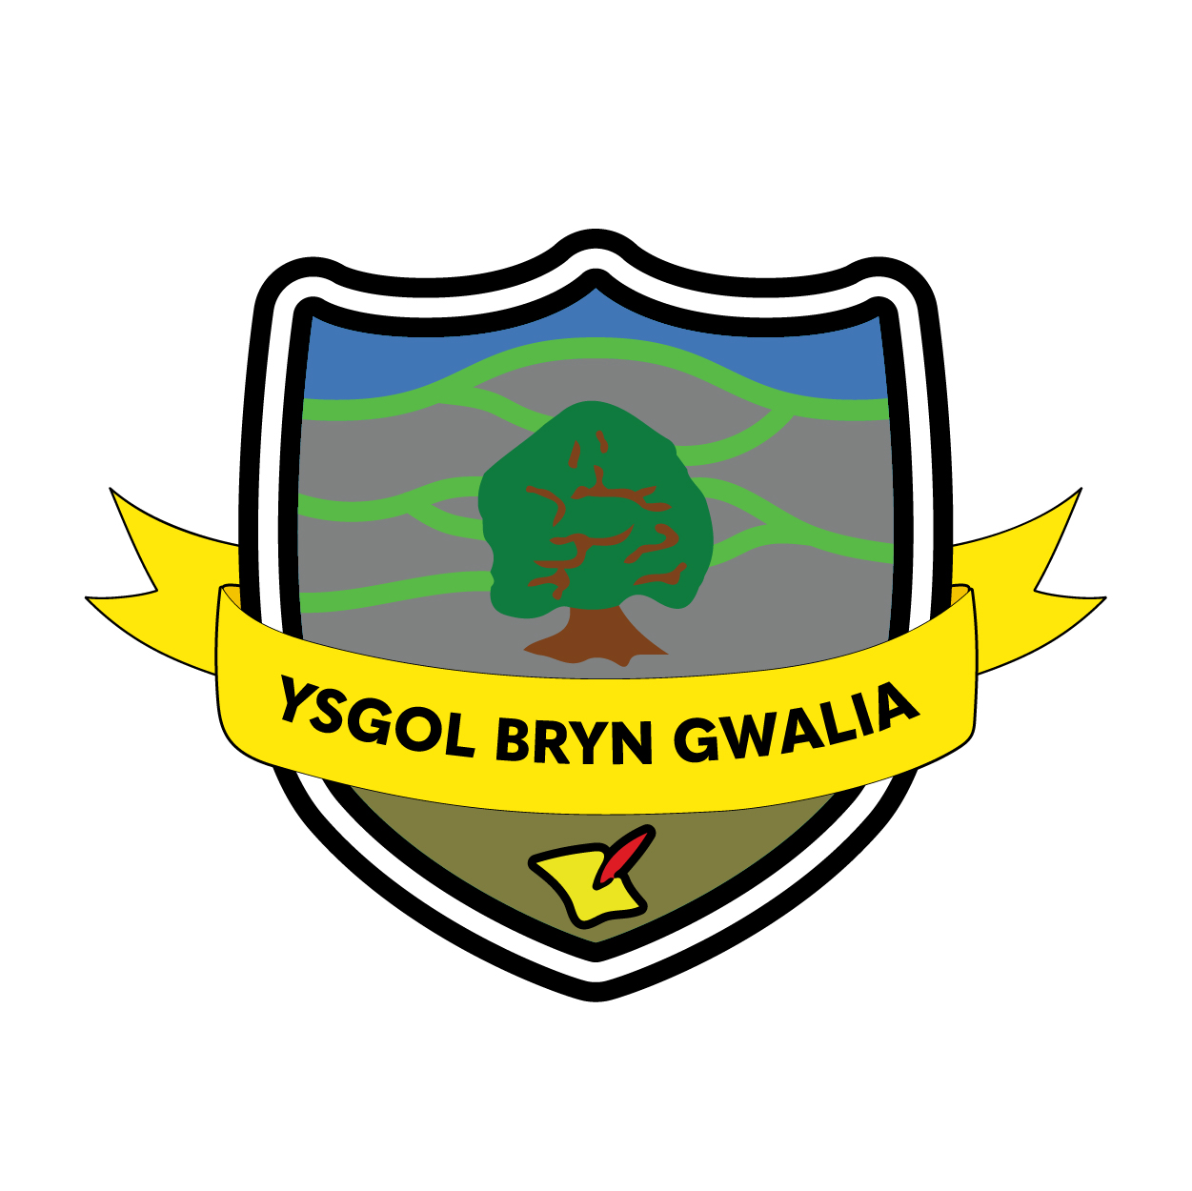

Counter Fraud Policy
Last Review Date | July 2025
Date to be reviewed by Senior Management Team | July 2028
Date Adopted by Governing Body | July 2025
Head Teacher – Mrs Lorraine Dalton | 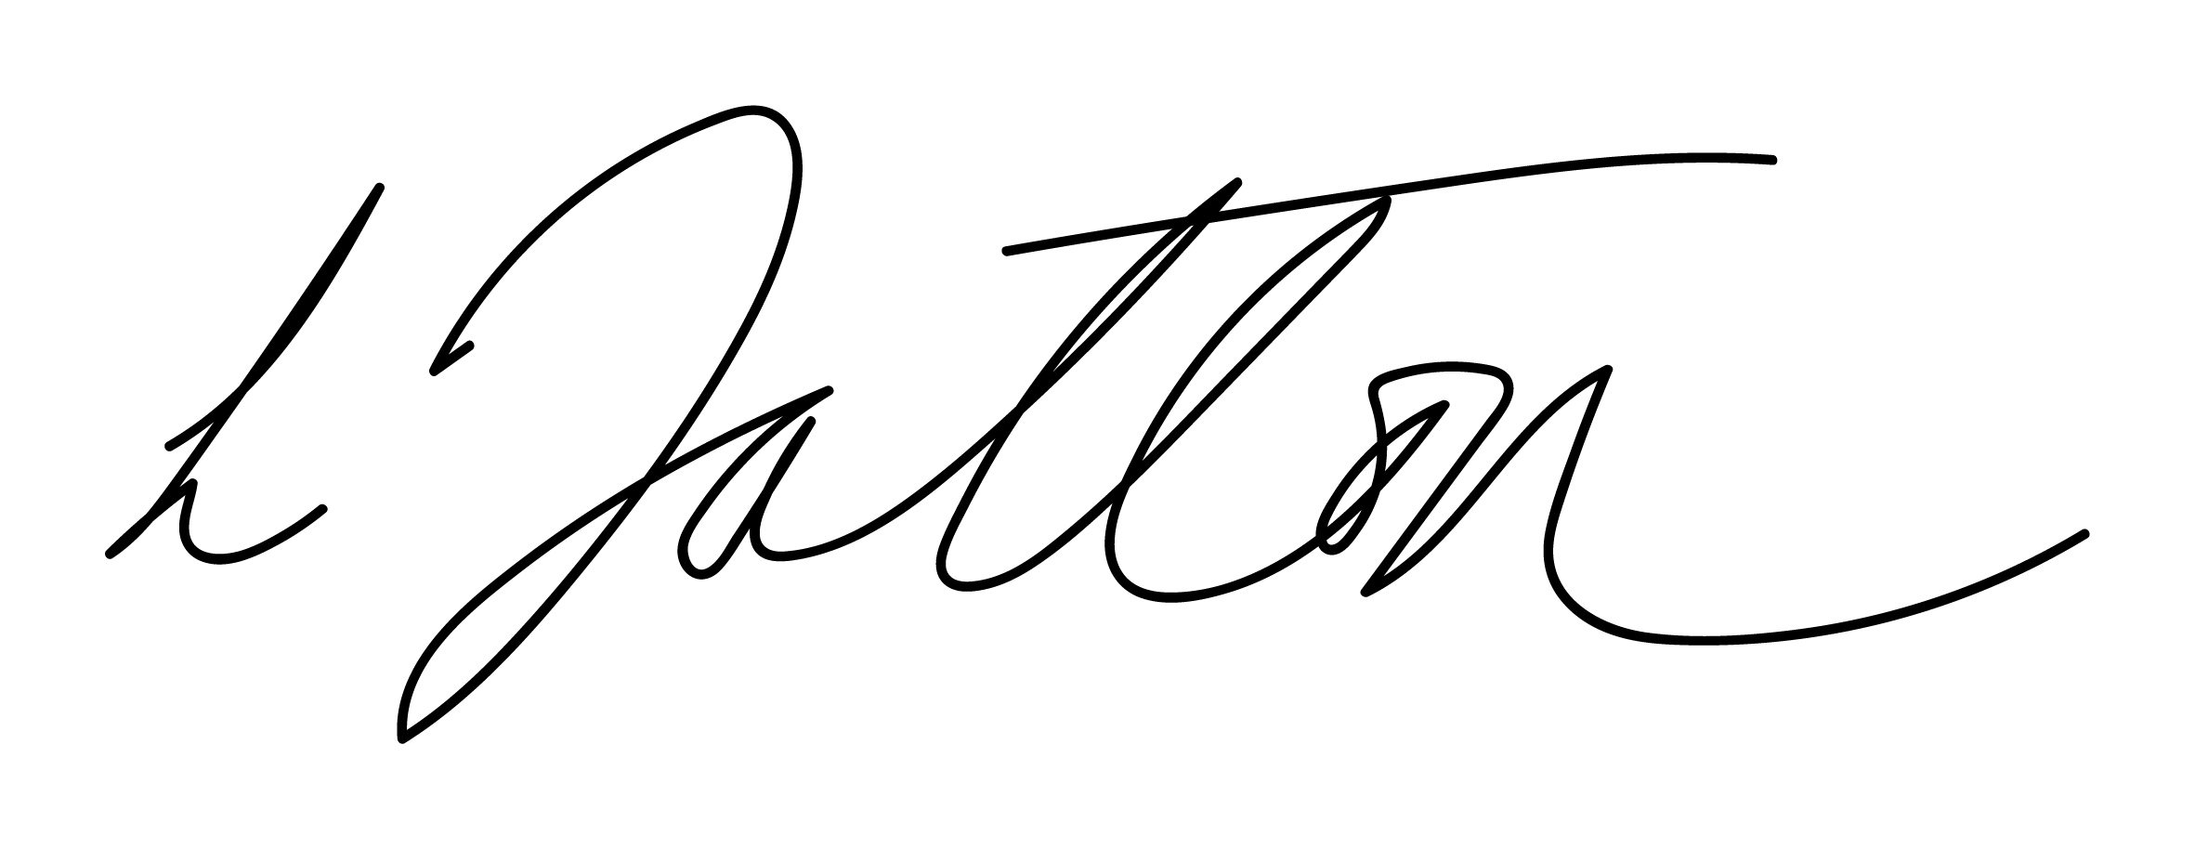
Chair of Governors – Mrs Janiene Davies | 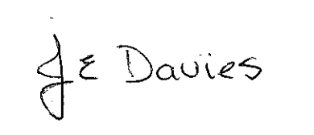



Introduction
Ysgol Bryn Gwalia is committed to the prevention of fraud and the promotion of an anti-fraud culture.

Ysgol Bryn Gwalia operates a zero-tolerance attitude to fraud and requires all staff, governors and volunteers to act honestly and with integrity at all times, and to report all reasonable suspicions of fraud.

Ysgol Bryn Gwalia will investigate all instances of actual, attempted or suspected fraud and will seek to recover any losses and pursue appropriate sanctions against the perpetrators. This may include criminal prosecution, disciplinary action, legal proceedings and professional sanctions.

This policy applies to all staff (full time, part time, temporary and casual), consultants, volunteers and the school’s Governing Body.

Definition of Fraud

The term ‘fraud’ is often used to describe complex financial offences such as false accounting. However, in its simplest form, fraud is lying. Some people will lie, or withhold information, or generally abuse their position to try to trick someone else into believing something that isn’t true. Examples might include:

- Sending fake invoices for goods and services that weren’t ordered or received.
- Use of the school’s purchase card to make personal purchases.
- Intercepting a school cheque and amending the name of the payee and/or the amount.
- Submitting false claims for sickness or expenses.

Individuals caught committing fraud can be prosecuted under the Fraud Act 2006 if they make a false representation, fail to disclose information or abuse their position.

Key Responsibilities

The Head Teacher is responsible for:

- Developing, implementing and maintaining adequate systems of internal control that prevent and detect fraud.
- Testing the system of internal control and seeking independent assurance when appropriate.
- Regularly reviewing the school’s anti-fraud policy and compliance with it to ensure it remains effective and relevant to the needs of the school.
- Reporting compliance with the policy on at least an annual basis to the Governing Body.
- Reporting allegations of actual, attempted or suspected fraud to the Full Governing Body and Flintshire County Council’s Section 151 Officer
- Ensuring all allegations of fraud are investigated appropriately, in compliance with relevant policies, procedures and legislation and commencing disciplinary and/or legal action where appropriate.

The Governing Body are responsible for:

- Overseeing the financial performance of the school, including its assets, making sure the school’s money is well spent and measures are in place to prevent losses or misuse, including arrangements for preventing and detecting fraud.

Staff are responsible for:

- Familiarising themselves with the types of fraud that might affect the school.
- Ensuing they adhere to the agreed policies and procedures, thereby protecting the school’s reputation and assets from fraud.
- Reporting allegations of actual, attempted or suspected fraud to the Head Teacher, and/or the Governing Body and/or Flintshire Council’s Section 151 Officer.
- Assisting in the investigation of suspected fraud when requested to do so, for example by providing witness statements.

Reporting Suspicions

The Governing Body and staff are an important element the school’s stance on fraud and are required to raise any concerns that they may have. The Head Teacher and Governors will deal with any financial irregularities robustly.

Staff should immediately report any concerns about actual, attempted or suspected fraud to the Head Teacher. However, if the concerns relate to the Head Teacher, staff should report their concerns to the Chair of Governors.

Under no circumstances should staff investigate the matter themselves.

Should a member of staff, including the Head Teacher and/or Governors wish to seek advice about how to deal with an allegation of fraud, or want to report the matter anonymously, they can call the Flintshire County Council whistleblowing helpline which is operated by Internal Audit. Alternatively, staff can email Flintshire County Council’s Internal Audit team.

The Public Interest Disclosure Act 1998 protects employees who raise concerns about certain matters of public interest in good faith. Staff can obtain free independent advice from the charity Protect (formerly Public Concern at Work) on 0203 117 2520 and find other helpful information at www.pcaw.org.uk.

A copy of the school’s Whistleblowing Policy can be obtained from the Headteacher.

A referral form has been provided at Appendix 2 which staff and Governors may wish to use as a guide to the type of information that should be captured when an allegation of fraud arises.

Contact Details

Telephone: 01352 752659

Email: gwmail@hwbcymru.net

Fraud Response Plan

Ysgol Bryn Gwalia has established guidelines for senior staff and the Governing Body on the immediate actions to be taken in the event of a fraud being discovered or suspected. It covers how and when to seek professional advice, securing evidence and preventing further losses.

Evaluation & Review
This policy will be reviewed by the Senior Management Team and Governing Body and adopted by the Governing Body as per the schedule on the front page.

