Ysgol Bryn Gwalia
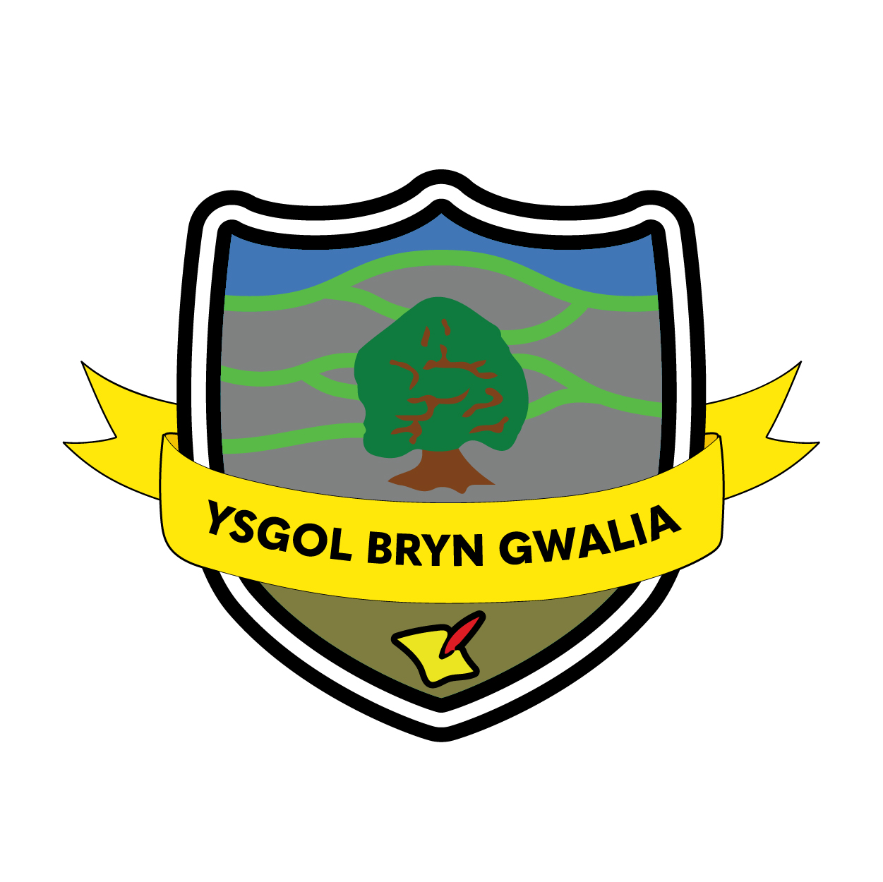

Fire Safety
Procedure & Policy
Last Review Date | January 2022
Date to be reviewed by Senior Management Team | September 2026
Date Adopted by Governing Body | Sept3ember 2023
Head Teacher – Mrs Lorraine Dalton | 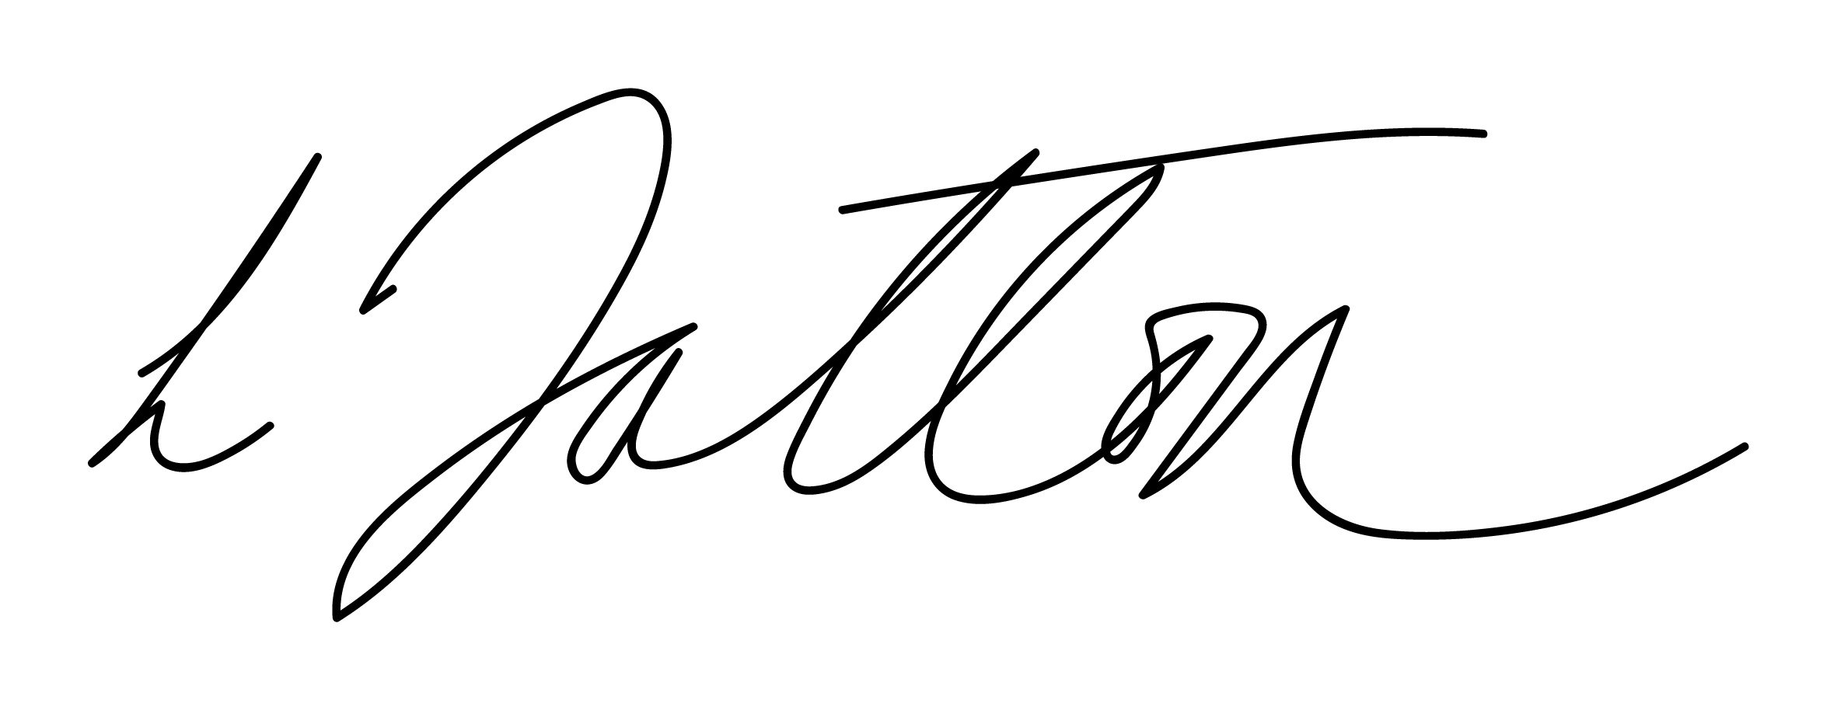
Chair of Governors – Mrs Janiene Davies | 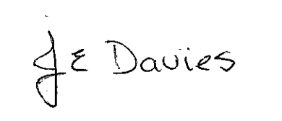



This policy and procedure are to be read and used in conjunction with the Fire Risk Assessment completed by the Local Authority of the school building and site. Ensuring the implementation of this policy is the responsibility of all staff, under the leadership of the Headteacher.

Fire Routine
The following should be adhered to:
- A notice detailing the action taken in the event of fire should be displayed in staff areas/adjacent to fire alarm contacts and fire points.
- All staff should be familiar with the Fire Routine.
- Fire drills should be carried out on at one occasion per half term. (6 per year).
- A fire log book should be kept, in which the following details are recorded:
  - Fire drills and fire instructions
  - Testing and maintenance of fire alarm system
  - Testing and maintenance of fire fighting equipment
  - Testing and maintenance of emergency lighting (where applicable)

The log book should be readily available for inspection as and when required.

Frequency of Inspections
The purpose of these inspections by Local Authority is to ensure that arrangements for the safety of occupants are properly available and maintained and that no additional fire hazards are introduced. A fire safety inspection by the Local Authority will be conducted every 3 years with the school Fire Risk Assessment updated.

Preparation:
- The teacher will have taken a register to ensure accurate records of those present is kept. This register will need to be taken out during a fire practice/actual fire situation to allow for all to be accounted for.
- Staff should check, prior to the commencement of every session that all doors which may be required as fire exits are accessible, easily opened and not obstructed.
- The staff should know how to call the Fire Brigade.
- There should be a signal that is used only for the purpose of calling children in an emergency (or drill). Inside the building it may be an electric sounder, or outside a whistle. Children must be aware of both sounds and their significance. Access to both these sounders should be easily accessible.
- Fire extinguishers should be fixed with their base at about 760mm from the ground. They should be serviced annually. Staff should familiarise themselves with the method of operation of the fire appliances provided.
- When starting to teach the children, the first stage is to train them to respond to the signal by stopping whatever they are doing and exiting the building in a safe and prompt manner, assembling in the designated area. Do not attempt the full drill until this has been mastered. Some children will not realise the urgency and may want to go and wash their hands or delay from some reason. When everyone has learnt the immediate response, the full procedure can be attempted.
- Detecting fire: If you see or smell smoke or hear crackling, do not wait to be certain that there is a fire; put the fire procedure into action, call the Fire Brigade.

In the event of a fire
- Operate the alarm (fire point).
- Person in charge to ensure that the Fire Brigade is called immediately.
- Close all doors and windows in the vicinity of the fire to prevent spread.
- Staff members must escort all children from the building to the assembly point, which is on the Fire Notice. During this procedure no person or child should return into the building for their clothing or books. The teacher should carry the register to the assembly point.
- The Senior Management Team should check toilets, cloakrooms. The Senior Staff member or nominated member of staff who is to be the last to leave the building will take all reasonable steps to ensure the building is clear.
- On reaching the assembly point a roll call should be taken at the earliest opportunity.
- The Officer-in-Charge of the first fire-fighting appliance to arrive should be informed of any missing persons and their last known whereabouts. They should also be informed of the last location of the fire.

Evaluation & Review
This policy will be reviewed by the Senior Management Team and Governing Body and adopted by the Governing Body as per the schedule on the front page.

