Ysgol Bryn Gwalia


Gifts & Hospitality Policy
Last Review Date | July 2025
Date to be reviewed by Senior Management Team | July 2028
Date Adopted by Governing Body | July 2025
Head Teacher – Mrs Lorraine Dalton | 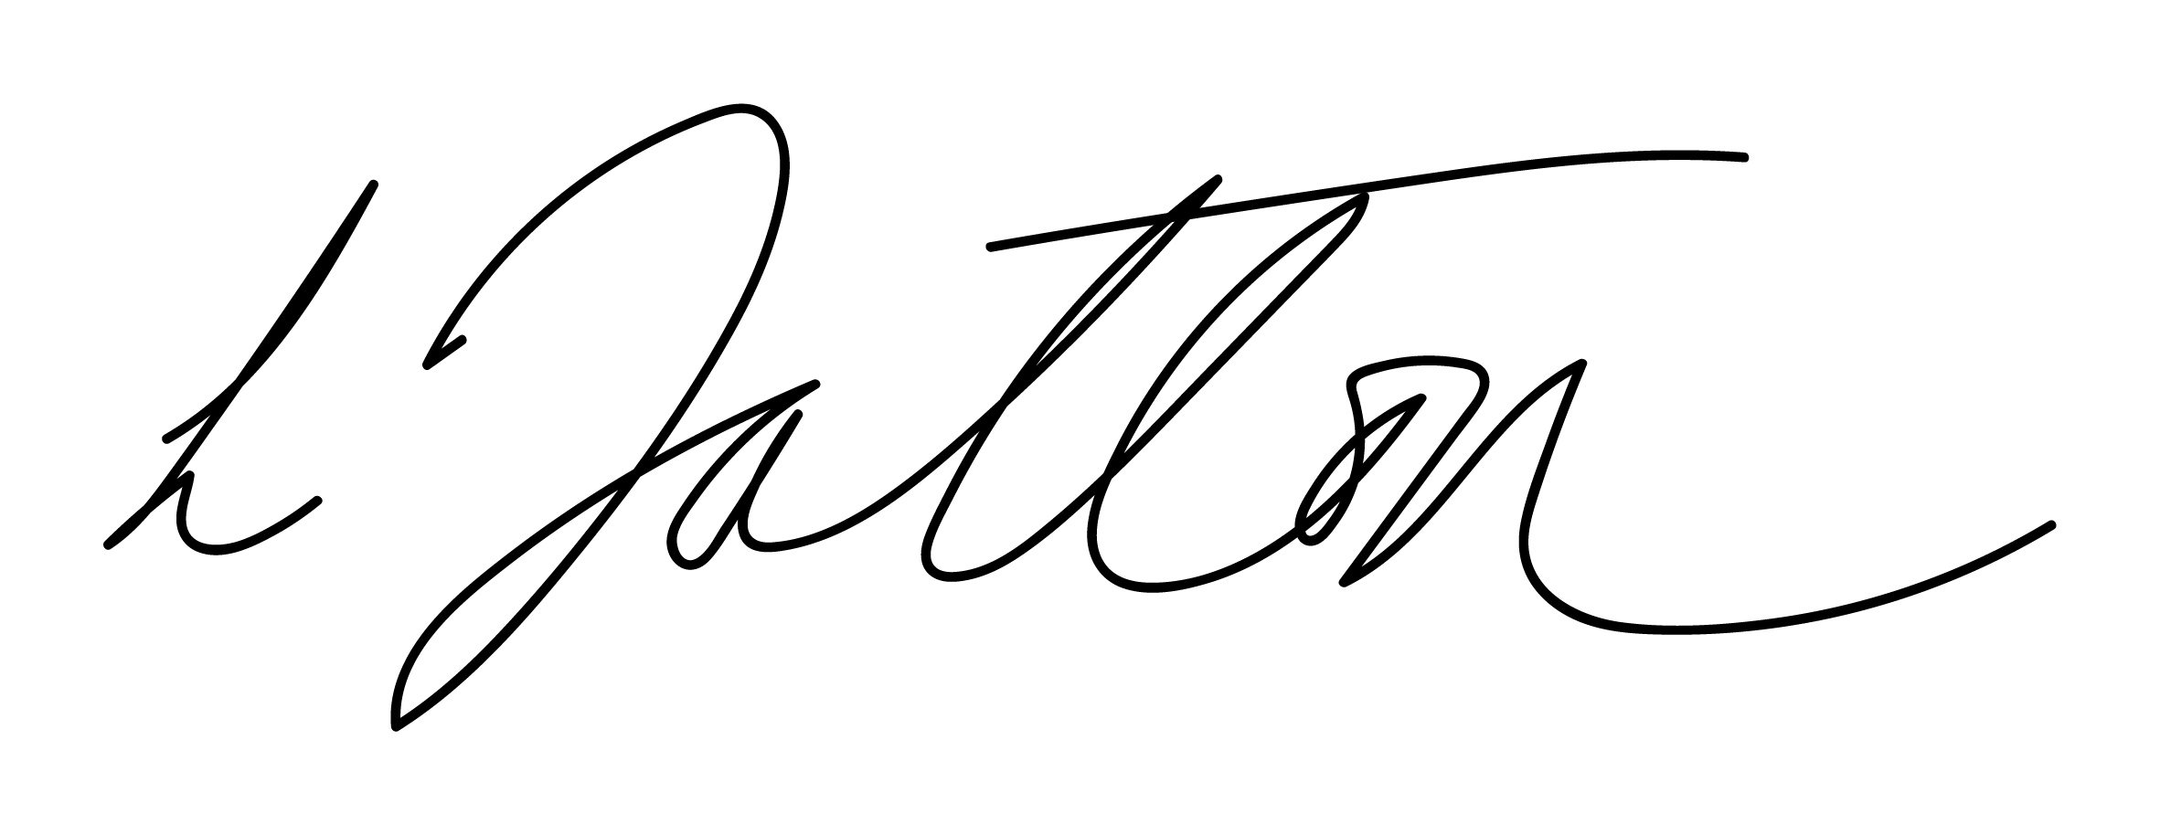
Chair of Governors – Mrs Janiene Davies | 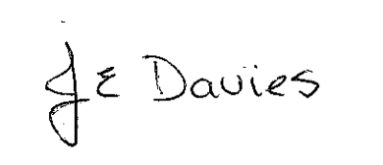



Introduction
This policy sets out the procedure staff must follow when giving or receiving gifts and hospitality.

Scope
This policy applies to full time and part time employees on a substantive or fixed-term contract, and to associated persons such as secondees, agency staff contractors and others employed under a contract of service.

Policy Statement
You must declare all offers of gifts and hospitality, made to or by you, above the value of £40, in your role as a member of Ysgol Bryn Gwalia staff. All such offers must be declared whether accepted or declined.

Declarations must be recorded on Ysgol Bryn Gwalia Gifts and Hospitality Register (the register). The register is maintained by the Headteacher and is publicly available.

It is your responsibility to ensure that you are not placed in a position that risks, or appears to risk, compromising your role or Ysgol Bryn Gwalia public and statutory duties. You should not be seen to be securing valuable gifts and hospitality by virtue of your job. You should not accept or provide any gift or hospitality if acceptance/provision will give the impression that you have been influenced/are deemed to be influencing while acting in an “official capacity”.

This Policy also applies to spouses, partners or other associates if it can be argued or perceived that the gift or hospitality is in fact for the benefit of the member of staff.
In exercising judgement as to whether to accept a gift or hospitality the question should be asked what public perception would be if the information was published given your role and circumstances.

Receiving gifts
You may retain all gifts valued at £40 or under, whether given in recognition of presentations or otherwise.

For gifts exceeding a value of £40 the following options are suggested:
- share the gift with all staff;
- raffle the gift for charity;
- donate the gift to charity; or
- make a donation to charity and keep the gift.

Accepting offers of hospitality – genuine business reasons
Hospitality offered should only be accepted where there is a direct link to working arrangements and a genuine business reason can be demonstrated, for example:
- attendance or speaking at a conference, which provides complimentary subsistence, travel and accommodation (this does not need to be declared on the register except where a gift was received, see paragraph 4);
- attending at a free training course; or
- attending a drinks reception to network.

It is recognised that, in the course of carrying out your duties, you will need on occasion to ensure good relationships with existing and future contractors and stakeholders and that this may involve for example, the receipt of modest gifts, working lunches and dinners. These are acceptable where there is a genuine business reason.

Hospitality invitations to events which are purely social events should be considered very carefully before accepting; in such circumstances it may be much more difficult to substantiate a genuine business reason.

Declaration
You should make your declaration as soon as possible after the offer or receipt of gifts or hospitality. All declarations above the value of £40 are to go to the Headteacher in the required format as shown below. These declarations will be recorded in the register. The register is an annual document and will be maintained on an academic year basis. It is recommended that you make your declaration and retain a copy for your personal records.
Your declaration will need to include the following information:
- date of offer of gift or hospitality, and date of event where relevant;
- name, job title and organisation of recipient / provider;
- nature and purpose of gift or hospitality received or declined;
- the name of any other organisation involved;
- estimated value.

Evaluation & Review
This policy will be reviewed by the Senior Management Team and Governing Body and adopted by the Governing Body as per the schedule on the front page.

Date received | Recipient | Received from | Description | Value  £ (Estimate) | Reason

