Ysgol Bryn Gwalia
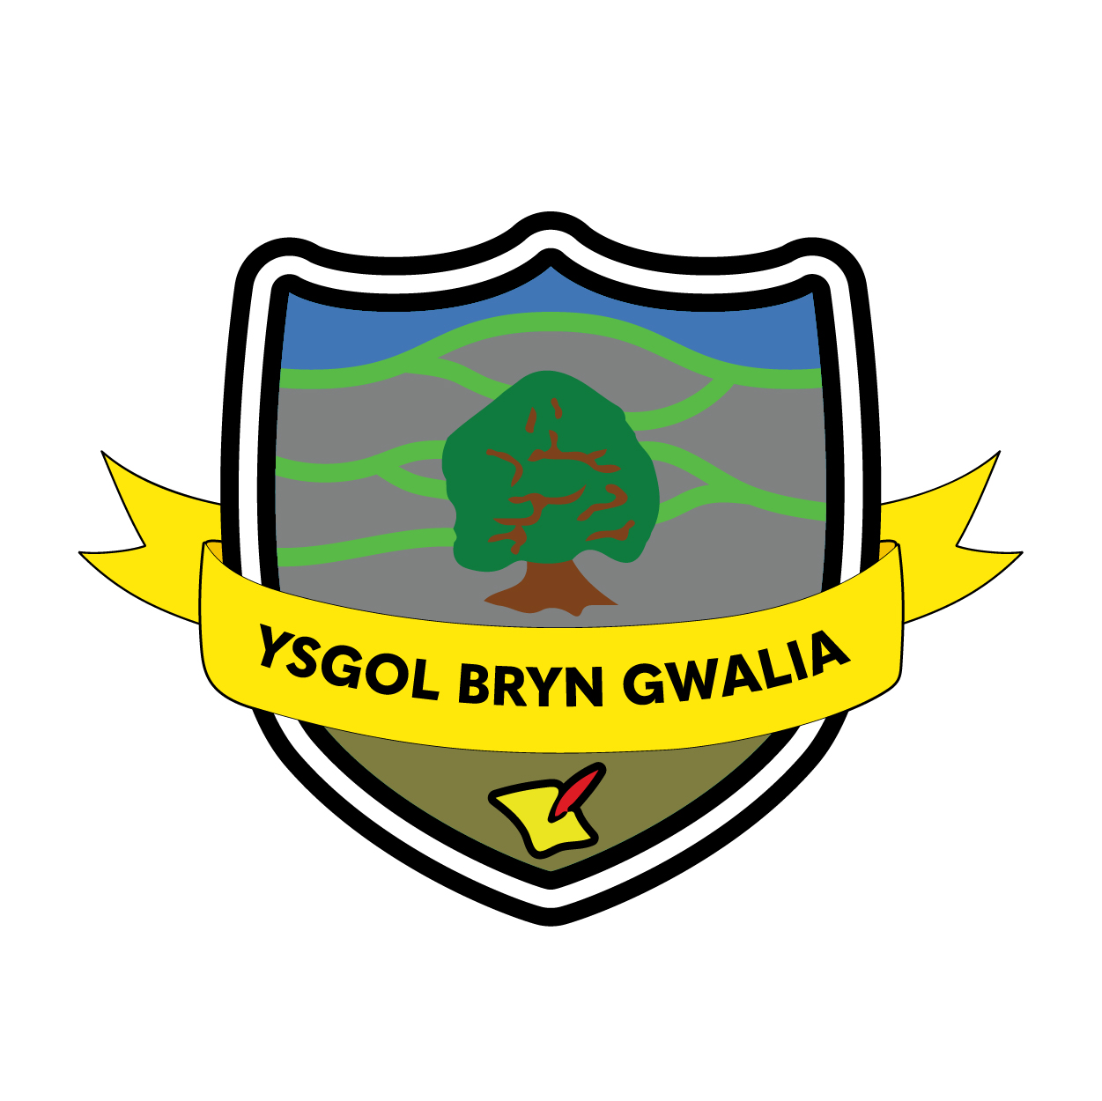

Lockdown Policy
Last Review Date | July 2025
Date to be reviewed by Senior Management Team | July 2028
Date Adopted by Governing Body | July 2025
Head Teacher – Mrs Lorraine Dalton | 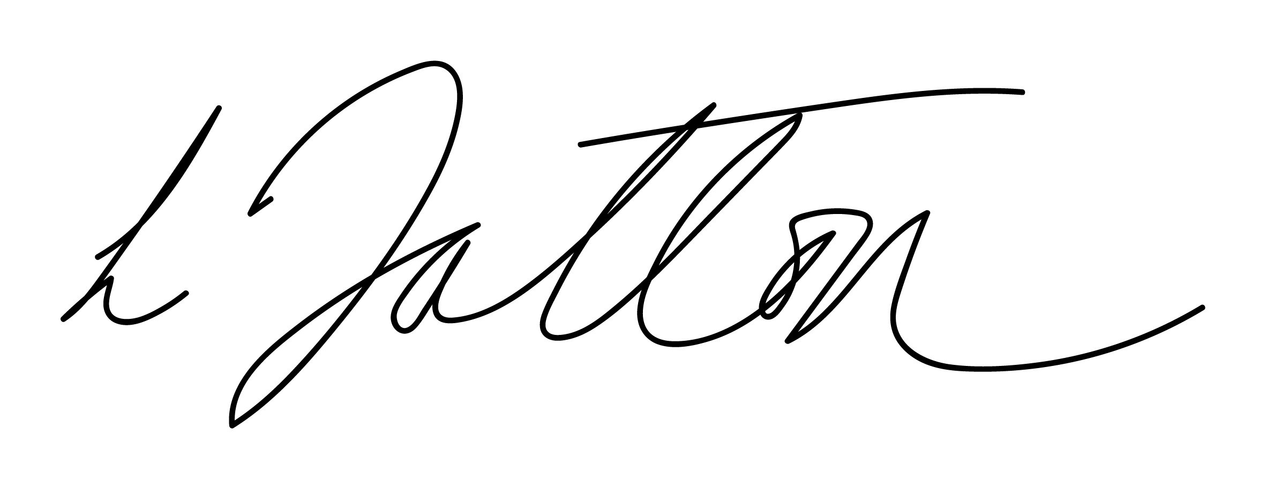
Chair of Governors – Mrs Janiene Davies | 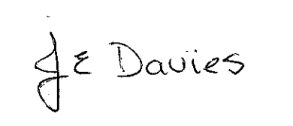



Introduction
Full Lockdown and Partial Lockdown procedures should be seen as a sensible and proportionate response to any external or internal incident which has the potential to pose a threat to the safety of pupils, staff, parents/carers or visitors.

Procedures should aim to minimise disruption to the learning environment whilst ensuring the safety of all pupils and staff. This may also include where there is a need to restrict the movement of pupils around the school environment.

Upon hearing the alert for a lockdown the procedures for a full lockdown will be implemented (worst case scenario). As soon as possible staff to be informed if this can be de-escalated to a partial lockdown where a full lockdown is not required.

Lockdown procedures may be activated in response to any number of situations, but some of the more typical might be:
- A warning being received regarding a risk locally, for example air pollution, smoke plume, gas cloud etc;
- A serious or emergency accident or incident requiring the emergency services at the school;
- A major fire in the vicinity of the school;
- The close proximity of a dangerous dog roaming loose;
- A swarm of bees or wasps;
- Dense fog where pollution could cause breathing difficulties;
- Wild animals on site e.g. foxes;
- Volcano Ash Cloud;
- A reported incident or civil disturbance in the local community with the potential to pose a risk to staff and pupils in the school;
- A visitor to the school site who becomes abusive, making threats with the potential to pose a risk to pupils, staff or parents/guardians;
- An intruder on the school site with the potential to pose a risk to staff and pupils; (please note this is extremely rare)

Signal for whole school lockdown:
An extended sounding of the air horn and/or internal bell (Deputy Headteacher) by the Headteacher, members of the Senior Management Team or Administration Officers.

Signal for the all-clear:
Verbal response from the designated persons; Headteacher; Senior Management Team or Administration Officers.

Full Lockdown
This may be as a result of a reported incident / civil disturbance at the school or on the school site. This may have the potential to pose a significant risk to staff and pupils. This would be where all pupils, staff and visitors are required to stay in their classroom and not wander around the school and would be required to follow the information contained in the table below:

 | Lockdown required | Communication | Hostage situation | Ongoing during full lockdown
Headteacher | Sounding airhorn/ Sounding internal bell.. | Provide updates on Class Seesaw/website as required. | Determine whether full evacuation of remaining staff and pupils is required to Parkfields Community Centre | Monitoring security of school site, wellbeing of staff and pupils and determining escalation/de-escalation.
Deputy Headteacher | Sounding airhorn/ Sounding internal bell. | Provide updates on SeeSaw /website as required. | Communicate and share information using Business Continuity Groups.
Senior Management Team | Secure all external doors and windows. | Provide updates on SeeSaw website as required. | Communicate and share information using Business Continuity Groups.
Administration Staff | Move to Headteacher’s office and inform Emergency Services, and other services as required. | Monitoring external calls from Headteacher’s office. | Monitoring external calls from Headteacher’s office.
Class teachers | Remain in or return to their classrooms.  Complete Fire/Lockdown Registers.  Secure classroom doors and windows and close all blinds. | Personal mobile phones turned on and Business Continuity Groups monitored. | Support movement of pupils and staff to Parkfields Community Centre if directed by Headteacher or Deputy Headteacher. | Maintaining good order, ensuring pupils remain away from windows/doors and that their wellbeing is supported.
All other staff | Remain in or return to their classrooms | Business Continuity Groups monitored. | Support movement of pupils and staff to Parkfields Community Centre if directed by Headteacher or Deputy Headteacher.
Pupils | Remain in or return to their classrooms.

Partial Lockdown
This may be as a result of a reported incident / civil disturbance in the local community with the potential to pose a risk to staff and pupils in the school. This would be where pupils are required to stay in their classroom and not wander around the school site. It may also be as a result of a major incident occurring in the school which it may not be appropriate for pupils to witness, for example a first aid emergency, or may be a warning received regarding the risk of air pollution, etc.

 | Lockdown required | Treat as a full lockdown until: | Communication | Move to partial lockdown
Headteacher | Sounding airhorn. | Determine that only a partial lockdown is required.  Verbal updates/Business Continuity updates provided to teaching staff. | Provide updates on SeeSaw/website as required. | Continually monitoring the situation using a dynamic risk assessment approach moving to increase/decrease the level of lockdown as required.
Deputy Headteacher | Sounding internal bell. |  | Provide updates on SeeSaw/website as required.
Senior Management Team | Secure all external doors and windows. |  | Provide updates on SeeSaw/website as required. | Support staff in escalating and de-escalating as required.
Administration Staff | Move to Headteacher’s office and inform Emergency Services, Local Authority and other services as required. |  | Monitoring external calls from Headteacher’s office. | Sharing updates and information from Emergency Services and Local Authority to Senior Management team to allow dynamic risk assessment.
Class teachers | Remain in or return to their classrooms.  Complete Fire/Lockdown Registers.  Secure classroom doors and windows and close all blinds. |  | Personal mobile phones turned on and Business Continuity Groups monitored. | Follow the direction of the Senior Management Team/Emergency Services.
All other staff | Remain in or return to their classrooms |  | Business Continuity Groups monitored. | Follow the direction of the Senior Management Team/Emergency Services.
Pupils | Remain in or return to their classrooms. |  |  | Follow the instructions of their class teacher/school staff.

- ‘Partial lockdown’ is a precautionary measure but puts the school in a state of readiness (whilst retaining a degree of normality) should the situation escalate and need to revert to a full lockdown.
- In the event of an air pollution issue, air vents/windows can be closed (where possible) as an additional precaution. Emergency Services will advise as to the best course of action in respect of the prevailing threat.
- Actions should be taken, where possible, to ensure that the incident does not re-occur.

Communication between parents/carers and the school:
• The School’s lockdown procedures will be published on the school website and routine practices communicated with parents/carers by text, newsletter or via the school website with information regarding the effectiveness of the procedure.
• In the event of an actual full or partial lockdown, any incident or development will be communicated to parents/carers as soon as is practicable;
‘Ysgol Bryn Gwalia is in a full/partial lockdown situation.
During this period the phones, office and entrances will be un-manned, external doors locked. Please wait for further instructions and information.’
• Parents/carers will be given enough information about what will happen/is happening or has happened so that they are reassured that the school understands their concern for their child’s welfare, and that it is doing everything possible to ensure their safety.
• Parents/carers will be reassured that any measures needed to ensure the incident does not re-occur are put into place;
• Parents/carers are asked not to contact the school during a lockdown or immediately afterwards. Calling the school could put pupil’s safety at risk as lines of communication are needed for contacting emergency providers, outside agencies, parents/carers or the Local Authority.
• Parents/carers are asked not come to the school. This could interfere with emergency provider’s access to the school and may even put themselves and others in danger;
• Parents/carers need to wait for the school to contact them about what happens next and when it is safe for them to collect their pupils, and where this will be from (if this is deemed necessary).
• Parents/carers will be informed when the ‘all clear‘ has been given.

Emergency Services
• It is important to keep lines of communication open with outside agencies and the Emergency Services as they are best placed to offer advice as a situation unfolds.
• The school site may or may not be cordoned off by Emergency Services depending on the severity of the incident that has triggered the Lockdown;
• Emergency Services will support the decision of the Headteacher regarding the timing of communication to parents/carers;
• In the event of a prolonged lockdown or more severe scenario, the Local Authority has the capacity to provide humanitarian assistance by establishing a Reception Centre for friends and family outside of the cordoned area – Parkfields Community Centre;
• It is of vital importance that the school’s lockdown procedures are familiar to all members of the school staff. To achieve this, a lockdown drill should be undertaken at least twice a year.
• Depending on their age pupils should also be aware of the plan. Pupils will be involved in regular practices similar to Fire Evacuation Practices to increase their familiarity with procedures.

Evaluation & Review
This policy will be reviewed by the Senior Management Team and Governing Body and adopted by the Governing Body as per the schedule on the front page.

