Ysgol Bryn Gwalia


Children Looked After Policy

Last Review Date | July 2025
Date to be reviewed by Senior Management Team | July 2028
Date Adopted by Governing Body | July 2025
Head Teacher – Mrs Lorraine Dalton | 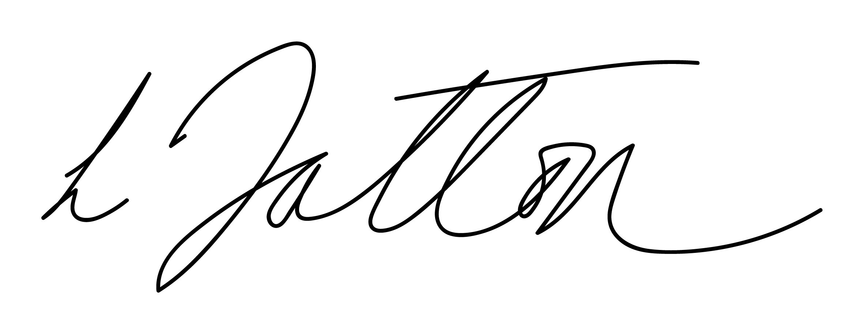
Chair of Governors – Mrs Janiene Davies | 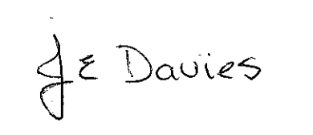



Introduction

Looked After Children (LAC) and Previously Looked After Children (PLAC) are one of the most vulnerable groups in society and it is nationally recognised that there is considerable educational under achievement when compared to other groups. It is recognised that schools are key in helping to raise the educational standards and improving the life chances of LAC and PLAC and in tackling the cause of social exclusion through careful planning, monitoring and evaluation.

Context and Principles

Under the Children Act 1989, a child is looked after by a local authority if s/he is in their care or is provided with accommodation for more than 24 hours. They include the following: children who are accommodated by the local authority under a voluntary agreement with their parents (section 20); children who are the subject of a care order (section 31(1)) or interim care order (section 38); and children who are the subject of emergency orders for the protection of the child (section 44).

A previously looked-after child is one who is no longer looked after in England and Wales because s/he is the subject of an adoption, special guardianship or child arrangements order which includes provisions relating to with whom the child is to live, or when the child is to live with any person, or has been adopted from ‘state care’ outside England and Wales.

The Role of the Designated Teacher

The designated person must be a qualified teacher. The role became statutory in September 2009 under the Children and Young Person’s Act 2008. Ideally, the designated teacher should also be a senior member of staff who is able to influence decisions about the teaching and learning, plus promote the educational achievements of every LAC and PLAC.

Some of the responsibilities of the designated teacher include the following:

- Designated teachers should take lead responsibility for ensuring school staff understand the things which can affect how LAC and PLAC learn and achieve and how the whole school supports the educational achievement of these pupils
- Have high expectations of LAC and PLAC learning and set targets to accelerate educational progress
- Are aware of the emotional, psychological and social effects of loss and separation (attachment awareness) from birth families and that some children may find it difficult to build relationships of trust with adults because of their experiences, and how this might affect the child’s behaviour
- Understand how important it is to see LAC and PLAC as individuals rather than as a homogeneous group, not publicly treat them differently from their peers, and show sensitivity about who else knows about their looked-after or previously looked-after status
- Appreciate the central importance of the LAC personal education plan (PEP) in helping to create a shared understanding between teachers, carers, social workers and, most importantly, the child’s own understanding of how they are being supported
- Have the level of understanding they need of the role of social workers, LAC Liaison Officer, Head Teachers and carers, and how the function of the PEP fits into the wider care planning duties of the authority which looks after the child; and for PLAC, understand the importance of involving the child’s parents or guardians in decisions affecting their child’s education, be a contact for parents or guardians who want advice or have concerns about their child’s progress at school
- Facilitate and encourage LAC to join extra-curricular activities and maximise out of school learning opportunities e.g. ‘more able and talented’ projects
- Be pro-active in supporting transitions and planning when moving children into a new phase in their education
- Promote inclusion in all areas of school life
- Children in care are among the groups who are most vulnerable to bullying. The Designated Teacher must ensure that they are actively monitoring and preventing bullying in school by raising awareness through the school’s behaviour and anti-bullying policy.

Designated Teacher for Looked After Children – Mrs L Dalton & Mrs Jo Wyatt

Personal Education Plans (PEP)

All LAC must have a Personal Education Plan (PEP), which their social worker will take the lead in developing. The PEP is a record of the child’s education and forms part of the overall Care Plan. It provides a clear and shared understanding about the teaching and learning provision to ensure their academic progress. The social worker, parents, carers and the child may be invited to the PEP meeting to ensure the views of all stakeholders are considered. The school’s role in this plan is crucial and at least one member of staff who knows the child well will attend the meeting to establish and subsequently review this.

The PEP should set clear objectives or targets which relate to academic achievement as well as out of school activities and wherever necessary behavioural targets. If a child moves school, the PEP should be forwarded, as a matter of urgency, to the new school when known..

Actions

As for all our pupils, Ysgol Bryn Gwalia is committed to helping every LAC to achieve the highest standards they can, including out of school activities and supporting career aspirations for further and higher education. This can be measured by improvements in their achievement and attendance.

This policy links with several of the school policies:

- Behaviour and Anti-Bullying
- E-Safety
- Equalities Policy and Plan
- Educational Visits
- Health and Safety
- Safeguarding and Child Protection
- Additional Learning Needs

Ysgol Bryn Gwalia will ensure that the needs of LAC and PLAC are reflected in all aspects of our provision, e.g. through assemblies and Personal, Social and Health (PSHE) education. We will raise awareness and challenge negative stereotypes about them to ensure that they achieve their full potential.

Responsibilities of the Head Teacher

- Identify a Designated Teacher for LAC and PLAC
- Ensure cover arrangements are put in place should the Designated Teacher not be available to carry out these legal duties
- Ensure that procedures are in place to monitor and track the admission, progress, attendance and exclusions (if any) of LAC and PLAC and that appropriate action is taken where outcomes fall below expectations
- Report on the progress, attendance and conduct of LAC and PLAC
- Ensure that all staff receive relevant training and are aware of their responsibilities under this policy and related guidance
- Ensure that all staff are briefed on the regulations and practice outlined in this policy

Responsibilities of the Governors

The role of Governors under Section 20 of the Children and Young Persons Act 2008 places a duty on the Governors to designate a member of staff (the Designated Teacher) as having responsibility to promote the educational achievement of LAC and PLAC.

To this effect, the Governors should:
- Ensure that the necessary provision is being made for any pupil who is a LAC or PLAC
- Ensure that the Designated Teacher/s are given the appropriate level of support and be given the opportunity to keep up to date with relevant training
- Ensure the Designated Teacher disseminates relevant training and provides support for all members of staff that will influence teaching and learning for LAC and PLAC
- In partnership with the Executive Head teacher, maintain responsibility for monitoring how well the role is working. As part of this monitoring an annual report will be received from the Designated Teacher with regard to reviewing the effective implementation of the school’s policy

Responsibilities of all Staff

All our staff will:
- Have high aspirations for the educational and personal achievement of LAC and PLAC, as for all pupils
- Maintain LAC and PLAC confidentiality and ensure they are supported sensitively
- Respond positively to a pupil’s request to be the named member of staff with whom they can talk to when they feel it necessary
- Respond promptly to the Designated Teacher’s requests for information
- Work to enable LAC and PLAC to achieve stability and success within the school
- Promote self-esteem for LAC and PLAC
- Have an understanding of the key issues that affect the learning of LAC and PLAC.

Confidentiality

Information on LAC and PLAC will be shared with school staff on a ‘need to know basis’. The Designated Teacher will discuss what information is shared with which school staff at the PEP meeting. Once this has been agreed by the social worker, carer, young person and other parties, complete confidentiality will be maintained and will comply with General Data Protection Regulation (GDPR) guidance.

Partnership Working

The school values partnership working. In order to secure the best possible outcomes for LAC and PLAC, it is essential that we work with parents/carers, social workers, the LAC Liaison Teacher and other external partners to ensure we are providing the best possible life chances for both LAC and PLAC.

