Ysgol Bryn Gwalia
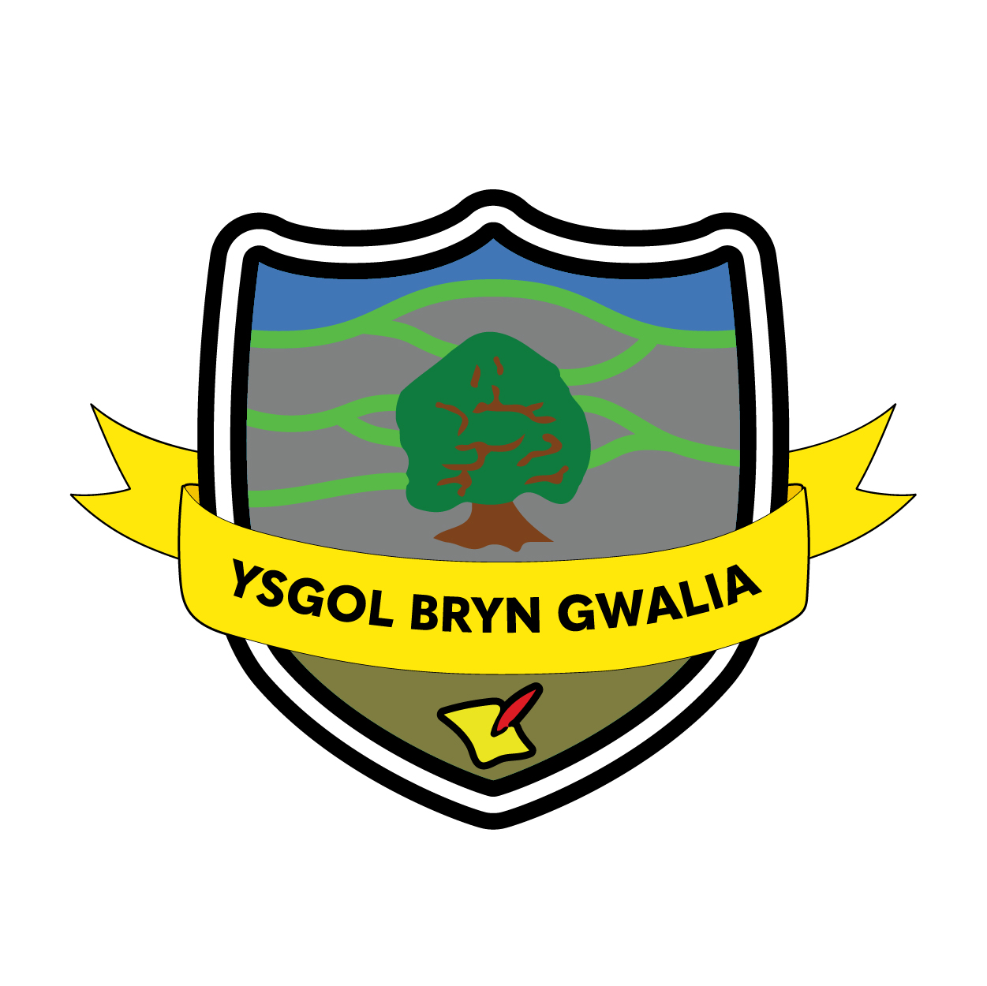

Marking & Feedback Policy
Last Review Date | April 2024
Date to be reviewed by Senior Management Team | April 2026
Date Adopted by Governing Body | April 2024
Head Teacher – Mrs Lorraine Dalton | 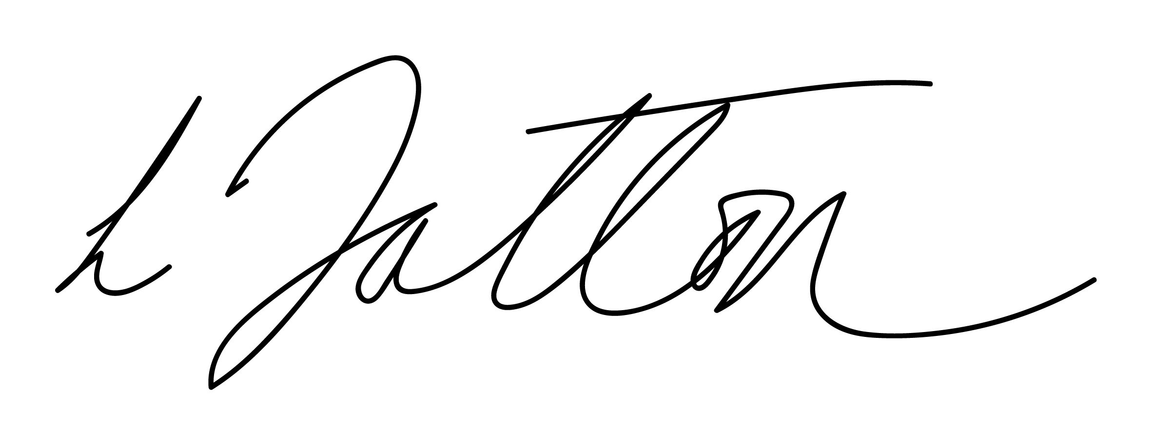
Chair of Governors – Mrs Janiene Davies | 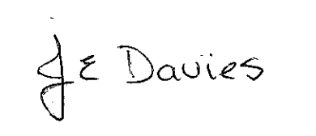



Ysgol Bryn Gwalia
Effective Marking and Feedback Policy
At Ysgol Bryn Gwalia we are committed to supporting the learning of our pupils by providing clear feedback through our comprehensive marking scheme.
Before feedback teachers should provide high quality instructions to pupils, using AFL throughout. Learning intentions should be clear and pupils should develop a Success Criteria for which they can assess their own and other’s learning. This should be accessible for all pupils – ‘Must have, Should have and Could have’ gives ALL pupils an opportunity to progress.
We believe that the purpose of marking work is to celebrate pupil achievements, to diagnose areas for development, to guide with targets and ‘next steps’ and to evaluate learning. Marking should be a process of creating a dialogue with the learner, through which feedback can be exchanged and questions asked: the learner is actively involved in the process.
At Ysgol Bryn Gwalia, we aim to:
- Provide consistency and continuity in marking throughout the school so that children have a clear understanding of teacher expectations.
- Use the marking system as a tool for formative ongoing assessment.
- Improve standards by encouraging children to give of their best and improve on their last piece of work.
- Develop children’s self-esteem through praise and valuing their achievements.
- Create a dialogue which will aid progression.
- Use verbal feedback consistently as a means of aiding progression during the lesson.

Effective marking should:
- Be manageable for staff.
- Be positive, motivating and constructive for children.
- Be at the child’s level of comprehension.
- Be written in handwriting that is legible and a model for the child.
- Be frequent and regular.
- Allow specific time for the children to read, reflect and respond to marking. 5 minutes at the start of the next lesson must be given for pupils to reflect on their work.
- Give children opportunities to become aware of and reflect on their learning needs.
- Give recognition and appropriate praise for achievement.
- Give clear strategies for improvement.
- Involve children in the marking process (whether oral or written) as regularly as possible.
- Relate to the learning objective/success criteria of the work set.
- Be consistently followed by teachers and TAs across the school in line with the Effective Marking and Feedback policy.
- Use the agreed Marking Code (See Appendix 1) to correct errors.
- Positively affect the child’s progress.

Procedures

- Children’s work should be marked using red pen.
- Supply and Student Teachers should mark in green.
- Marking should feedback to your learning journal and this should inform your next session.
- At least one piece of work per term should be added to the digital portfolio and pupils should explain why it’s their chosen work.
- All pupils should have at least 5 minutes at the start of the next session in order to respond to feedback.
- If there is so specific target in books, each pupil should still have a task to do – as evaluated in your journals (possibly being ‘gurus’, write a number sentence to show the rule you learnt etc..)
- Look for progress and success before areas to develop. Effective marking and feedback is supportive and positive for children.
- Link marking to the learning objective and success criteria. Refer to these when giving written and verbal feedback.
- Link marking to individual targets, IEP targets and LNF.
- Acknowledge verbal comments and praise with the appropriate symbol from the code. Encourage pupils to respond to feedback.
- Look for persistent errors and patterns of errors rather than every error made: be selective and sensitive in marking i.e. not every incorrect spelling will be highlighted, only words that the child should be reasonably expected to know.

Effective Marking and Feedback Strategies

The following strategies can be used to mark, assess and provide feedback.

Verbal Feedback
This means the discussion of work and direct contact with the child. Pupils should respond to this immediately.

A discussion should be accompanied by the appropriate marking code symbol in the child’s book to serve as a permanent record for the child, teacher and parent. A VF stamp should be used to acknowledge verbal feedback has been given.

Success Criteria Checklists
Success Criteria checklists can be used in all subjects and may include columns for self/peer assessment and teacher assessment. These should be differentiated where appropriate.

Success criteria should indicate a ‘Must, ‘Should’ and ‘Could’ so that all pupils can be challenged at all times.

Peer Marking
Children are encouraged to support each other and feedback on learning and achievement. Children should be given the opportunity to act as response partners and pair mark work. This is often linked to ‘talking partners’. Children should be trained to do this and ground rules set such as listening, confidentiality, etc. Children should first point out things they like then suggest ways to improve the piece but only against the learning objective or success criteria. The pairing of children should be based on ability and trust. Children could highlight evidence of success or write a comment(s) in another child’s book, which is then initialled.

Quality Feedback Comments
Personalised quality feedback comments should be used frequently to extend learning and must be differentiated appropriately. When marking, staff may see a piece of work that requires clarification or is a good opportunity to extend that child’s learning. The emphasis when marking should be on both success and areas for development against the learning objective and success criteria. The three tick system is used to evaluate the work achieved:

ü  üü  üüü | Working below expected level - see teacher at the start of the lesson  Working at expected level  Working above expected level

Useful “Closing the Gap” comments are:
- A reminder prompt – e.g. “What else could you say here?”
- A scaffolded prompt- e.g. “What was the dog’s tail doing?”, “The dog was angry so he…”, “Describe the expression on the dog’s face”.
- An example prompt – e.g. “Choose one of these or your own: He ran around in circles looking for the rabbit / The dog couldn’t believe his eyes”
Time is then given at the start of the following lesson for the child to respond to the written prompt, thus enabling them to ‘close/ bridge the gap’ and improve their work further.

Monitoring

Marking and Feedback will be monitored termly by the Senior Leadership Team and will form part of our annual monitoring cycle on Formative Assessment and Assessment for Learning.

Review and Evaluation of the Policy

The policy will be reviewed annually, to ensure it is kept in line with any curriculum changes that take place within the school or externally.

ü  üü  üüü | Working below expected level  Working at expected level  Working above expected level
X3 | Don’t forget capital letters
VF | Verbal feedback given
Sp | Check your spelling
P | Punctuation
? | Confusing/unclear
^ | Word missing
/ | Start new sentence
// | Start new paragraph
Green  Highlighter | Next steps

