Ysgol Bryn Gwalia
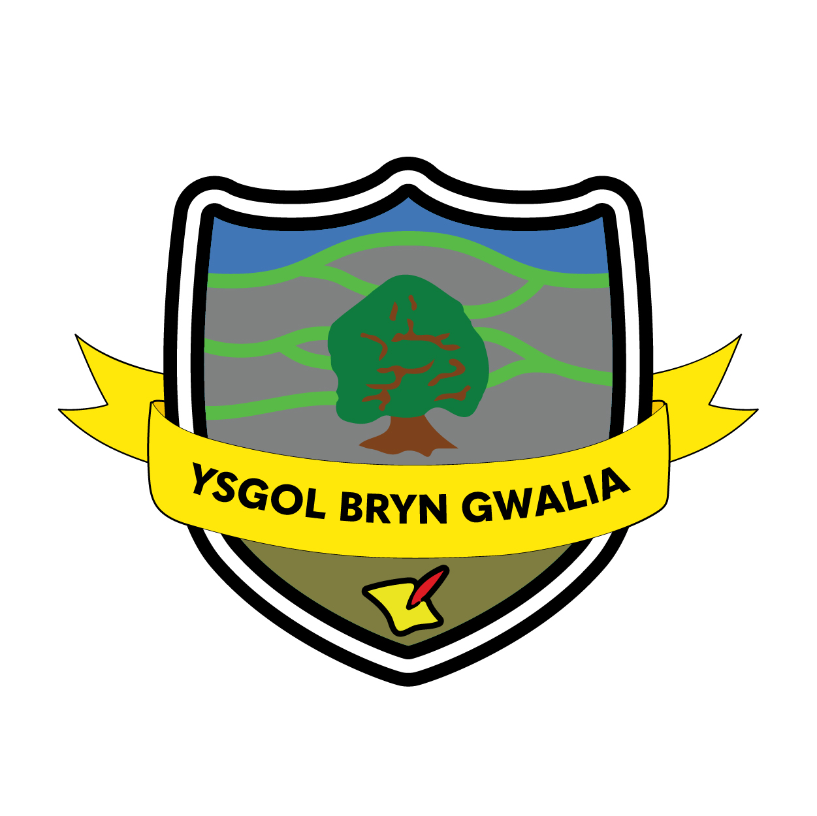

More Able & Talented Policy
Last Review Date | July 2025
Date to be reviewed by Senior Management Team | July 2027
Date Adopted by Governing Body | July 2025
Head Teacher – Mrs Lorraine Dalton | 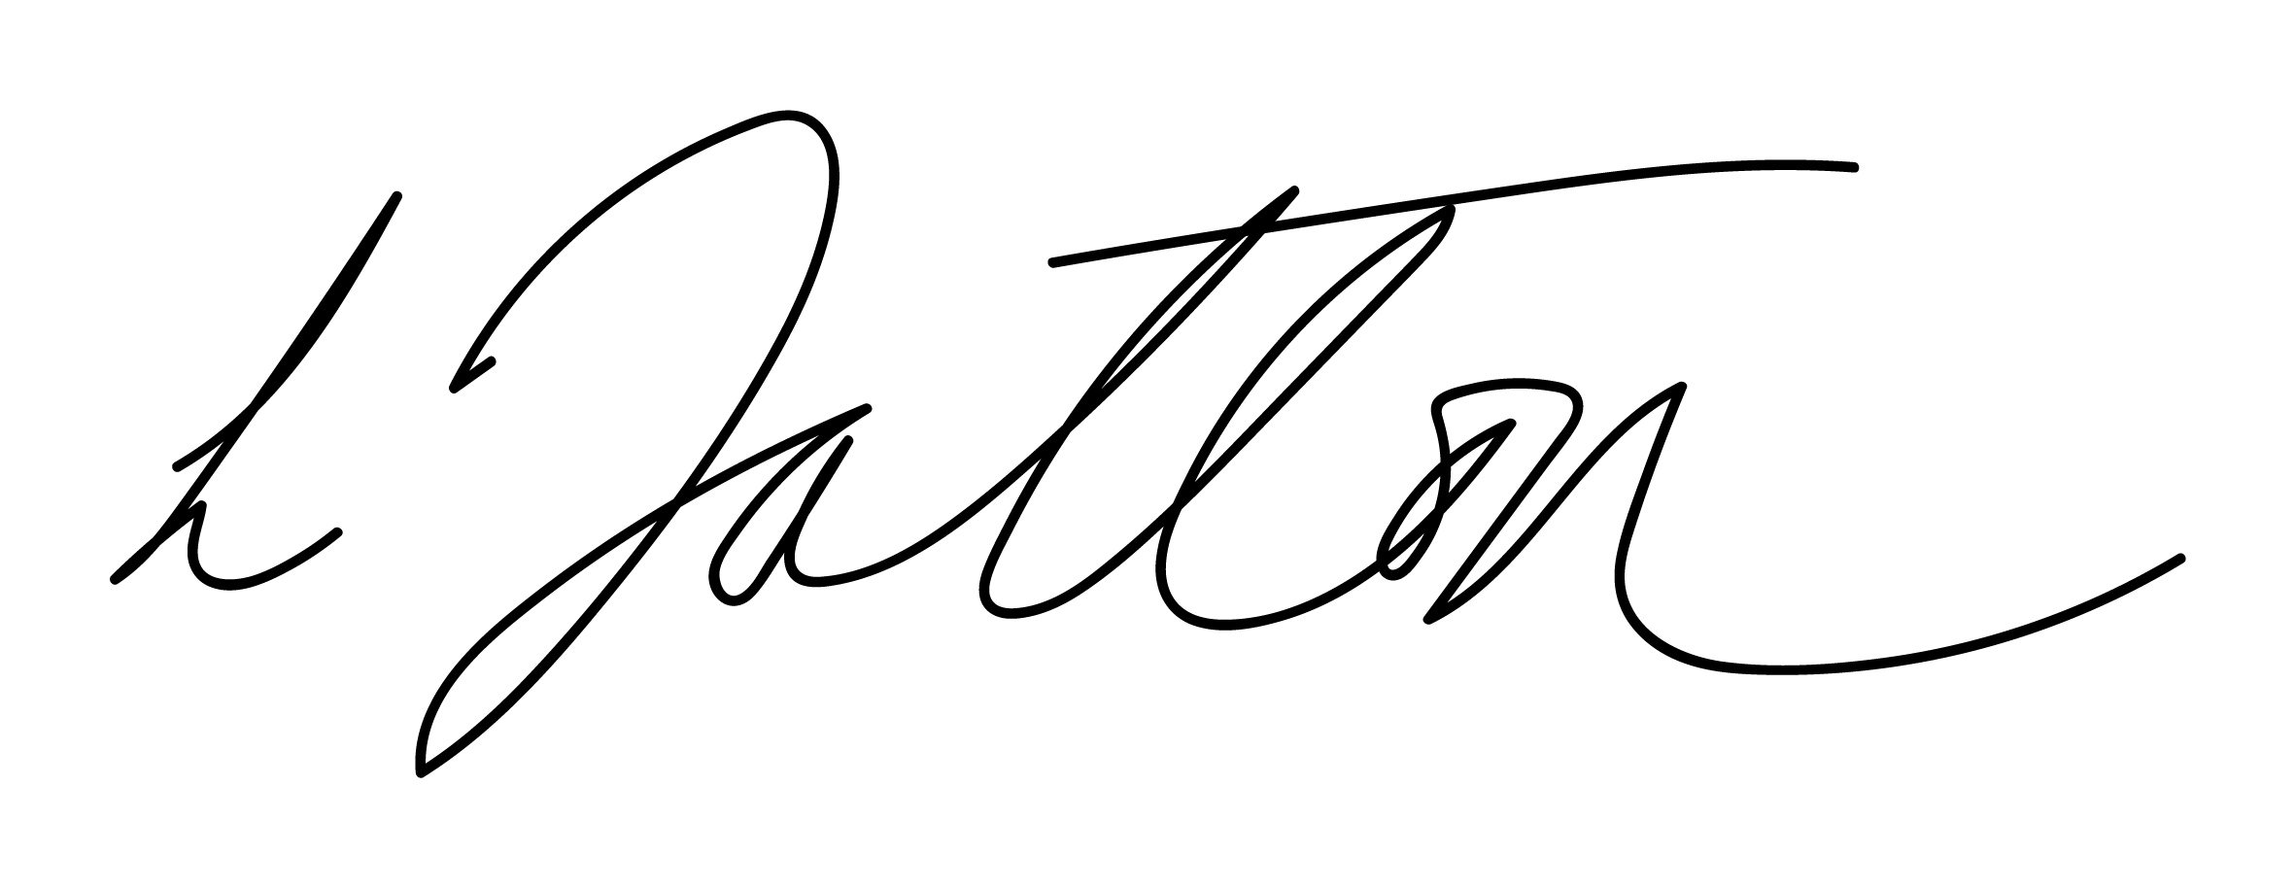
Chair of Governors – Mrs Janiene Davies | 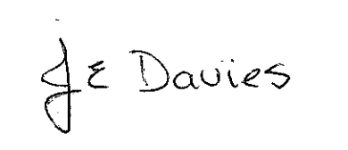


Introduction
At Ysgol Bryn Gwalia, we aim to provide a curriculum that is appropriate to the needs and abilities of all of our pupils. We recognise that each pupil is unique, displaying a range of intelligences and abilities. We plan our teaching and learning in such a way that we enable each child to develop their full potential academically, socially and spiritually.

We respect the right of all pupils in our school, irrespective of differences in ability, to access a number of areas of learning, and to develop the knowledge, skills, understanding and attitudes that are necessary for their self-fulfilment and eventual development into active and responsible adults. The aims of our school include valuing the success of all our children and make reference to using a variety of methods of teaching and learning to provide equal opportunities for all. They also identify the commitment to giving all our children every opportunity to achieve the highest of standards.

This policy guides the way in which this happens for our More Able and Talented (MAT) pupils at Ysgol Bryn Gwalia. Our aim is that our school establishes a clear vision which;
- Set out aspirations for, and commitment to, raising the achievement of all pupils.
- Ensures that the school’s ethos, culture and climate support the conditions of increasing educational inclusion.
- Ensures that these aims and principles are compatible with all other aspects of the school’s policy and practice.’ This policy seeks to promote this vision for inclusion for all learners and in particular our More Able and Talented pupils.

Definition
In Wales, we use the term ‘more able and talented’ to describe pupils who require opportunities for enrichment and extension that go beyond those provided for the general cohort of pupils. In every school there are more able and talented pupils who are more able across the curriculum as well as those who show talent in one or more specific areas. The identification of more able and talented learners is linked to the context of our school.

More Able and Talented pupils are those pupils identified as being above the core of the class in any area. (including the curriculum areas plus leadership creative etc.) These are the 20% or 6 pupils in every class of 30 (approximate as each cohort will differ). These pupils may be good in one or more area. Most Able learners are those who have the ability to excel in one or more area. These can be described as the top 2% (although not necessarily present in every class). We will strive to identify those MAT learners who have the potential to achieve, but do not regularly demonstrate high achievement and we will seek to identify barriers to that achievement and help them overcome them.

It is important to note that some learners will have ‘Dual Exceptionality’ and may appear on more than one school list. For example, a child could be included in the ALN register and still be described as MAT. At Ysgol Bryn Gwalia, we recognise this dual exceptionality and aim to provide for the needs of individual pupils accordingly.

Aims and objectives
Our aims are to:
- Ensure that we recognise and support the needs of our More Able and Talented children;
- Enable MAT children to develop to their full potential;
- Offer pupils opportunities to generate their own learning;
- Ensure that we challenge and extend the pupils through the work that we set them;
- Encourage pupils to think and work independently;
- To promote individualised/personalised approaches to learning;
- Enable pupils to be fully involved in how and what they learn.
- Link with other agencies that may help the development of identified pupils.

Identification of More Able & Talented Pupils
Identification of MAT pupils includes the use of;
- Results of statutory tasks and tests
- Results of whole school assessment procedures
- Tracking data on SIMS
- Checklists
- Teacher identification
- Discussion with colleagues
- Self/Peer Identification

Links with parents and carers
At Ysgol Bryn Gwalia, we make sure the identification process is rigorous, transparent and fair. Where attainment is not high but there are indications of potential high ability, the school strives to identify that potential and nurture it. The names of pupils identified as MAT are recorded on a list so that their progress can be specifically tracked.

Pupils may be identified at any time and the lists are reviewed during termly Pupil Progress Meetings with class teachers. Pupils remain on the list unless they cease to fit the criteria and they will then be monitored using the schools usual procedures.

Teaching and learning
Our teachers plan carefully to meet the learning needs of all our pupils. We give all pupils the opportunity to show what they know, understand and can do, and we achieve this in a variety of ways when planning for pupil's learning, such as by providing:
- a common activity that allows the pupil to respond at their own levels;
- an enrichment activity that broadens a pupil's learning in a particular skill or knowledge area;
- an individual activity within a common theme that reflects a greater depth of understanding and higher level of attainment;
- the opportunity for children to progress through their work at their own rate of learning;
- Planning top down, Must, Should , Could differentiated tasks.

Pupils are familiarised with a variety of organisational strategies as they move through the school. These strategies can be used by all pupils, but give due scope to higher achievers;
- Allowing different starting points
- Setting open ended tasks
- Asking open ended questions
- Higher order Thinking Skills
- Encouraging imaginative and creative work
- Varying group arrangements: working in ability groups. Co-operative and mixed ability group work.
- Encouraging pupils to explain their learning and coach their peers.
- Providing enrichment and extension activities specifically for MAT pupils.
- Valuing and rewarding quality.

Teachers regularly review the progress of pupils. This enables teachers to plan work that reflects the ability band of each group. We offer a range of extra-curricular activities for our pupils. These activities offer higher achievers the opportunity to further extend their learning in a range of activities. Learning is also enriched through regular homework activities linked to the work being undertaken in classes. This offers teachers a further opportunity to set work at the level of individual pupils. The pupils will also have the opportunity to experience a range of educational visits that further enrich and develop learning.

Roles and Responsibilities
The More Able & Talented Coordinator is Ms Kate Sturdy. She has the overall responsibility, alongside the Senior Leadership Team and class teachers for coordinating the identification, record keeping, policy development, learning and teaching, home/school partnerships, whole school provision and her own continued Professional Development.

The coordinator's role also includes:
- Running a list of more able and talented pupils, and keeping it up to date;
- Monitoring teachers' planning to ensure that suitable tasks and activities are being undertaken across all curriculum areas by the higher achievers;
- Regularly reviewing the teaching arrangements for these particular pupils;
- monitoring their progress through termly discussions with teachers;
- Supporting staff in the identification of these pupils;
- Providing advice and support to staff on teaching and learning strategies;

Transfer and Transition
Transition within the Foundation Phase and Key Stage 2 and between classes relies on effective communication systems. Teaching and support staff have transition meetings to pass on relevant information for MAT pupils.

Transition from Foundation Phase has a well-developed Transition Plan involving parent meetings and visits for children to their new classes and teacher. Transition from Key Stage 2 to relevant High Schools has a well-developed and we have a Cluster Transition Plan.

Monitoring and Review
The Governor with responsibility for inclusion issues monitors the school provision for more able and talented pupils. The governor will work with the school's more able and talented coordinator in support of the school's efforts to help these pupils to reach the highest standards. The coordinator for our provision for more able and talented pupils provides feedback to the governing body on an annual basis.

The monitoring includes feedback from parents/carers and children, as well as regular classroom observations by the Senior Management Team of teaching and learning, and termly evaluations of children's written work. The MAT coordinator collects samples of work from the higher achievers, in order to demonstrate the standards that they are achieving. We use these examples to inform the process of identifying gifted and talented children.

The policy will be updated in response to any guidance provided from the LA and Welsh Government. Termly Learning reviews with class teachers will enable the MAT list and provision to updated. Parents/carers of MAT pupils will be kept up to date through parent meetings and information on the website or Seesaw.

Evaluation & Review
This policy will be reviewed by the Senior Management Team and Governing Body and adopted by the Governing Body as per the schedule on the front page.

