Ysgol Bryn Gwalia
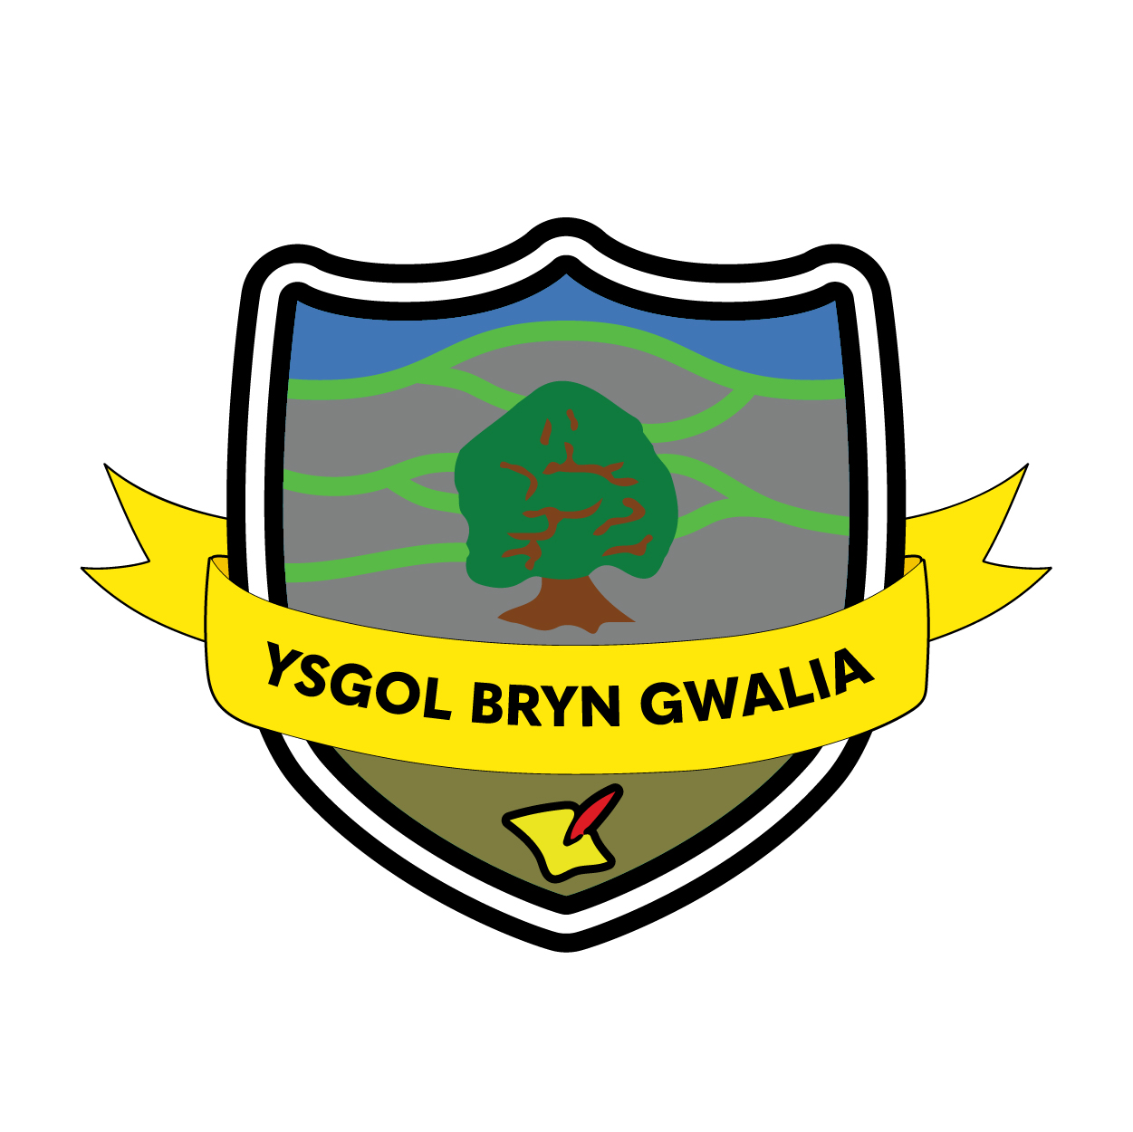

Smoke Free Policy
Last Review Date | January 2025
Date to be reviewed by Senior Management Team | July 2028
Date Adopted by Governing Body | July 2025
Head Teacher – Mrs Lorraine Dalton | 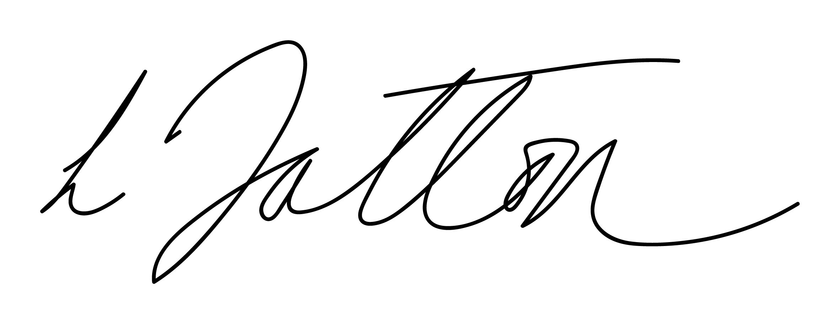
Chair of Governors – Mrs Janiene Davies | 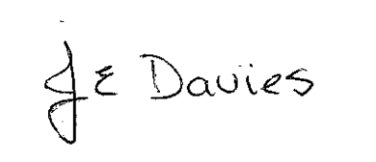


Introduction
Smoking is the single most preventable cause of ill health in our society and passive smoking has been shown to cause lung cancer and other serious illnesses in non-smokers.

A Smoke Free school reinforces our commitment to the Flintshire Healthy Schools Scheme’s ethos of adopting a whole school approach to smoking issues and reinforcing messages learnt in the classroom. The Smoke Free environment at Ysgol Bryn Gwalia is in accordance with the Welsh Government legislation and Flintshire County Council’s Smoke Free Policy Guidance (2006).

This policy should be read in conjunction with the Substance Misuse Policy and contains very similar approaches, but highlights smoking following the Welsh Government school ground smoking ban in March 2021.

Definition of substance
The standard definition of a substance used for this policy is – ‘A substance is something people take to change the way they feel, think or behave’ (United Nations). A defined range of substances covered by the policy will be tobacco. For the purposes of the Smoke Free policy e-cigarettes shall be classed in the same manner as smoking of other materials in all cases. This includes prohibiting the use of e-cigarettes in all school buildings, grounds or vehicles.

Aim
To provide a Smoke Free environment that protects and promotes the health and well being of the entire school community.

Objectives
The school will:
- Not permit smoking in any part of the premises, entrances or grounds at any time, by any person regardless of their status or business with the school. The Smoke Free Policy extends to the use of the building outside school hours.
- Raise awareness of the risks of smoking to pupils using the schools PSE programme.
- Participate in Welsh Government initiatives to promote non smoking.
- Advise contractors and other workers within the school‘s premises of the Smoke Free Policy.
- Ensure that organisations/individuals using school facilities agree to comply with the Smoke Free Policy.
- Provide new members of staff a copy of the Policy.
- Support staff who want to quit smoking by providing relevant information including the Stop Smoking Wales Helpline number in the staffroom (0800 085 2219).
- Provide information and advice to parents as required.
- Inform parents of new pupils of the school’s Smoke Free Policy.

Environment
It is illegal to smoke in any part of the premises, entrances or grounds at any time, by any person regardless of their status or business with the school. The Smoke Free Policy extends to the use of the building and grounds outside of school hours

Premises and grounds are required by law to display No-Smoking signs at all entrances to the school grounds.

Curriculum
Effective Substance Misuse Education including smoking will enable children and young people at Ysgol Bryn Gwalia to make responsible informed choices about their lives. It will not be delivered in isolation; this will reflect the approach within the Personal and Social Education (PSE) Framework for Wales, which underpins this Policy.

Key Stage | PSE Framework | National Curriculum Science
Foundation Phase | Understand that medicines are taken to make them better, but that some drugs are dangerous | Pupils should be taught about the role of drugs as medicines
2 | Know the harmful effects, both to themselves and others of tobacco, alcohol, solvents and other legal and illegal substances | Pupils should be taught that tobacco and other drugs can have harmful effects
3 | Know the effects of and risks from use of a range of legal and illegal drugs (including alcohol and tobacco) and the laws governing their use | Pupils should be taught that the abuse of alcohol, and other drugs affect health
4 | Know the pattern of drug use (including alcohol and tobacco) in their community and beyond and where to get help, information and advice | Pupils should be taught the dangers of contracting HIV and hepatitis by the use of intravenous drugs.

Schemes of Work

 | Topic | Learning Objectives | Suggested resources
KS 2 | 1. The effects of smoking | - To learn the facts about smoking and that tobacco has a harmful effect upon the body  - To understand the reasons why people choose/choose not to smoke cigarettes  - To understand the effects of smoking/not smoking on other people.  - To understand the benefits of being a non-smoker, or giving up | AWSLCP  - ‘T.A.S.K’  - ‘It’s your choice’  Smoke signals  - Units 3 and 4  Keys to smoking-Tacade  - sessions 1-10  Smokebugs  Visit to Dangerpoint  The World of Tobacco-Tacade  -Section 3  AWSLCP- All Wales School Liaison Core Programme
KS 2 | 2. Smoking and the body | - To understand more fully the way the body works, for example, the lungs (breathing) , and circulation (heart, arteries and veins  - To learn the ways in which smoking has an effect on the lungs and circulation
KS 2 | 3. Saying NO | - To understand the benefits of being a non smoker  - To emphasise the reasons why people choose not to smoke  - To practise saying ‘no’ to an offer of a cigarette

 | Topic | Learning objectives | Suggested resources
KS3 | 1.The effects of smoking  2. Smoking and the body  3. Saying NO | - To learn the facts about smoking and that tobacco has a harmful effect upon the body  - To understand the reasons why people choose/choose not to smoke cigarettes  - To understand the effects of smoking/not smoking on other people.  - To understand the benefits of being a non-smoker, or giving up  - To learn the ways in which smoking has an effect on the lungs and circulation  - To practise saying ‘no’ to an offer of a cigarette | Smoking Awareness Handbook  (National Public Health Service Publication – August 2007)  Healthy Schools  Substance misuse programme

Delivery
Largely, education about Substance Misuse will take place in PSE and Science lessons but will also be delivered through other subjects including English, Welsh and Drama.

At Ysgol Bryn Gwalia, pupils will learn about the risks of smoking using approaches that provide:

- Consistent accurate information presented simply and clearly.
- Informative and accessible reading material.
- Access to peers and credible adult experts, in addition to teachers/youth workers.
- Stimulating and enjoyable tasks.
- Appropriate challenges in an atmosphere, where they feel secure enough to play a full and active part.

Use of outside Speakers
Where people from external agencies are invited into the school they are ‘visitors’ and will be seen as contributing to the school’s agreed programme and not replacing it. Visitors will be involved in the planning of the full programme and contribute their specific expertise where required e.g. Police School Liaison Officer, Youth Worker, Healthy Schools.

Training

The Senior Management Team will ensure that there is adequate training and resources for all staff involved in the delivery of the aims and objectives of the policy.

Media Contact
Staff at Ysgol Bryn Gwalia will not report incidents and/or issues concerning tobacco use to the local press and media generally. The Head teacher, in conjunction with Local Authority and Governors will deal personally with all media matters. All media enquiries will be referred to the Council Press Office.

Procedures for dealing with an incident
Staff who become aware of incidents involving pupils and smoking will inform the responsible staff member. The responsible staff member will then notify the head teacher. The response will depend on the type and degree of risk, with some situations requiring immediate action.

Pupils and staff who disregard the policy will be disciplined according the school’s disciplinary and behavioural procedure.

All tobacco will be confiscated and destroyed.

Immediate action is needed when there is a clear risk to safety, for example:

Example | Action
Tobacco is being supplied on, or near premises to underage pupils | Contact police
Pupils in possession tobacco | Contact parents

Contact with Parents/Carers
There will a reasonable attempt to contact parents to inform them of any tobacco related incident unless:

- There are child protection concerns
- It would interfere with a school investigation
- It would interfere with a police investigation
- It could result a greater harm to the child for another reason.

Contact with Police
The school will refer to the School Crime Beat Protocol guidance for tobacco related incidents, if appropriate.

Procedure for dealing with pupil after an incident
Staff who become aware of difficulties and /or incidents involving pupils will inform the head teacher.

The response will depend on the type and degree of risk, with some situations requiring immediate action and others requiring time for assessment of information, seeking advice and the involvement of other agencies. In all, cases the safety and security of pupils is priority.

If a pupil is at risk because of impaired mental state, parents should be contacted and required to take control of their child. Failing that, any emergency contact will be asked to assist. Alternatively social services and the police can be called for advice.

Supporting pupils after an incident
The school will have procedures in place to protect the welfare of any pupil after an incident. They may require support in the period following a tobacco incident, as they may feel extremely vulnerable at the time.

The range of responses may include:
- Pupil assistance programmes
- Referral to smoking cessation service
- School based counselling
- Youth support services
- Behaviour contracts
- Restorative approaches
- Fixed term exclusion
- Permanent exclusion

Recording of Incidences
At Ysgol Bryn Gwalia the system for recording an incident must include accurate factual records of all tobacco and related incidents using:

- Incident Record Form (appendix 1)
- Interview Record Form (appendix 2)

The record of the incident and interview will be signed and dated by the responsible member of staff / Police, including at least one witness.

Out of School Procedures
The school has no role in dealing with tobacco incidents outside school hours and premises other than on school trips. On educational trips, including residential, the school Smoke Free policy will apply.

Safeguarding and Confidentiality
Teachers will not promise confidentiality. The boundaries of confidentiality will be made clear to pupils. It maybe necessary to invoke local Child Protection if a pupils’ safety or welfare or that of another pupil is under threat. If a pupil discloses information which is sensitive, not generally known, and which the pupil asked not to be passed on, it will be discussed with a senior member of staff.

Confidentially maybe broken against the wishes of the person confiding the information when necessary:
- Where there is a child and young person safeguarding issue
- Where the life of a person is at risk or there is a risk of serious harm to others
- When criminal offences are disclosed

Evert effort will be made to secure the pupils’ agreement to the way in which the school intends to use any sensitive information.

Procedure for Dealing with Incidents Involving Staff
Tobacco related incidents involving staff is subject to the ‘Disciplinary Procedures for School Staff’

Procedure for Dealing with Incidents Involving Adults (not staff)
Where a parent/carer or visitor is /or appears to be involved in a tobacco related incident they will be asked to leave the premises immediately and reported to the relevant agency if appropriate. e.g. selling tobacco to pupils – report to School Liaison Officer

Equality
As an employer and provider of services Ysgol Bryn Gwalia will not unlawfully discriminate on grounds of age, disability, gender, gender reassignment, race or ethnicity, religion or belief, sexual orientation, marriage or civil partnership, pregnancy and maternity or on the grounds of Welsh language.

All pupils, their parents and guardians, volunteers, staff and school governors are valued and will be treated with dignity and respect. We will not tolerate any form of discrimination, harassment or victimisation.

We will work across our school community to ensure our commitment to equality and fairness is shared and take steps to ensure that our school is accessible, welcoming and inclusive.

Please refer to WCBC Strategic Equality Plan & Equality and Diversity Policy (2012 – 2016) for further information

Implementation
The Head teacher and Governing Body have ultimate responsibility for the implementation of the Smoke Free Policy.

At Ysgol Bryn Gwalia, the member of staff with responsibility for the Smoke Free Policy is Lorraine Dalton (Headteacher).

Monitoring and Evaluation
- Opportunities will be provided which will enable pupils’ to participate and evaluate what they have learnt according to their age, needs and ability.
- Parents will be invited to feedback their ideas for improvements on a regular basis both verbally and through questionnaires
- School council (if applicable)
- Progress will be monitored at regular intervals by SMT and governors: specific issues will be discussed at staff meetings as appropriate

This policy will be reviewed in accordance with the school development plan

References
- Public Health (Wales) Act 2017 and the Smoke-free Premises and Vehicles (Wales) Regulations 2020
- WG Guidance for substance misuse education. Circular (2013)
- Wrexham County Borough Council: Smoke Free Policy Guidance (2006)

Evaluation & Review
This policy will be reviewed by the Senior Management Team and Governing Body and adopted by the Governing Body as per the schedule on the front page.

(Appendix 1)
Incident Record Form

School: ………………………………………………………………………………

Date & time of incident: | Date & time reported: | Reported by:

Pupils involved: | Dates of birth: | Home contact no | Parent/guardian
-  -  - | -  -  - | -  -  - | -  -  -

Description of incident:
Immediate Action taken: | By whom: | Date & time of action

(Appendix 2)
Interview Record Form

School: ………………………………………………………………………………

Date & time of interview: | Interviewed by: | Others Present:

Pupil involved: | Date of birth: | Home contact No | Parent/guardian

Home Address:

Summary of incident and action already taken:
Action to be taken: | By whom: | Date & time:

