Ysgol Bryn Gwalia


Whistleblowing Policy
Last Review Date | September 2025
Date to be reviewed by Senior Management Team | September 2026
Date Adopted by Governing Body | September 2025
Head Teacher – Mrs Lorraine Dalton | 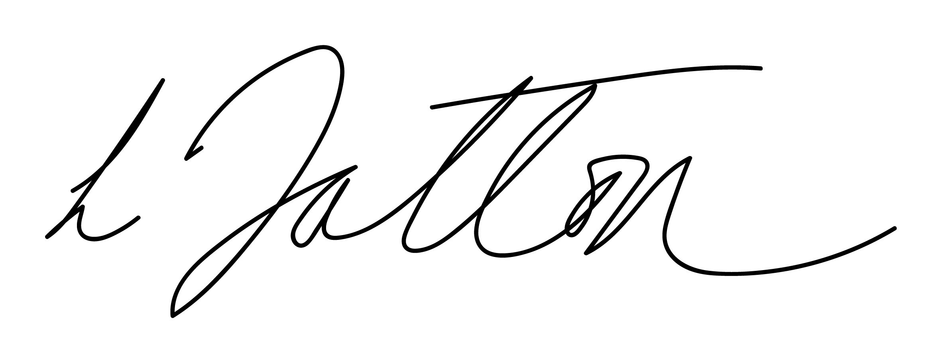
Chair of Governors – Mrs Janiene Davies | 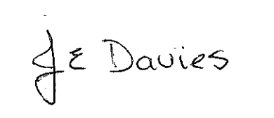



Introduction
Employees are often the first to realise that there may be something wrong within the school
but may feel unable to express their concerns because they feel that speaking up would be
disloyal to their colleagues, managers or to the School Governors. They may also fear
harassment or victimisation. They may be worried about raising such issues or they may
want to keep the concerns to themselves, perhaps feeling it’s none of their business or that
it’s only a suspicion. They may decide to say something but find that they have spoken to
the wrong person or raised the issue in the wrong way and are not sure what to do next.

The Governors have introduced this policy to enable you to raise your concerns at an early
stage and in the right way. We would rather the matter is raised when it is just a concern
than wait for proof.

This policy makes it clear that concerns can be raised without fear of victimisation,
subsequent discrimination or disadvantage and is intended to encourage and enable
employees to raise concerns.

The policy applies to all employees, contractors and suppliers working in the school.

The Headteacher will ensure that all Staff, Governors and Contractors are aware of this policy

Aims and scope
This policy aims to:

- encourage confidence in raising concerns and to question and act on concerns regarding practice
- provide avenues for concerns to be raised and to receive feedback on any action taken
- ensure that a response to concerns is received and the means by which to take the matter further if required
- provide re-assurance that protection from reprisals or victimisation will be available for any disclosure made in good faith

There are existing procedures in place to enable you to lodge a grievance relating to your own employment. The Whistleblowing policy is intended to cover concerns other than your employment, where the interests of pupils or others or of the School itself are at risk. These include:

- conduct which is an offence or a breach of law
- disclosures related to miscarriages of justice
- health and safety risks, including risks to pupils, parents/carers and the public as well as other colleagues
- damage to the environment
- the unauthorised use of public funds
- possible fraud and corruption
- sexual or physical abuse
- the neglect, emotional, physical or sexual abuse of children or other inappropriate behaviour towards them, or
- other unethical conduct

Any concerns that you have about any aspect of school provision or the conduct of the school staff, or others acting on behalf of the School can be reported under the Whistleblowing policy. This may be about something that:

- makes you feel uncomfortable in terms of known standards, your experience or the standards you believe the School subscribes to; or
- is against Financial Regulations and policies; or
- falls below established standards of practice; or
- amounts to improper conduct.

If an employee becomes aware of activities which he or she believes to be illegal, improper or unethical, the employee should report the matter in accordance with this procedure.

This policy does not replace the school complaints procedure.

The Law
Employees who raise concerns in good faith are protected by the law. The Public Interest Disclosure Act 1998 (PIDA) provides legal protection for workers (including contractors and agency staff) who raise genuine concerns about malpractice internally, and, provided they acted reasonably and not for personal gain, externally.
Concerns about crime, failure to comply with any legal duty (including negligence and breach of contract or administrative law), miscarriage of justice, matters that are a danger to health, safety or the environment, or the cover-up of any of these, are all concerns that are covered by PIDA. This means that a worker who is victimised, penalised or who loses his or her job, as a result of raising such concerns, can bring an action against their employer in an employment tribunal, provided that certain tests are met, eg the concerns were raised in good faith. Employment Tribunals can award compensation and in some cases order that the worker be reinstated.

Some concerns raised will not be covered by PIDA (eg if it would be an offence to do so) and some individuals will not be protected (eg the genuinely self-employed). If you require more information on PIDA it can be obtained from the Council’s Chief Legal and Administration Officer.

Harassment of a member of staff who raises concerns is likely to be a disciplinary offence, and in some cases, a criminal offence.

Your safety
The school is committed to good practice and high standards and wants to be supportive of employees.

The School recognises that the decision to report a concern can be a difficult one to make. If you believe what you are saying is true, you have nothing to fear because you will be doing your duty to your employer and those for whom you are providing a service, or in your care. You will not be at risk of losing your job or suffering any form of retribution as a result.

The School will not tolerate harassment or victimisation (including informal pressures) and will take appropriate action to protect you when you raise a concern in good faith.

Any investigation into allegations of potential malpractice will not influence or be influenced by any disciplinary or redundancy procedures that already affect you.

Your confidence
All concerns will be treated in confidence and every effort will be made not to reveal your identity if you so wish. If the situation arises where we are not able to resolve the concern without revealing your identity (for instance because your evidence is needed in further proceedings) we will discuss with you whether and how we can proceed.

Anonymous allegations
This policy encourages you to put your name to your allegation whenever possible.

Concerns expressed anonymously are much less powerful, but will be considered at the discretion of the school Governing Body.

In exercising this discretion, the factors to be taken into account would include:

- the seriousness of the issues raised
- the credibility of the concern; and
- the likelihood of confirming the allegation from attributable sources.

Remember that if you do not tell us who you are, it will be much more difficult for us to look
into the matter, or to protect your position, or to give you feedback. Accordingly, this policy
is better suited to concerns not raised anonymously.

Untrue allegations
If you make an allegation in good faith, but it is not confirmed by the investigation, no action
will be taken against you. If, however, you make an allegation frivolously, maliciously or for
personal gain, disciplinary action may be taken against you.

How to raise a concern
As a first step, we hope you will feel able to raise concerns with your immediate manager. If you feel unable to raise the matter with your manager, for whatever reason, please raise the matter with the Headteacher.

If these channels have been followed and you still have concerns, or if you feel that the matter is so serious that you cannot discuss it with the above people, you should approach the Chair of the Governing body or the Chief Education Officer.

If you have serious concerns which you feel unable, for whatever reason, to raise within the School or council, you should raise the matter with one of the external contact points referred to in this policy.

Concerns may be raised verbally or in writing. Staff who wish to make a written
report are invited to use the following format:

- the background and history of the concern (giving relevant dates);
- the reason why you are particularly concerned about the situation.

The earlier you express the concern, the easier it is to tak action.
Although you are not expected to prove the truth of an allegation, you will need to demonstrate to the person contacted that there are sufficient grounds for your concern.

Advice and guidance on how matters of concern may be pursued can be obtained either
from your Headteacher, or the Chief Education Officer.

There are specific procedures to be followed where concerns are raised about the welfare
of children and young people, so that if necessary, child protection measures can be initiated
without delay. These procedures are set down in the ‘All Wales Child Protection
Procedures’. These procedures will be initiated by Children’s Services (where appropriate)
when you raise a concern.

More information on these procedures, please consult the Safeguarding and Child Protection Officer at the school of the Designated Local Authority Officer for Safeguarding and Child Protection. This policy should be read in conjunction with the Child Protection and Safeguarding Policy.

Failure to report actual or suspected physical, sexual or emotional abuse of a child or vulnerable adult by a member of staff (or any other person having contact with the pupil will potentially be regarded as gross misconduct.

You may invite your trade union professional association representative or a friend to be
present during any meetings or interviews in connection with the concerns you have raised.

How the school will respond
The school will respond to your concerns. Do not forget that testing out your concerns is not the same as either accepting or rejecting them.

Where appropriate, the matters raised may:

- be investigated internally by management, internal audit, or through the disciplinary process
- be referred to the Police
- be referred to the External Auditor
- form the subject of an independent inquiry

In order to protect individuals and those accused of misdeeds or possible malpractice, initial
enquiries will be made to decide whether an investigation is appropriate and, if so, what form it should take. The overriding principle which the School will have in mind is the public interest. Concerns or allegations which fall within the scope of specific procedures (for example, child protection or discrimination issues) will normally be referred for consideration under those procedures.

Some concerns may be resolved by agreed action without the need for investigation. If
urgent action is required this will be taken before any investigation is conducted.

Within ten working days of a concern being raised, you will receive a letter:

- acknowledging that the concern has been received
- indicating how we propose to deal with the matter
- giving an estimate of how long it will take to provide a final response
- telling you whether any initial enquiries have been made;
- supplying you with information on staff support mechanisms, and
- telling you whether further investigations will take place, and if not, why not.

The amount of contact between the persons considering the issues and you will depend on
the nature of the matters raised, the potential difficulties involved and the clarity of the
information provided. If necessary, further information will be sought from you.

Where any meeting is arranged, off-site if you so wish, you can be accompanied by a Union
or Professional Association representative or a friend

The School will take steps to minimise any difficulties that you may experience as a result
of raising a concern. For instance, if you are required to give evidence in criminal or
disciplinary proceedings, the School/Local Authority will advise you about the procedure
and provide you with the necessary support.

The School accepts that you need to be assured that the matter has been properly
addressed. Thus, subject to legal constraints, you will receive information about the
outcome of any investigations.

If you are unhappy with our response, remember you can go to the other levels and bodies
detailed in this policy.

Whilst we cannot guarantee that we will respond to all matters in the way that you might
wish, we will try to handle the matter fairly, and expeditiously and properly. By using this
policy, you will help us to achieve this.

Independent advice
If you are unsure whether or how to raise a concern or you want confidential advice, you
can contact the independent charity Public Concern at Work on 020 7404 6609 or at
helpline@pcaw.co.uk.

Their advisors can give you free confidential advice on how to raise a concern about serious malpractice at work.

How the matter can be taken further
This policy is intended to provide you with an avenue to raise concerns within the school if
at all possible. The school hopes you will be satisfied with any action taken. If you are not,
and if you feel it is right to take the matter outside the school, the following are possible
contact points:

- your local Council Member (if you live in the area of the Council)
- the Audit Commission in Wales
- relevant professional bodies or regulatory organisations
- your solicitor
- the Police
- the relevant trade union
- in respect of children and young people, the NSPCC/Children’s Commissioner

If you do take the matter outside the Council, you need to ensure that you do not disclose confidential information. Check with the contact point about that.

Responsibility
The Governing Body have overall responsibility for the maintenance and operation of this
policy. The Governing Body will maintain a record of concerns raised and the outcomes
(but in a form which does not endanger your confidentiality) and will report if necessary to
the Council via the Chief Education Officer.

Evaluation & Review
This policy will be reviewed by the Senior Management Team and Governing Body and adopted by the Governing Body as per the schedule on the front page.

