Ysgol Bryn Gwalia
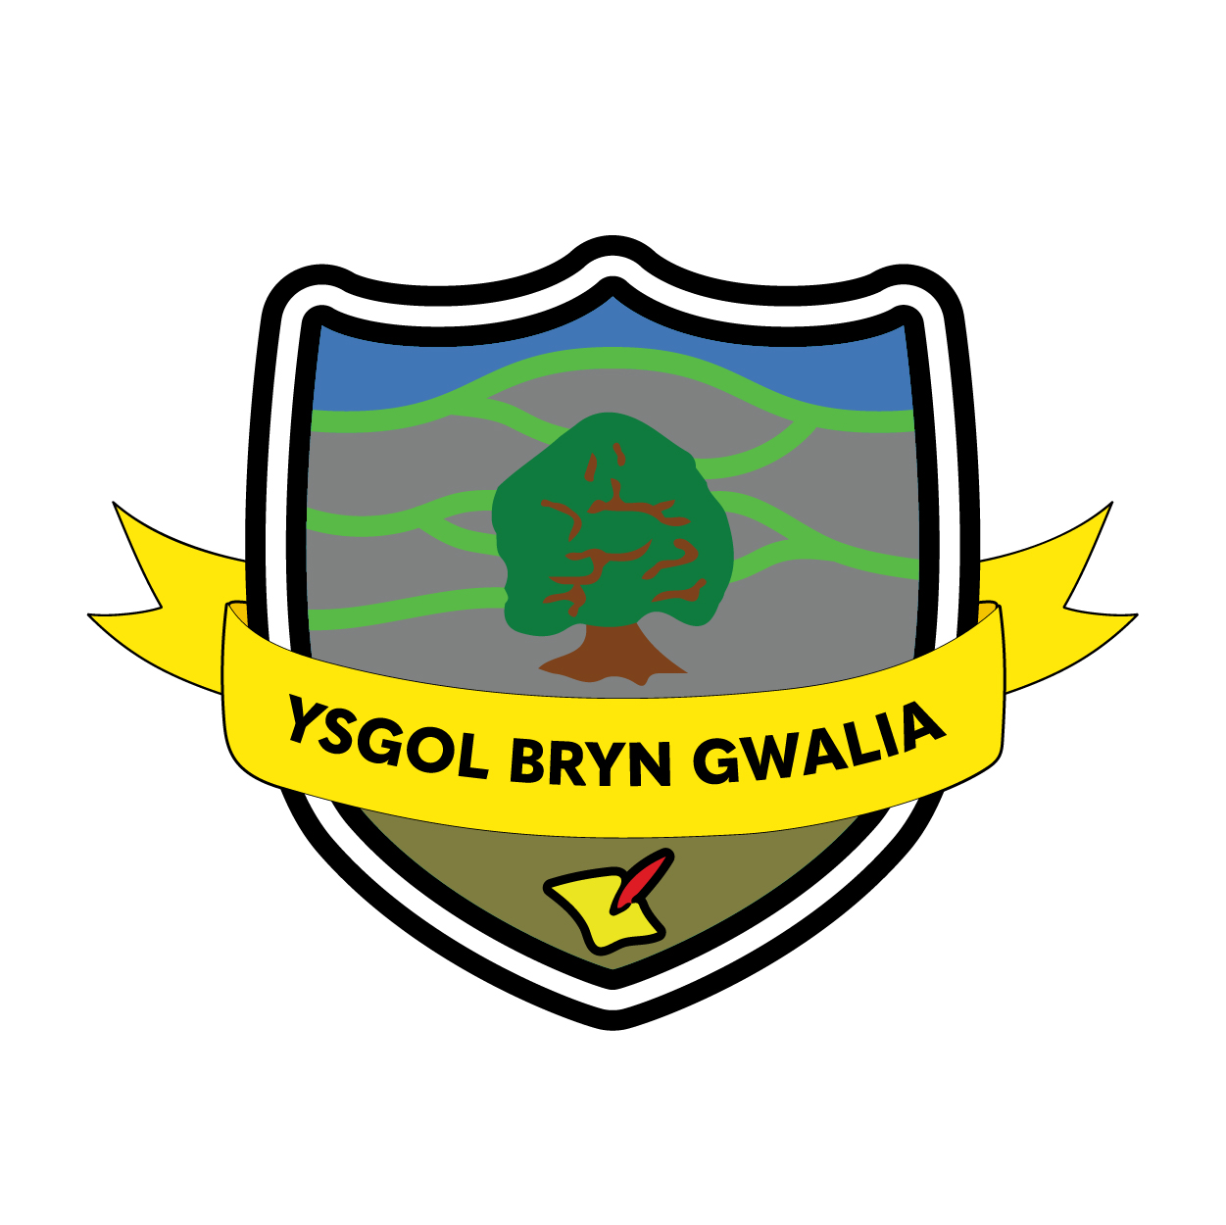

Y Cwricwlwm Cymreig Policy
Last Review Date | July 2022
Date to be reviewed by Senior Management Team | July 2025
Date Adopted by Governing Body | July 2022
Head Teacher – Mrs Lorraine Dalton | 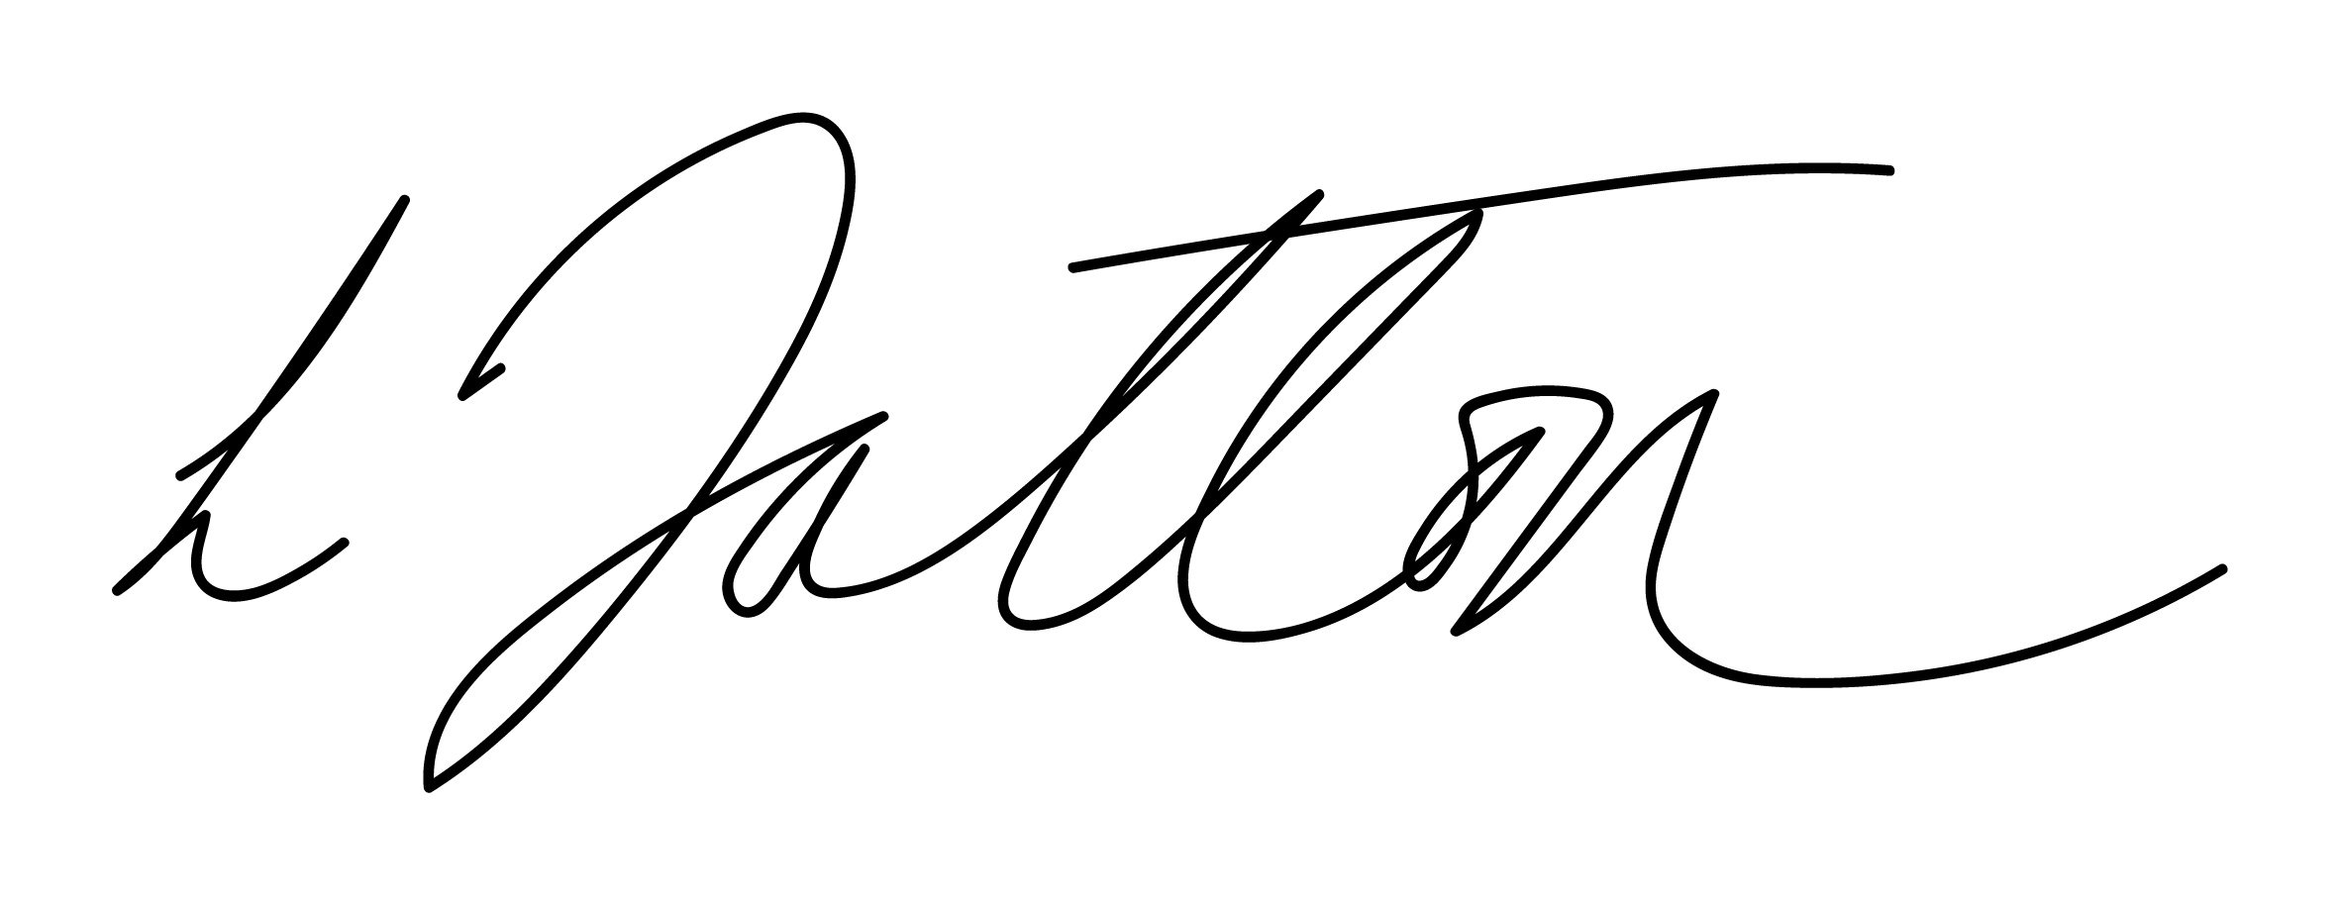
Chair of Governors – Mrs Janiene Davies | 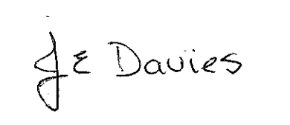


Introduction
It is important that at the beginning of this policy, we give a definition to the term ‘Curriculum Cymreig.’ Cymreig should not be confused with the Welsh word Cymraeg which means Welsh language. Cymreig means Welsh as in something pertaining to Wales. Immediately then we see that Curriculum Cymreig is much more than an issue relating to the Welsh Language. Curriculum Cymreig is about giving the National Curriculum in Wales a unique, distinctive and special flavour and identity. The Common Requirements of the School Curriculum in Wales provide that: “Pupils should be given opportunities, where appropriate to develop and apply knowledge and understanding of the cultural, economic, environmental, historical and linguistic characteristics of Wales”.

At Ysgol Bryn Gwalia we aim to fully cultivate pupils experiences of living and learning in Wales and develop in them a deeper understanding and knowledge of these characteristics through a broad and balanced curriculum which reflects the plurality and diversity of Wales in the 21st Century.

Aims
The curriculum and ethos of our school, wherever possible, will reflect and celebrate what is distinctive about life in Wales and help pupils to acquire a sense of belonging. At times, contributions will be made through National Curriculum subjects and at other times it will require a whole school approach. Pupils will learn and understand about their own locality and community and also about parts of Wales. Care will be taken, however to avoid promoting a stereotypical view of Welshness. Although the images of daffodils, dolls in Welsh costumes, castles and red dragon flags may have some value in helping to convey a sense of identity to younger pupils, it will give a false impression of Wales in the modern world to older pupils. Ysgol Bryn Gwalia experiences will be planned to ensure that pupils’ learning is progressive; they will begin with the familiar and move on to a wider perspective relating to the diversity of all Welsh cultures.

We will ensure that: -
• There is a consistent approach to Y Cwricwlwm Cymreig across the school in all its aspects.
• Planning in all subjects shows clearly how and where elements of Y Cwricwlwm Cymreig are taught.
• There is systematic monitoring and evaluation of Y Cwricwlwm Cymreig in order to identify areas for improvement.
• There is a Welsh ethos, influenced by policies, that is reflected in the management, organisation and administration of the school.
• The concept of Y Cwricwlwm Cymreig is used to inform and enrich not only the pupils of the school but the wider community.

Specific Aims
• To give pupils a sense of place and heritage.
• To give pupils a sense of belonging.
• To help pupils become aware of the part played by language and literature in the history and life of Wales.
• To give pupils an awareness of the creative and expressive arts in Wales.
• To give pupils an awareness and understanding of the factors which have shaped the religious beliefs and practices of people in Wales.
• To give pupils an awareness of contemporary issues as they affect Wales. Objectives Pupils’ knowledge and understanding of the cultural, economic, environmental, historical and linguistic characteristics of Wales will be developed in the following ways: Cultural
• Celebrating the distinctive cultures, languages and traditions of Wales while respecting the values of other cultures.
• Gaining knowledge of one’s own community and its values and traditions.
• Exploring the creative and expressive arts in Wales; traditional and contemporary literature, music, art, craft, dance and sport.
• Gaining knowledge about the religious beliefs and practices of Wales, Christian and other, past and present, and their influence on all aspects of Welsh life.
• Exploring links between Wales, the UK, Europe and the wider world. Economic
• Understanding the role played by Welsh industry and agriculture in shaping the economic, political and cultural character of Wales.
• Learning how the development of resources and technology in the past and present can change life in Wales.
• Appreciating the part which different sectors of the population play in the economic life of Wales.
• Visiting and researching examples of past and present economic activity.
• Keeping abreast of new business enterprise and economic change in the local area and Wales through the media and use of ICT.
• Understanding the developing economic links between Wales, Europe and the wider world. Environmental
• Learning about the relationship between the environment and the people of Wales and the effect this has on Welsh life today and in the past.
• Exploring current issues that affect the lives of people in Wales and the Welsh economy.
• Learning about the character of the built environment, past and present.
• Learning about sustainable development in Wales and the wider world.
• Understanding that opinions on issues such as sustainability can be expressed through the decision making process in Wales.
• Visiting, studying and appreciating the various landscapes of Wales. Historical
• Understanding how lives and localities have been shaped by the past, through learning about the history of Wales, its political, economic, social and cultural aspects.

How we will develop Y Cwricwlwm Cymreig in school.
• Visiting historical sites, using artefacts, making comparisons between past and present, and developing and understanding of how these have changed over times.
• Learning about the relationship of Wales with other parts of the UK today and in the past.
• Learning about past and present links with Europe and the wider world, using a range of scales of reference – local, regional, national, British, European and world. Linguistic
• Using the Welsh language with access for all.
• Recognising that there are many different levels of fluency in Welsh.
• Teaching Welsh as a second language and using incidental welsh in the life of the school.
• Studying the accents and dialects of Wales.
• Becoming aware of Welsh as a language and its links with other languages.
• Using Welsh to create a school ethos that reflects the schools’ position as a school in Wales. Equal Opportunities All pupils in the school, irrespective of gender, race or cultures will have equal access to experiences which will enable them to gain knowledge and understanding of the distinctive characteristics of Wales.

Cymraeg Campus
We will engage actively in the Cymraeg Campus scheme to develop use of everyday Welsh language. This will in turn support the Welsh Government one million Welsh speakers target and will support pupils and the wider community to develop a deeper understanding of the unique culture and heritage of Wales.

Additional Learning Needs
In its approach, the school will cater for the needs of pupils of all abilities and disabilities when teaching about Wales, its cultural, historical, economical, environmental and linguistic characteristics and will provide a differentiated curriculum to meet each pupil’s individual needs wherever possible.

The Role of the Cwricwlwm Cymreig Co-ordinator
• To support and motivate other teachers in the development of Y Cwricwlwm Cymreig.
• To co-ordinate a planned approach for the whole school.
• To ensure that the school takes full advantage of all possible community links.
• To lead discussion, innovation and give advice on all matters involving Y Cwricwlwm Cymreig.
• To facilitate liaison with other institutions with comparable development of Y Cwricwlwm Cymreig.

Evaluation & Review
This policy will be reviewed by the Senior Management Team and Governing Body and adopted by the Governing Body as per the schedule on the front page.

