Ysgol Bryn Gwalia
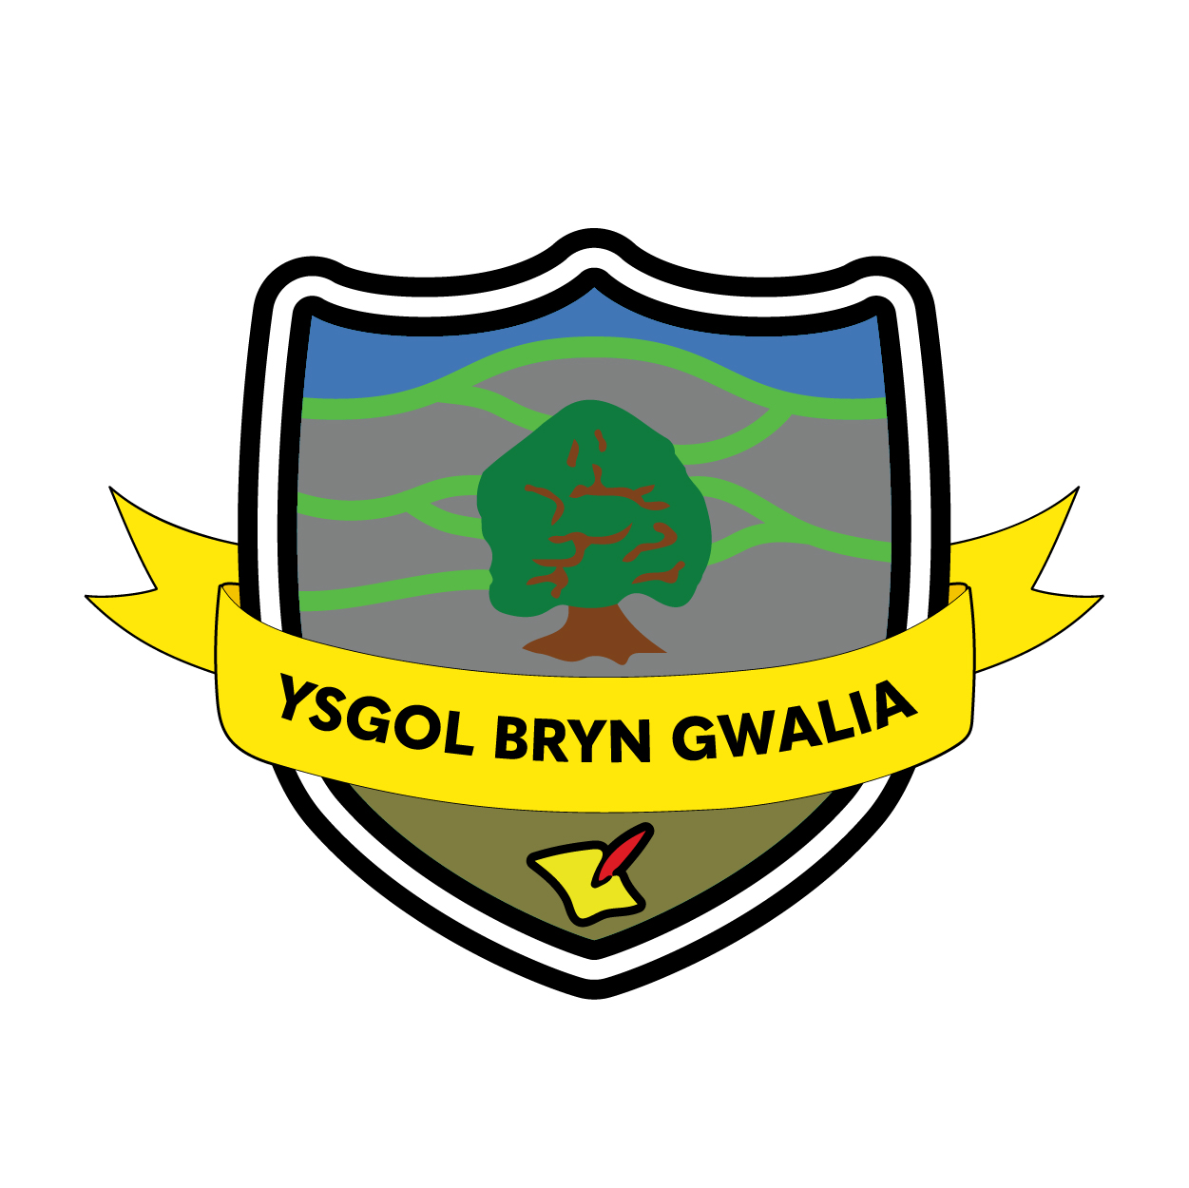

Anti-bullying Policy
Last Review Date | April 24
Date to be reviewed by Senior Management Team | April 26
Date Adopted by Governing Body | April 24
Head Teacher – Mrs Lorraine Dalton | 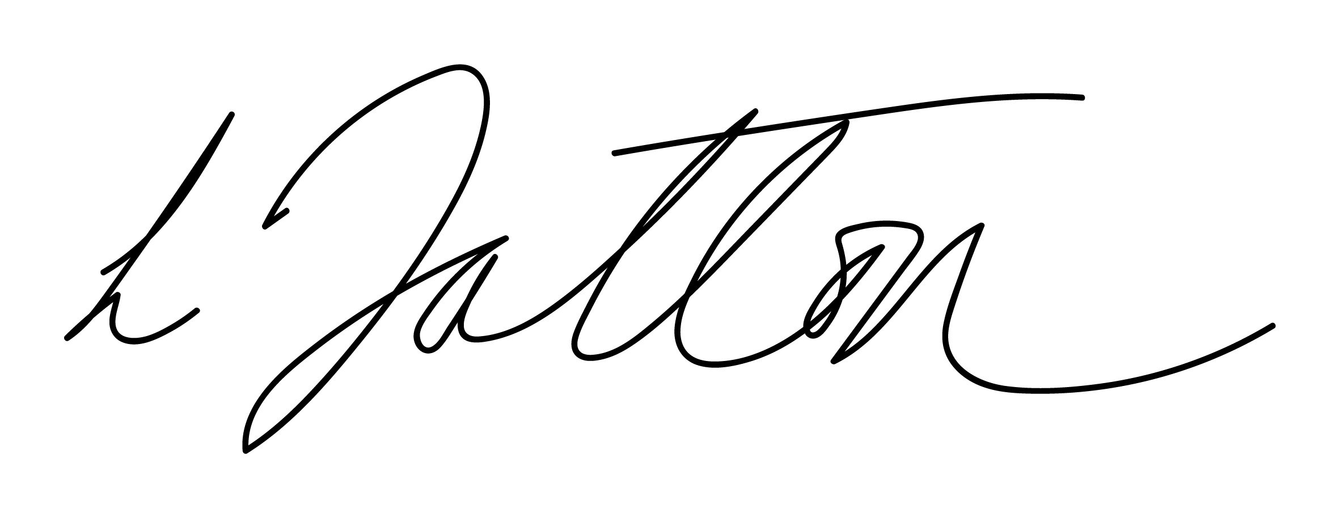
Chair of Governors – Mrs Janiene Davies | 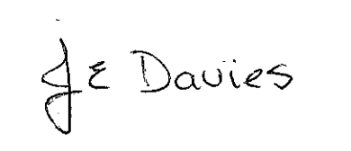



Introduction
Ysgol Bryn Gwalia continues to be committed to ensuring that all pupils have the opportunities they need to fulfil their potential, including the right to learn in a safe and protective environment free from racism, bullying or discrimination of any kind.

The work we propose through this document is in keeping with the “Respecting Others” Welsh Government Anti-Bullying guidance (www.wales.gov.uk/educationandskills) and The Equality Act 2010 in understanding the importance of identifying and protecting those individuals who share a protected characteristic as much as those who do not. Research clearly shows that emotional and social wellbeing is the basis of both good academic attainment and also the development of social skills that all members of a community need to successfully interact and thrive.

As such, the damaging effects of bullying are long term and far reaching, impacting upon personal and social development as well as educational achievement. We know that bullying happens, but preventing it can present a huge challenge. That is why we need to work together to be proactive to address this issue. The purpose of this strategy is to promote a consistent message across the school that bullying is taken very seriously and managed through a combination of prevention and intervention measures. It also intends to outline the responsibilities of the school and Governing Body in tackling bullying through the development and implementation of effective anti-bullying strategies and partnership work.

The main objectives of this policy are to;
Aims of this Policy:
- To contribute to a child’s spiritual, emotional, social, moral and physical development
- To develop positive approaches and attitudes to the diverse needs of others and enable children to
- become responsible and active members of our diverse society.
- To eliminate all forms of bullying including prejudice-driven bullying

What bullying is and isn’t

Bullying is when the same student is repeatedly and deliberately harmed. The victim finds it difficult to defend him or herself against the perpetrator/s. There is an imbalance of power. The victim is the same student who is subjected over and over again to mean and hurtful actions by others. The purpose of bullying is to hurt, harm and cause distress. A victim may be physically weak, timid or might be new to a class with no circle of friends to support him or her. Children who do not share similar characteristics with their peers, for example their race and culture, their sexuality or their educational ability, can also be victimised through
bullying. Sometimes children hurt each other by accident. A fight or falling out between two children of equal strength and status is not bullying. When such incidents arise the school will deal with these in line with our behaviour policy.

What do we know about bullying?

Bullying harms children and is not ‘a rite of passage’ to adulthood. Research shows that bullying in childhood diminishes the victims’ ability to cope in difficult situations. This is why at our school, we take extensive measures to both prevent and tackle all forms of bullying.
Bullying can be:
Direct – physical, name calling, teasing, mocking
Indirect (Hidden) – spreading rumours, negatively influencing the way others think about a victim,
cyberbullying
A bullying situation doesn’t just involve a bully and a victim. ‘Bystanders’ to bullying can either join in with the bullying (assistants and reinforcers) or stand on the side-line and do nothing (silent approvers).

Prevention

At Ysgol Bryn Gwalia we use the KiVa Bullying Prevention Programme to help prevent all forms of bullying. The programme was developed in Finland and has been used in the UK since 2012. The programme has been shown in large scale studies to be highly effective in reducing bullying in schools.

The KiVa ‘curriculum’ is taught to all classes in years 3-6. Each lesson lasts for
approximately 45 minutes and is delivered once a month. During lessons the children typically learn about respecting others, including everyone, how to function in a group and how to help someone who is being bullied. The lessons are complimented by the KiVa computer game where students go into a virtual school and practice anti-bullying actions. The goal of the curriculum work is to educate students about their role in stopping bullying. Instead of being ‘silent approvers’ or ‘assistants to the bully’, children start to support the
victimised child, developing a shared sense of responsibility within the class. At the end of each lesson, each class develop and agree on an anti-bullying class rule.

In Foundation Phase we follow the KiVa strategies and messages. We teach lessons related to friendships and anti-bullying.

Tackling bullying incidents

Ysgol Bryn Gwalia has a dedicated task force to tackle bullying, the ‘KiVa Team’. The team consists of two adults in school who have been specially trained to tackle bullying incidents. For 2023 - 2024 the team are Mrs Dalton and Mrs Wyatt.

When a parent or student reports a case of bullying the KiVa Team will decide if it is bullying or a conflict or fight between children. (Screening Form A).

All cases that fulfil the criteria for bullying are dealt with in a systematic way by the KiVa Team and all children involved will be spoken to individually. (See KiVa flowchart and process in Appendices)

After this, all those children who were involved in the bullying (not the victim) meet together as a group where they agree on how they will change their behaviour. Support for the victim is also identified during their meeting with the KiVa Team. Follow up discussions with all students take place after an agreed amount of time to make sure that things are improving for the victim. All adults at the school have received basic awareness training about bullying and will report any concerns to the KiVa Team. Parents of all those involved in a bullying situation are notified by the KiVa Team. However, discussions are primarily held between adults at the school and the students. All incidents and reports are uploaded to C-POMS and categorised as to the nature of the incident. The Kiva Screening form will be uploaded, even if it is not deemed Bullying by the KIVA team.

Guidance:
STAFF

- To ignore is to condone. Listen carefully and, if necessary, make a note of the incident.
- All staff to be aware of the times and areas, when and where bullying could happen e.g. cloakrooms; toilets; areas of the playground.
- Offer the victim immediate support and help. Refer to the KiVa team
- Ensure all pupils are aware that there are consequences to any anti-social behaviour and that incidents will be dealt with and the consequences made visible if necessary.
- Make the unacceptable nature of the behaviour, and the consequences of any repetition, clear to the bully.
- Stress that it is the “behaviour” and not the pupil that is unacceptable.
- Try to support the bully in changing the behaviour, by using practical, attainable targets.

PUPILS
Children are aware of KiVa and upstand as much as possible. They should speak to a teacher if they are concerned. KiVa kids wear yellow vests at break.

What to do if someone is being bullied:
- When someone is being bullied, take action. Watching and doing nothing can suggest support for the bully.
- If you see someone else being bullied, tell an adult.
- Be an upstander
- If you witness severe bullying (e.g. physical violence) then inform an adult immediately.
PARENTS

- Watch for signs of distress in your children, e.g. unwillingness to attend school, headaches, illnesses, missing personal items, requests for money, damaged clothes etc.
- It may be manifested as stomach pains, sleeping problems and tiredness.
- Listen when they talk to you about their social life, eg. friends, playtimes, walking to and from school.
- Do not assume all they tell you is “bullying”. Bullying is persistent / repeated anti-social behaviour.
- If you think your child is being bullied, inform the school immediately, using the Kiva screening form which you can find on the school website.
- If necessary, keep a written record.
- Do not encourage your child to “hit back”. It may make matters worse and not be in your child’s nature. Instead, encourage your child to make friends.

Examples of strategies for staff:
- Ensure that children can differentiate between “telling tales” and telling about bullying.
- Telling tales – deliberately getting someone into trouble without any positive outcome.
- Telling about bullying – helping someone.
- Ensure that children can identify between ‘bullying’ and falling out or arguing with their friends (peer conflict).
- Is the bullying a compensatory activity? E.g. no friends, academically poor, etc.
- Use drama lessons for social skills work, eg. Bullies and Victims (name-calling, how do others feel?)

Restorative practices to be used by KiVa team so as not to escalate the situation.
- Discuss the “bully’s” aggression / behaviour with his/her parents / carers.
- Praise good behaviour in the bully.
- Give appropriate responsibility to the bully.
- Use the curriculum for opportunities to counteract stereotyping and prejudice, eg. cultural, racial, social, body image, sexual orientation - homophobic bullying etc.
- Make sure adults and older pupils are modelling good behaviour. We need to monitor our own behaviour rigorously to set good examples.
- Any damage done by the bully must be redressed as soon as possible.
- All children in school need to understand what bullying is, and its
consequences.
- Working with pupils who are victims
- Let the victim and their parents/ carer know there will be a determined effort to stop the bullying.
- Help him/her restore his/her self-esteem and confidence, eg. write down good things they think about themselves, especially those to do with the curriculum.
- Make sure that the victim does not believe that the bully is right.
- Take his/her mind off the bullying by helping master a new skill or by joining a new group, eg. Art Club / chess club / Eco Club / Sports activity etc.
- Help establish victim in a new peer group for play etc.
- Ask older pupils to be supportive.
- Ensure victim has an adult contact.
- Establish a nurture group with a trained adult e.g. Circle of Friends, Positive People etc
- Give self-protective strategies:
- Ensure children know the Anti-Bullying code
- Talk through individual strategies for that child:

Reporting to Governors and LA:
Any bullying incidents will be reported to Governors via the Headteacher’s termly report. Incidents of bullying should be reported to FCC

Review:
This policy will be reviewed annually.

Related Policies:
Behavioural Policy/ E-Safety/ Equal Opportunities / Racial Equality /
Complaints/Safeguarding Policy

Related Reading:
Bullying - Childline - Childline Coping With Bullying - ChildLine.org.uk
Bullying UK: Bullying advice KiVa International – KiVa

