Ysgol Bryn Gwalia
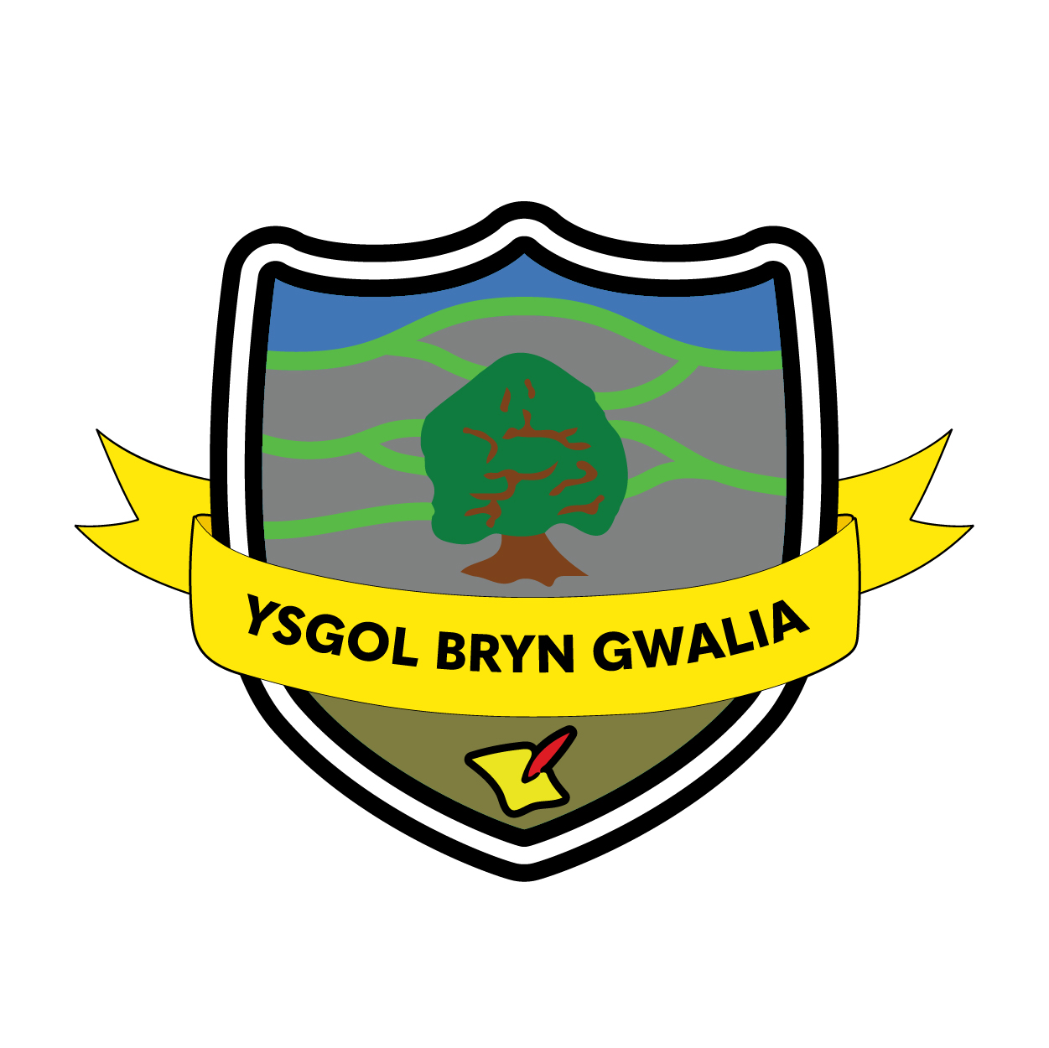

Behaviour Policy
Last Review Date | September 2023
Date to be reviewed by Senior Management Team | September 2026
Date Adopted by Governing Body | September 2023
Head Teacher – Mrs Lorraine Dalton | 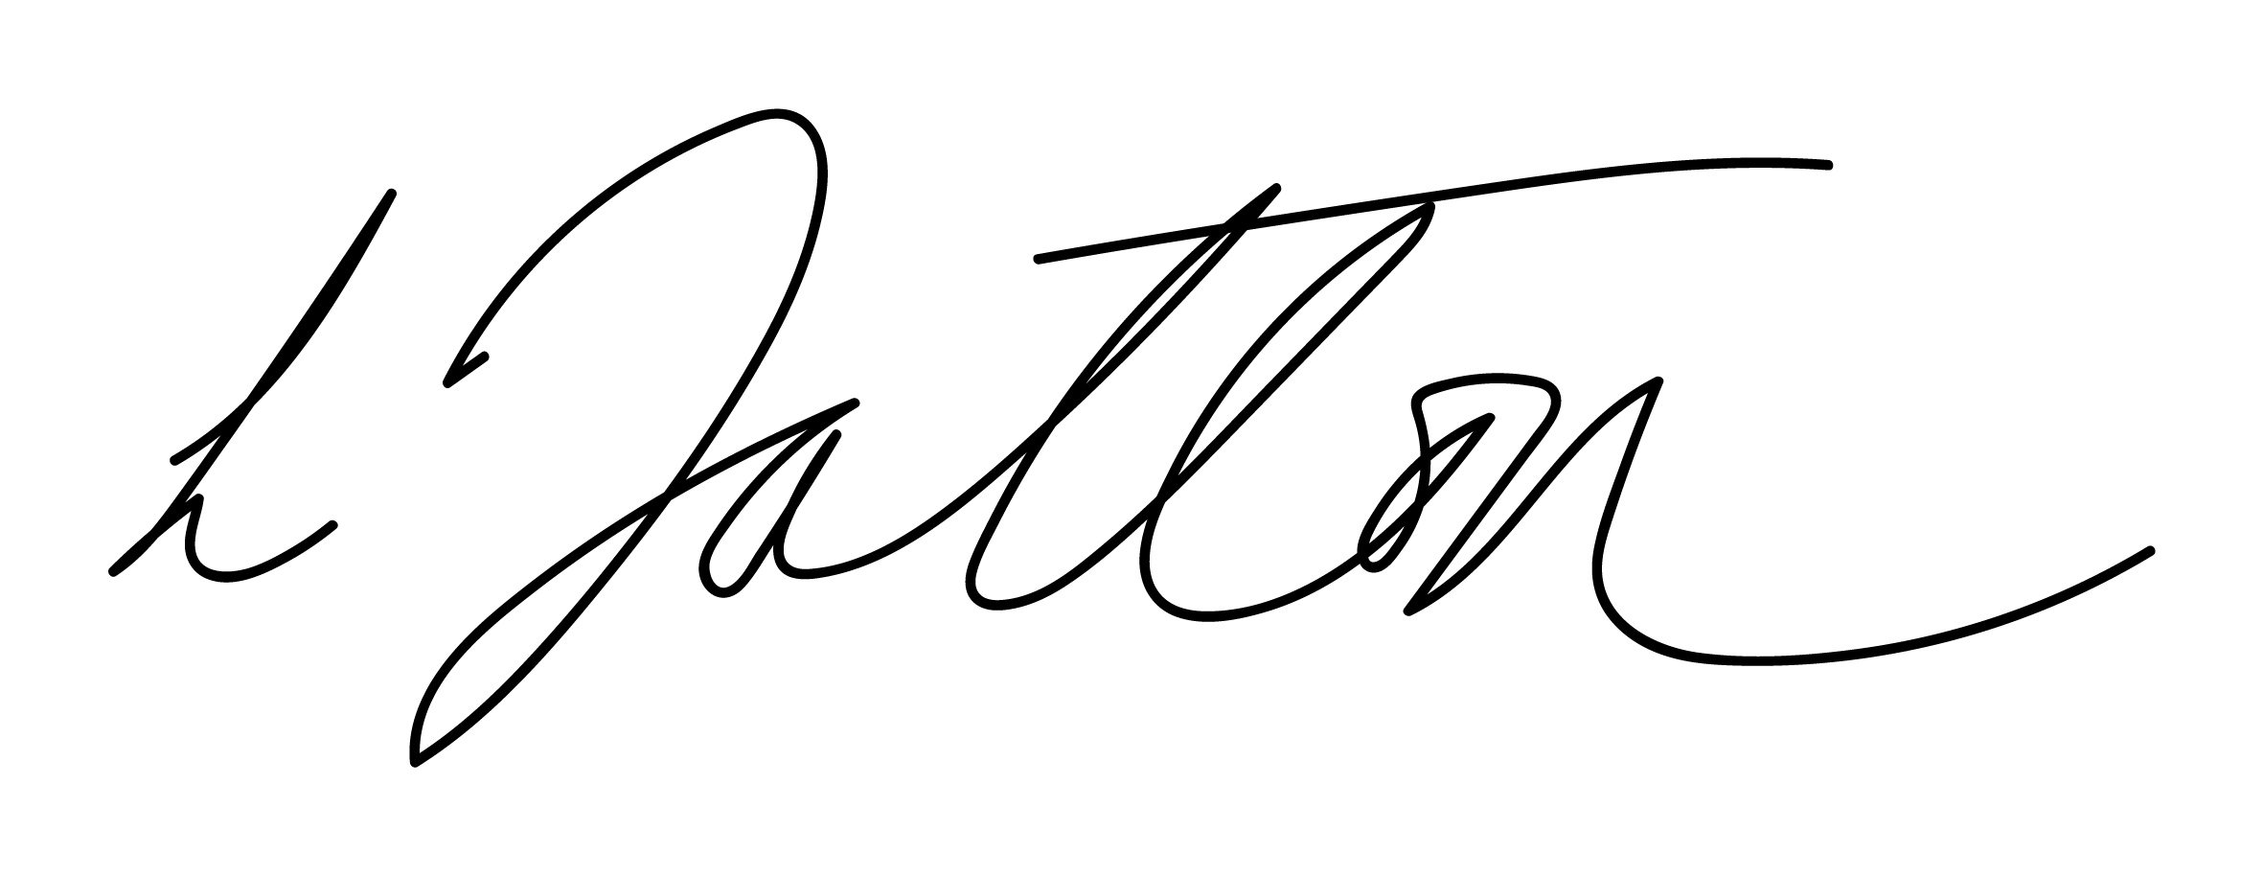
Chair of Governors – Mrs Janiene Davies | 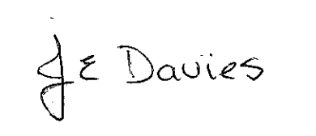



Introduction
"Good behaviour is a necessary condition for effective teaching and learning to take place."
“….consider how much impact could be made if every member of the school whether child or adult was committed to creating an environment where everyone was regularly listened to and encouraged, where a school made clear its commitment of finding ways to building relationships and giving respect and support to all its members.”
Jenny Mosley
At Ysgol Bryn Gwalia Primary School we like to work alongside parents/carers to encourage children to develop as fully as possible. We want to help our children to grow socially, personally and academically and this policy is concerned with promoting positive attitudes to behaviour.

We believe that good behaviour needs to be carefully developed. We think young children learn best when they are clear about what it is that they are supposed to do and when they are constantly encouraged to do it. This policy sets out:

- What we mean by good behaviour.
- What we think are the benefits of good behaviour.
- How we encourage good behaviour in school.
Aims of this policy
- To develop frameworks within which initiative, responsibility and sound relationships can flourish
- To enable children to develop a sense of self-worth and a respect and tolerance for others
- To produce an environment in which adults and children feel safe, secure and respected
- To create a consistent environment that encourages and reinforces good behaviour
- To define acceptable standards and the principles of good behaviour

What do we mean by good behaviour?

At Ysgol Bryn Gwalia, we have a clear set of routines so that the children know what is expected of them at a given time. Our belief system for appropriate behaviour is supported by clear rules and consequences / sanctions which are regularly shared with the children and prominently displayed in all classrooms.

Throughout school, children are actively encouraged to consider the consequences of their behaviour and to take responsibility for their own actions. We believe that positive reinforcement is the best way to achieve good behaviour, to reward good behaviour and to help those who struggle to make the right choices with their behaviour.

What do we mean by discipline?

Discipline is not control of children – many children are not easily controlled. When children’s lives and behaviour are too regulated by others, they feel no need to control themselves, since others do it for them. An important long-term goal is to teach self-discipline. We believe that discipline is about leading by example, guiding, encouraging and instructing children within a framework of rights, responsibilities and rules (the 3 Rs). These should work together to create a caring community atmosphere.

Rights, Rules and Responsibilities
RIGHTS  All children have the right to develop their potential and be safe and happy.  RULES  The rules or codes of behaviour are essential for maintaining the rights. These are split into three areas:  - whole school  - classroom  - playground  RESPONSIBILITIES  For their rights to be maintained, children have to take on the responsibility of following the rules. If children break the rules, they must understand that they have chosen to do this and therefore must accept the consequences of their actions.  The children and teachers have worked together to establish and draw up the Codes of Conduct for the whole school and within each classroom. | 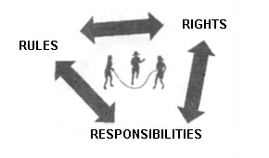
We have many systems set up across the two phases of the school (Foundation Phase and Key Stage 2) to accomplish our aims, but the intended outcomes are exactly the same, irrespective of the age of the child, in order to highlight positive behaviour and raise children’s self-esteem.

Each person in our school community has the right:

- To feel safe
- To learn
- To respect and be treated fairly

‘You OWN your OWN behaviour’ is what we teach the children to encourage them to take full responsibility for their actions and also think about the consequences if they make the incorrect choice.

Restorative Practices

Restorative practice is a strategy that can be used to resolve minor incidents that occur in our school.

In broad terms, restorative practices constitute an innovative approach to offending and inappropriate behaviour, which puts repairing harm done to relationships and people over and above the need for assigning blame and dispensing punishment (Wright 1999). Simply, it is about getting the offender together with the victim to understand the harm that the offender’s behaviour has caused to the victim(s). Set questions are asked by the teacher to the offender and then to the victim, to resolve a situation:
- What happened?
- Who has been affected and how?
- How can we make things right?
- What have we learnt so as to make the right choices next time?

The teacher acts as facilitator. It is the children themselves, who come up with the solutions.

Benefits of good social behaviour

By encouraging good behaviour we know we will be supporting our ethos at Ysgol Bryn Gwalia, one that aims to foster a very positive attitude to life. We aim to promote self-image and respect for the attitudes and values of others.

We encourage children at Ysgol Bryn Gwalia to play an active role in their education and to develop their self-confidence. We aim to create an environment in which children can achieve their full potential and do as well as possible in their school work. We want them to have a sense of identity with their school and show a high degree of self-motivation.

As a school, we aim to meet the needs of all pupils and good behaviour helps to facilitate this, enabling effective learning and teaching to take place, and our children are free to realise their potential.

The curriculum and learning

We believe that developing an ethos of Peer support within the classroom and the Curriculum will contribute to good behaviour through motivating, involving and engaging learners. Thorough planning for the needs of individual pupils, the active involvement of pupils in their own learning, and structured feed- back all help to avoid the alienation and disaffection which can lie at the root of poor behaviour.

It follows that lessons should have clear learning outcomes co-constructed with pupils and hence understood by the children and differentiated to meet the needs of children of different abilities. Marking and record keeping can be used both as a supportive activity, providing feed-back to the children on their progress and achievements and as a signal that the children's efforts are valued and that progress matters.

Classroom management

Classroom management and teaching methods have an important influence on children's behaviour. The classroom environment gives clear messages to the children about the extent to which they and their efforts are valued. Relationships between teacher and children, strategies for encouraging good behaviour, arrangements of furniture, access to resources and classroom displays all have a bearing on the way children behave. Expectations should be clearly displayed in classrooms.

Classrooms have been organised to develop independence and personal initiative. Furniture arranged to provide an environment conducive to on-task behaviour. Materials and resources arranged and labelled to aid accessibility and reduce uncertainty and disruption.

Displays provide prompts to aid learning and to help develop self-esteem through demonstrating the value of every individual's contribution. Grwoth Mindset and The Learning Pit displays help pupils to self regulate their emotions. Overall the classrooms provide a welcoming environment.

Teaching methods encourage enthusiasm and active participation for all. Lessons aim to develop the skills, knowledge and understanding which will enable the children to work and play in co-operation with others. Praise should be used to encourage good behaviour as well as good work. Situations should be handled sensitively and dealt with in a way appropriate to the situation.

Reward Systems

We expect that all pupils behave well in School and follow the rules and expectations set out pupils, staff and Governors. We give praise and reward as much as possible to encourage those good behaviours.

Each term the School Council will gather ideas for reward days. These will be held at the end of each term. Tokens will be issued by staff for role model behaviour and pupils will add to the reward of their choice.

Each week there will be a celebration service in school where one or two pupils are chosen to receive a role model certificate. These will be our Bryn Gwalia ‘Gems’: Pupils who are:

Gentle and kind
Excellent in Attitude
Mindful of Others
Supportive and nurturing

We will also award for acts of kindness. Pupils are picked by the class teacher or nominated by other classmates for being kind. They are allowed to place their heart on the kindness tree.

Consequences

At Ysgol Bryn Gwalia we feel it is important to have consistency for helping children who have difficulty with finding the right behaviour. There is no place for unacceptable behaviour and consequences exist to protect individuals from negative forms of behaviour in the classroom and in other areas of school life. Where rules are not followed we have a system of consequences, which is intended to deal effectively with the inappropriate behaviour.

All behaviour is a form of communication
Most incidences of behaviour are rectified with a verbal reminder. However, should the behaviour continue then we recognise that this may be a way of communicating something to us. Therefore, our structure allows pupils to think, regulate and aspire to join in again with learning.

Our steps to improved behaviour are:

Aim to be Green! All pupils start at Green. They can move in and out but will be given time to reflect on their choices (Appendix 1)

1-minute timer from Green to Yellow as warning
3-minute timer from Yellow to amber as warning
5-minute timer from Amber to Red
At red, breaktime is used for reflection
Continued red is visit to Head/ Deputy Head Teacher

These steps should minimise any low/medium priority behaviours. However, if children persistently display Medium/High Priority behaviours a ‘check in, check out’ daily record sheet should be used to track behaviour. Goals should be set for Green behaviour and if met the pupils will receive recognition for this (Appendix 2)

For constant High Priority behaviours, Teachers will work with TA, Nurture Manager and pupil to devise a plan for shorter lesson time coupled with outdoor time and reward time.

The following tables outline the undesired behaviours:
Low Priority behaviours | Medium Priority behaviours | High Priority behaviours
- Name calling/ deliberately unkind e.g. put downs  - Misuse of school property  - Messing about/ preventing self and others from working - fiddling/ distracting  - Poor participation in class activities - not paying attention  - Delay tactics such as wandering around the classroom or needlessly visiting the toilet  - Swinging/ rocking on chair (repeatedly)  - Lying - dependant on context e.g. in defence  - Not responding to adult when called. | - Persistent repetition of Low level behaviours  - Purposeful defiance  - Deliberate throwing of objects e.g. rubber, pencils & papers (exercising poor judgement)  - Rough play - pinching and pushing  - Misbehaviour in toilets  - Lying - dependant on context e.g. in defiance  - Ignoring instructions  - Misbehaviour in the dining hall  - Non directed swearing  - Climbing on school furniture  - Cruel name calling with intent to belittle e.g. friendship issues that can be resolved with intervention  - Responding inappropriately/ rudely to correction of behaviour from adult | - Persistent repetition of medium level behaviours  - Absolute defiance  - Wilfully damaging property or damaging property as a result of a more serious misdemeanour  - Throwing dangerous objects with the intention to hurt  - Swearing at member of staff  - Arguing with a member of staff  - Refusal to cooperate with requests  - Removing themselves from close supervision i.e. running out of the class without permission/ running away from a member of staff  - Racist comments  - Extremely aggressive behaviour towards others  - Biting

If little progress is being made to improve behaviour identified as targets within the time frame agreed, or if additional misbehaviours of concern occur, in addition to the previous steps, a member of the Leadership Team will become involved. An IBP/ Behaviour Plan will be issued and behaviour recorded. The Head teacher will be informed and the plan discussed during half termly Multi Agency Meetings,

Wherever possible, the consequence should be appropriate for the behaviour.
Fresh Start: although persistent or serious misbehaviour needs recording, every child must feel that everyday is a fresh start.

*Staff will endeavour to keep parents informed where possible/ necessary.

Serious Misbehaviour
Serious types of misbehaviour such as verbal/physical bullying, stealing or swearing will be dealt with as follows.

- First incidence will be dealt with by class teacher.

- On second/third occasion the child will be sent to Head of Year then Deputy Head, who will if necessary inform parents.

- Depending on the seriousness of the misbehaviour, it may result in a warnings of exclusion followed by a period of exclusion if a further serious incident takes place.

As most serious types of misbehaviour occur in the playground, if the behaviour becomes persistent we will inform parents and give them one week’s notice to find alternative arrangements for the child during the lunchtime break for an agreed period of time. When child returns following exclusion, any further incidents will be referred to Inclusion Welfare Officer or the Local Education Authority.
Any and all periods of exclusion will be the sole decision of the Headteacher or the Deputy Headteacher in the absence of the Headteacher and will follow the Welsh Government guidance set out in ‘Exclusion from Schools and Pupil Referral Units’ April 2015

Pupils who Require Additional Support
Some pupils require additional support to encourage and/or assist them to manage their behaviour. These children will have an individual plan which will support them to develop the ability to independently manage their behaviour appropriately.

School Trips and Visits
Any child who repeatedly misbehaves may be excluded from such visits. The final decision will be made by the Headteacher in consultation with class teacher and Deputy Head. A letter will be sent home prior to visit. The child will still be expected to attend school. Alternative arrangements will be made for their continued education.

The governing Body has a Discipline Committee whose role is set out in strict guidelines whenever a child is excluded from school.

Breakfast Club/Playtime/ Lunch time behaviour management

1. Verbal reminder
2. Quiet conversation
3. Time out with the nurture room staff.
4. Removal of privileges
5. Intervention by Head/Deputy Head Teacher

If the behaviour has not altered, children will have their position in dining hall changed to prevent recurrence and remove temptation.

Time out must always be supervised

Special Educational Needs

In exceptional circumstances, where a pupil with Special Educational Needs is unable to understand or comply with this policy because of the nature of their difficulties, a different range of rewards and sanctions will be agreed between the school and the pupil’s parents.
The Role of the Nurture Room and School Liason Officer
The Nurture room staff deliver timetabled sessions to those that need support within the school with Emotional Health and Wellbeing. Pupils will also visit the nurture room should they need time to regulate their emotions and become ‘ready to learn’ again. Staff are highly skilled in understanding the reasons behind choices in behavior and work with the child to develop strategies to move forward. Our School Liaison Officer works closely with parents to devise a plan moving forward. We also take Parent referrals to help with behaviours at home.
The Role of School Council
The School Council meets approximately once a month. The School Council consists of children from Year 1 – Year 6. All classes have two elected members on the School Council. School Councillors have their photographs on the School Council board so that they can be identified throughout the school.
As part of their duties the School Council discusses particular rules and their implementation. They also play a major part in deciding on activities that spread a positive message around the school. It is envisaged that they will play an important role in implementing the rules.
The Role of Parents/Carers
Parents and carers have a vital role to play in their children’s education. It is very important that parents support their child’s learning and co-operate with the school. We are very conscious of the importance of having strong links with parents and good communication between home and school. Thus, the school works collaboratively with parents, so children receive consistent messages about how to behave at home and at school.
We expect parents to behave in a reasonable and civilised manner towards all school staff. Incidents of verbal or physical aggression to staff by parents/guardians/carers of children in the school will be reported immediately to the head teacher who will take appropriate action. (Refer to School Code of Conduct for Parents 2014)
If the school has to use reasonable sanctions to punish a child, parents should support the actions of the school. If parents have any concern about the way that their child has been treated, they should initially contact the class teacher. The head teacher may then be involved and, if the concern remains, they should contact the Chair of the school governors. If these discussions cannot resolve the problem, a formal complaint or appeal process can be implemented.
We feel that all the above is most effectively achieved when we work in partnership with parents.

If parents are at all concerned with any issues regarding behaviour, the person to speak to first is the child’s class teacher or School Liaison Officer. The school’s aim is to promptly address these issues to a satisfactory conclusion.

Parents can be assured that their children will receive support when they need it and, above all, they can feel welcome in the school to discuss their children’s progress in a positive atmosphere.

The Role of Non-teaching Staff
All school staff have a responsibility to uphold the Positive Behaviour Policy.
Non-teaching staff should ensure that children move sensibly and quietly through the school at all times helping to ensure a calm atmosphere in the corridors, classrooms and other school areas.
Children should be made aware that rough play and potentially dangerous behaviour in the playground is unacceptable.
Lunchtime Supervisors are in close touch with the class teachers and communicate with them about incidents of unacceptable behaviour at lunchtime.
The Role of the Class Teacher
Ysgol Bryn Gwalia Primary is aware that good classroom organisation is a key to good behavior. Keeping a good pace and challenging pupils appropriately is key to managing good bahaviour in class.
Teachers at Ysgol Bryn Gwalia are positive, enthusiastic and have high expectations of both learning and behaviour. They foster a sense of self esteem in all children, linked with an understanding of the needs of others. They encourage a calm and responsive atmosphere, avoiding shouting.
Teachers deal with parental concerns in a timely, respectful, sympathetic and professional manner, involving senior staff as appropriate. Teachers expect that parents will behave in a reasonable manner towards them, as professionals, and that issues will be dealt in an atmosphere of trust and mutual respect.
It is the responsibility of the class teacher to ensure that the Golden Rules are enforced in their class and across the school, and that their class behaves in a responsible manner during lesson time.
Role of the Governors
The governing body has the responsibility of setting down general guidelines on standards of discipline and behaviour, and of reviewing their effectiveness. The governors support the head teacher in carrying out these guidelines.
The head teacher has the day-to-day authority to implement the school behaviour and discipline policy, but governors will be fully informed of the policy and changes made.
Role of the Head teacher
It is the responsibility of the head teacher to lead the implementation of the school behaviour policy consistently throughout the school, and to report to governors, when requested, on the effectiveness of the policy. It is also the responsibility of the head teacher to ensure the health, safety and welfare of all children in the school.
The head teacher supports the staff by implementing the policy, by setting the standards of behaviour, and by supporting staff in the implementation of the policy.
The head teacher keeps records of all reported serious incidents of misbehavior on CPOMS and has the responsibility for giving fixed-term exclusions to individual children for serious acts of misbehaviour. For repeated or very serious acts of anti-social behaviour, the head teacher may permanently exclude a child.
Monitoring and review

The monitoring of this policy is the responsibility of the Headteacher. The work of the coordinator also involves supporting colleagues in this area, being informed about current developments and providing strategic direction.

If children live with criticism, they learn to condemn,

If children live with hostility, they learn to fight,

If children live with ridicule, they learn to be shy,

If children live with shame, they learn to feel guilty,

If children live with tolerance, they learn to be patient,

If children live with confidence, they learn confidence,

If children live with praise, they learn to appreciate,

If children live with fairness, they learn justice,

If children live with security, they learn to have faith,

If children live with acceptance and friendship, they learn to find love in the world.

Appendix 1


