Ysgol Bryn Gwalia
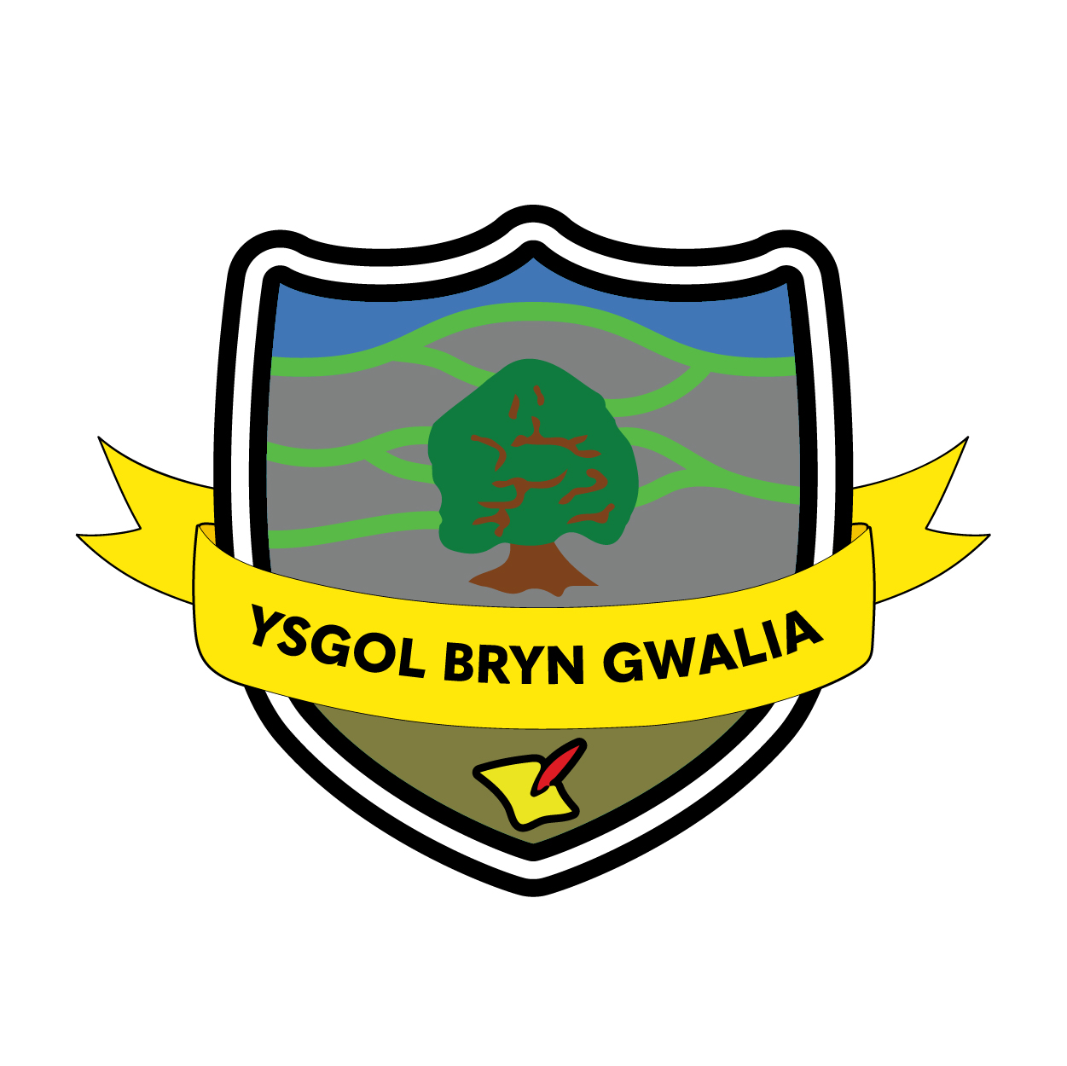

Charging Policy
Last Review Date | April 24
Date to be reviewed by Senior Management Team | April 26
Date Adopted by Governing Body | April 24
Head Teacher – Mrs Lorraine Dalton | 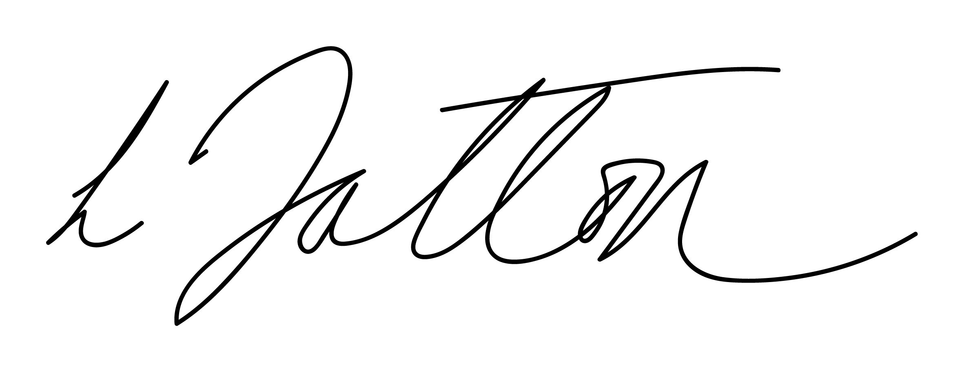
Chair of Governors – Mrs Janiene Davies | 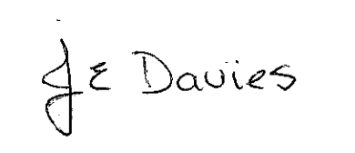



Introduction
The purpose of the policy is to clarify the charges that can and cannot be raised for activities at Ysgol Bryn Gwalia. The policy has been created according to Sections 449-462 of the Education Act 1996 which explain the law about the charges that can and cannot be made for activities in schools maintained by local authorities.

Circumstances where charges are not raised
Charges are not raised for the following:

Education in School
- Education provided wholly or mostly during school hours.
- Cases of receiving compulsory school aged children into the school.
- Activities that are part of the National Curriculum, or a part of a special examination syllabus, or part of religious education.
- Any materials, books and instruments or equipment provided.

Transport
- Transporting registered pupils to and from the school site, if the local authority has a statutory obligation to provide transport.
- Transporting registered pupils to another site where the governing body or the local authority have arranged for the pupils to be taught.
- Arranging transport that enables a pupil to meet examination requirements, when he has been prepared for that examination in the school.
- Arranging transport that enables a pupil to meet examination requirements, when he has been prepared for that examination in the school.

Residential visits
- Education provided during any visit that takes place during school hours.
- Education that is provided during any visit that takes place outside school hours, if it is part of the National Curriculum, or part of a syllabus for a specific public examination for which the pupil is being prepared in the school, or part of religious education.
- Supply teachers to work in place of those teachers absent from school because they are taking pupils on a residential visit.

Musical instrument training
- Children who are learning to play musical instruments as part of the National Curriculum, or part of a syllabus for a specific public examination for which the pupil is being prepared by the school, or part of religious education; or
- The cost involved in preparing a pupil for an examination.

Examination fees
- The registration fee for a specific public examination, if the pupil has been prepared for it in the school, or the registration fee for resitting an examination if the pupil is being prepared for the examination in question in the school.

Circumstances when the school may charge parents/carers
Additional Optional Activities A charge can be made for other activities called an optional activities. When an extra optional activity is provided, a charge can be made as follows for the provision of materials, books, instruments or equipment:-

Education
- Activities that take place wholly or mostly outside school time,
- If they are not part of the Curriculum, part of a syllabus for a specific public examination for which the pupil is being prepared in the school, or part of religious education.
- Materials used in practical subjects and project assignments , on condition that the parents have agreed beforehand that they or the pupil wish to keep the finished product, e.g. ingredients or materials.

Musical instrument training
Musical instrument training provided to individual pupils, or a group of a maximum of four pupils, if the teaching is not part of the National Curriculum or a public examination syllabus that the pupil is following.

Transport
Transport that is not needed to take the pupil to the school or other site where the governing body has arranged for education to be provided for the pupil.

Examination fees
The examination is on the prescribed list, but the pupil was not prepared for it at the school. The examination is not on the prescribed list, but the school arranges for the pupil to sit it. The pupil fails, without good reason, to meet the requirements of any public examination, when the governing body or the local authority have paid or agreed to pay the registration fee originally.

Food and accommodation
The cost of food and accommodation for residential trips, even when the trips take place mainly during school time. (Pupils whose parents receive certain benefits will be exempted from paying the cost of food and accommodation, see page 4).

Voluntary Contributions
Although schools cannot charge for activities that take place during school time, it is possible to ask for voluntary contributions from parents for activities that supplement the normal school curriculum. Requests to parents for voluntary contributions will state:-
- that there is no legal obligation to make a voluntary contribution;
- that pupils will not be left out because of their parents’ inability or unwillingness to pay;
- that children of parents who cannot contribute will not be treated differently in any way;
- that the activity will be cancelled if there are not enough voluntary contributions to make the activity possible, and if there is no way to make up the shortfall.
- Requests for voluntary contributions connected with individual pupils cannot include any element of subsidy for any other pupils who wish to take part in the activity, whose parents are unwilling or unable to pay the full charge.

Refraining from charging
- Parents/Carers who can prove that they receive the following benefits may be exempted from paying the full cost of food and accommodation on a residential trip. School will pay 25% of the full cost if in receipt of:-
  - a. Income Support.
  - b. Job seekers allowance based on income.
  - c. Any other benefit or allowance, or if they are entitled to any tax credits under the Tax Credits Act 2002 or an element of such a tax credit, as regulations note from time to time, for any period that is related fully or partly to the time spent on the trip. At present the following are noted:-
    - Support from Part 6 of the Immigration and Asylum Act 1999.
    - Child Tax Credits, on condition that the individuals in question also receive Working Tax Credits and that the family income (according to an assessment by Her Majesty’s Revenue and Customs) is not more than £16,040 (for 2009/10) (i.e. children who are entitled to have free school meals).
  - Guarantee element of the State Pension Credit.
  - Universal Credit.

The Governing Body may want to refrain from charging parents, wholly or partly, for the cost of other activities in specific circumstances. Additional Information School uniform, physical education kit, calculators, pens etc., aprons Parents can be invited to provide items of personal equipment for their child that is intended to be used by their child only.

Breaking and Damaging Property
If a pupil’s behaviour causes damage to school property or equipment, the parents/carers can be asked to pay for the necessary repair work or to pay for the purchase of new equipment. Every incident should be treated on its own merits and as the school sees fit.

Policy Review
This policy will be reviewed by the Senior Management Team and Governing Body and adopted by the Governing Body as per the schedule on the front page

