Ysgol Bryn Gwalia
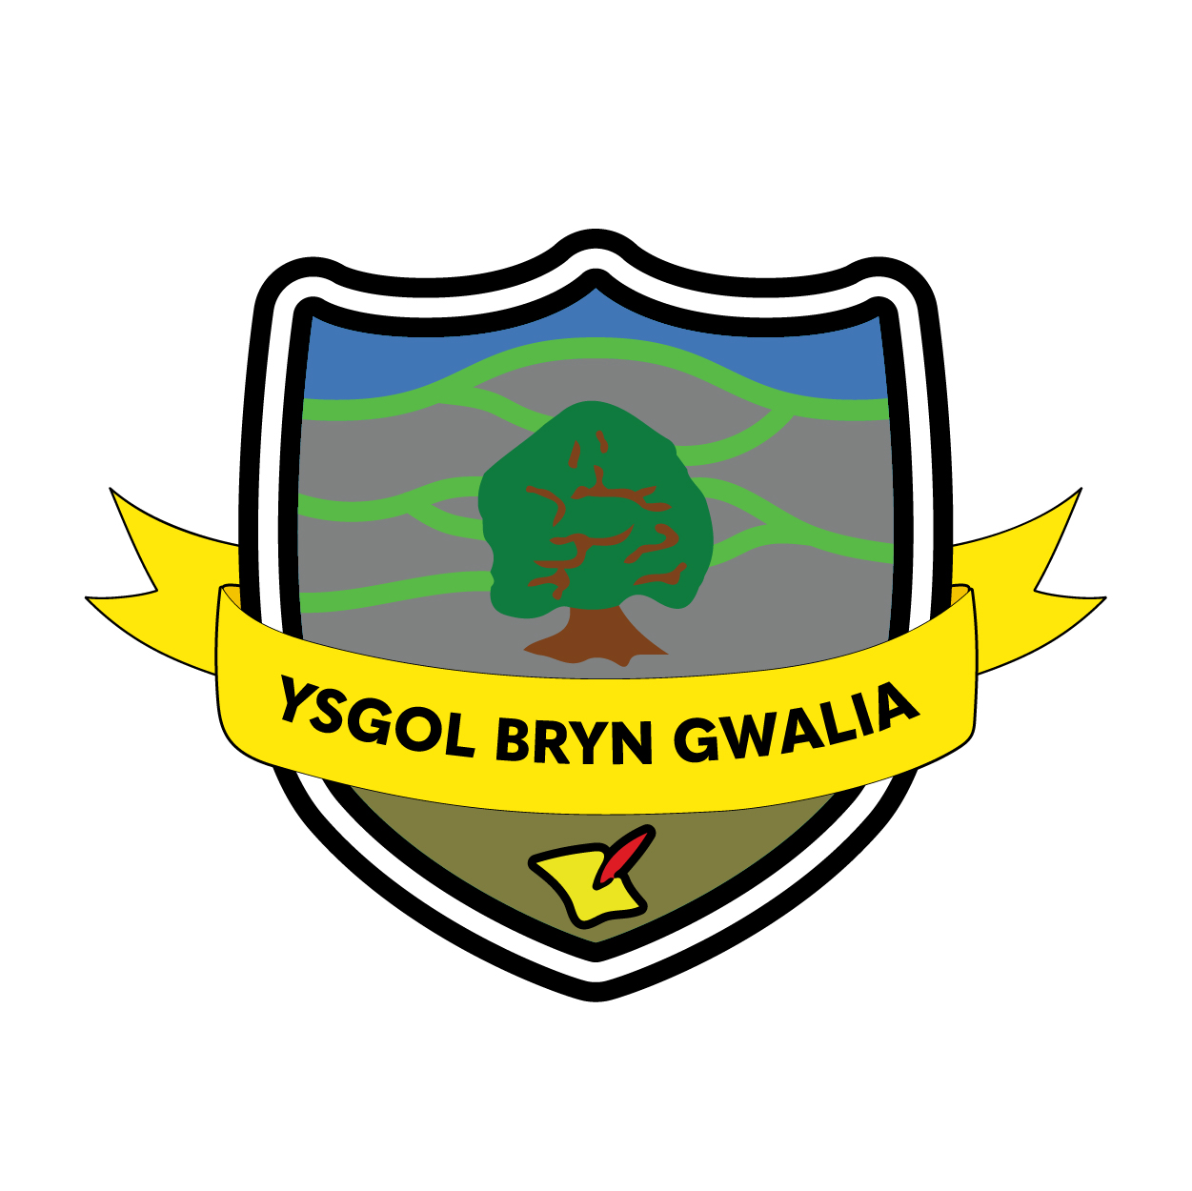

Curriculum Policy

Last Review Date | September 2025
Date to be reviewed by Senior Management Team | September 2026
Date Adopted by Governing Body | September 2023
Head Teacher – Mrs Lorraine Dalton | 
Chair of Governors – Mrs Janiene Davies | 


Contents

Curriculum definition
Vision
Curriculum aims
Curriculum structure and design:
- The four purposes
- Integral skills
- Inquiry Based Curriculum
- Areas of Learning and Experience (Areas)
- Statements of what matter
- Description of learning
- Progression
- The role of disciplines in our curriculum
- Mandatory curriculum elements
- Cross-cutting themes
- Learners’ choice
- A curriculum accessible to all
- Cynefin Learning and teaching Assessment
- The purpose and role of assessment within our curriculum
- The role of different participants in our assessment process Curriculum

Summary Curriculum review, evaluation and revision

Curriculum definition
Our school curriculum is defined as everything our learners experience in pursuit of the four purposes. It is not just what we teach but is also how we teach it and importantly, why we teach it.

Vision
Our school vision is
‘Growing Together, Aiming High’
Our Curriculum vision is
‘Our curriculum inspires our learning community to become creative lifelong learners, equipped with the skills to thrive in a challenging, technological and diverse world’

Curriculum aims
To make our vision a reality for our learners, our curriculum will:
• enable our learners to realise the four purposes and equip them for ongoing learning, work and life;
• build high expectations and enable all learners to achieve their full potential;
• offer a broad and balanced education, which enables our learners to make links between the different areas of learning and experience (Areas) and apply their learning to new situations and to more complex issues;
• support progression along a continuum of learning;
• support our learners’ health and well-being, including their mental health and well-being;
• support our learners’ development of knowledge that is the foundation of being an informed citizen;
• recognise our learners’ identity, language(s), ability and background and the different support they may need given their particular circumstances;
• reflect the diversity of perspectives, values and identities which shape our locality and Wales and develop understanding of the wider world;
• enable our learners to make sense of growing up in contemporary Wales and of issues which will be important in the future, including well-being, sustainable development and citizenship;
• support our learners to critically engage with a range of information and to assess its value and validity;
• enable our learners to develop an understanding of their rights and the rights of others.
• be built in co-construction with our stakeholders (learners, families, the wider community, our cluster colleagues

Curriculum structure and design
The four purposes
ambitious, capable learners who:
• set themselves high standards and seek and enjoy challenge
• are building up a body of knowledge and have the skills to connect and apply
that knowledge in different contexts
• are questioning and enjoy solving problems
• can communicate effectively in different forms and settings, using both Welsh
and English
• can explain the ideas and concepts they are learning about
• can use number effectively in different contexts
• understand how to interpret data and apply mathematical concepts
• use digital technologies creatively to communicate, find and analyse
information
• undertake research and evaluate critically what they find

..and are ready to learn throughout their lives

enterprising, creative contributors who:

• connect and apply their knowledge and skills to create ideas and products
• think creatively to reframe and solve problems
• identify and grasp opportunities
• take measured risks
• lead and play different roles in teams effectively and responsibly
• express ideas and emotions through different media
• give of their energy and skills so that other people will benefit

..and are ready to play a full part in life and work
ethical, informed citizens who:
• find, evaluate and use evidence in forming views
• engage with contemporary issues based upon their knowledge and values
• understand and exercise their human and democratic responsibilities and
rights
• understand and consider the impact of their actions when making choices and
acting
• are knowledgeable about their culture, community, society and the world, now
and in the past
• respect the needs and rights of others, as a member of a diverse society
• show their commitment to the sustainability of the planet

..and are ready to be citizens of Wales and the world

healthy, confident individuals who:
• have secure values and are establishing their spiritual and ethical beliefs
• are building their mental and emotional well-being by developing confidence,
resilience and empathy
• apply knowledge about the impact of diet and exercise on physical and mental
health in their daily lives
• know how to find the information and support to keep safe and well
• take part in physical activity
• take measured decisions about lifestyle and manage risk
• have the confidence to participate in performance
• form positive relationships based upon trust and mutual respect
• face and overcome challenge
• have the skills and knowledge to manage everyday life as independently as they can

..and are ready to lead fulfilling lives as valued members of society.
The four purposes are the starting point for all decisions around curriculum design. Our curriculum is planned in a way that supports our learners to make progress toward them.

Integral skills

The four purposes are also underpinned by integral skills which will be developed through a wide range of teaching and learning within our curriculum.

Creativity and innovation

Our curriculum will be designed in a way that develops our learners’ creativity and innovation by providing the space for and the opportunities that support them to:
• be curious and inquisitive, and to generate ideas;
• link and connect disparate experiences, knowledge and skills, and see,
explore and justify alternative solutions;
• be able to identify opportunities and communicate their strategies.
This will support our learners to create different types of value.
Critical thinking and problem-solving
Our curriculum will be designed in a way that develops our learners’ critical thinking
and problem solving by providing the space for and opportunities that support them
to:
ask meaningful questions, and to evaluate information, evidence and
situations;
• analyse and justify possible solutions, recognising potential issues and
problems;
• become objective in their decision-making, identifying and developing
arguments;
• be able to propose solutions which generate different types of value.
Personal effectiveness
Our curriculum will be designed in a way that develops our learners’ personal
effectiveness by providing the space for and opportunities that support them to:
• develop emotional intelligence and awareness helping them to become
confident and independent;
• lead debate and discussions, helping them to become aware of the social, cultural, ethical and legal implications of their arguments;
• evaluate their learning and mistakes, helping them to identify areas for
development;
• become responsible and reliable;
• be able to identify and recognise different types of value and then use that value.

Planning and organising

Our curriculum will be designed in a way that develops our learners’ planning and organising by providing the space for and opportunities that support them to:
• set goals, make decisions and monitor interim results (where developmentally appropriate);
• reflect and adapt, as well as manage time, people and resources.
• check for accuracy and be able create different types of value.
• develop an appreciation of sustainable development and the challenges facing humanity
• develop awareness of emerging technological advances
• confidently meet the demands of working in uncertain situations, as changing local, national and global contexts result in new challenges and opportunities for success
• generate creative ideas and to critically evaluate alternatives
• build their resilience and develop strategies which will help them manage their well-being – they should be encountering experiences where they can respond positively in the face of challenge, uncertainty or failure
• learn to work effectively with others, valuing the different contributions they and others make – they should also begin to recognise the limitations of their own work and those of others as they build an understanding of how different people play different roles within a team.

Inquiry-Based Learning (IBL)

Following our most recent inspection, and in response to the recommendation to refine provision to ensure consistent opportunities for pupils to apply their literacy, numeracy and digital skills in relevant, real-life situations, we made the strategic decision to adopt an inquiry-based curriculum at Ysgol Bryn Gwalia.

This shift ensures that learning is consistently purposeful, authentic, and embedded in real-world contexts. It enables pupils to apply key skills in literacy, numeracy, and digital competence across the curriculum in ways that are both meaningful and motivating.

What is Inquiry-Based Learning (IBL)?

Inquiry-Based Learning is a learner-centred approach that places curiosity at the heart of the learning process. It begins with a meaningful question or real-world problem, which learners explore through active investigation and reflection. Throughout the inquiry, pupils build essential skills, knowledge, and language, while taking ownership of both their learning and its direction.

For younger learners, this approach complements their natural curiosity and supports deep engagement through hands-on, creative experiences.

Why Do We Use Inquiry-Based Learning at Ysgol Bryn Gwalia?

We understand that no single method suits every learner. The flexibility of IBL allows learning to be tailored to each child’s interests, strengths, and preferred learning styles, supporting greater engagement and deeper learning.

By offering multiple pathways into learning, IBL ensures that every learner can participate, contribute, and thrive — helping us meet our commitment to equity, inclusion, and excellence for all.

This inquiry-based approach ensures that learning is purposeful, empowering, and driven by the interests and needs of our pupils — giving every learner the tools they need to grow, question, and succeed.

Planning for Purposeful Inquiry

To ensure we are actively addressing the Estyn recommendation—to provide consistent opportunities for pupils to apply their literacy, numeracy, and digital skills in relevant, real-life situations—teachers at Ysgol Bryn Gwalia now plan their inquiry-based learning using a set of reflective questions. These questions help ensure that all learning is purposeful, authentic, and rooted in the real world, making it meaningful for every learner:

In 2025, we redesigned our two-year topic cycle to ensure that our curriculum is relevant, meaningful, and well-suited to an inquiry-based approach. Each overarching topic is intentionally broad and open-ended, allowing it to be adapted across all year groups—from Nursery to Year 6. This flexibility enables teachers to pose big questions that are developmentally appropriate for their learners, while still connecting to a shared theme across the school. This structure ensures both coherence and progression, allowing all pupils to engage deeply with their learning through exploration, curiosity, and cross-curricular inquiry.

Our Topic Cycle:
- Identity and Belonging – Who am I? Where do I belong? How does identity and community shape us?
- Sustainability and the World Around Us – How do we live responsibly in a changing world? What is our impact on the planet?
- Change and Process – How do people, ideas and technologies evolve? What drives change?
- Communication and Expression – How do we connect, express ourselves and influence others?
- Choices and Values – What guides our decision? How do we live with others?
- Innovation and Enterprise – How do we solve problems and create solutions?

Areas of Learning and Experience (Areas)

Our school curriculum is designed in a way that ensures learning and teaching that encompasses all six Areas of Learning and Experiences (Areas)

Expressive arts -https://hwb.gov.wales/curriculum-for-wales/expressive-arts/#
Health and Wellbeing - https://hwb.gov.wales/curriculum-for-wales/health-and-well-being/
Humanities - https://hwb.gov.wales/curriculum-for-wales/humanities/
Languages, Literacy and Communication - https://hwb.gov.wales/curriculum-for-wales/languages-literacy-and-communication/
Mathematics and Numeracy - https://hwb.gov.wales/curriculum-for-wales/mathematics-and-numeracy/
Science and Technology - https://hwb.gov.wales/curriculum-for-wales/science-and-technology/

Our school curriculum provides opportunities for our learners to engage with and develop their understanding of the key concepts within all the statements of what matter.

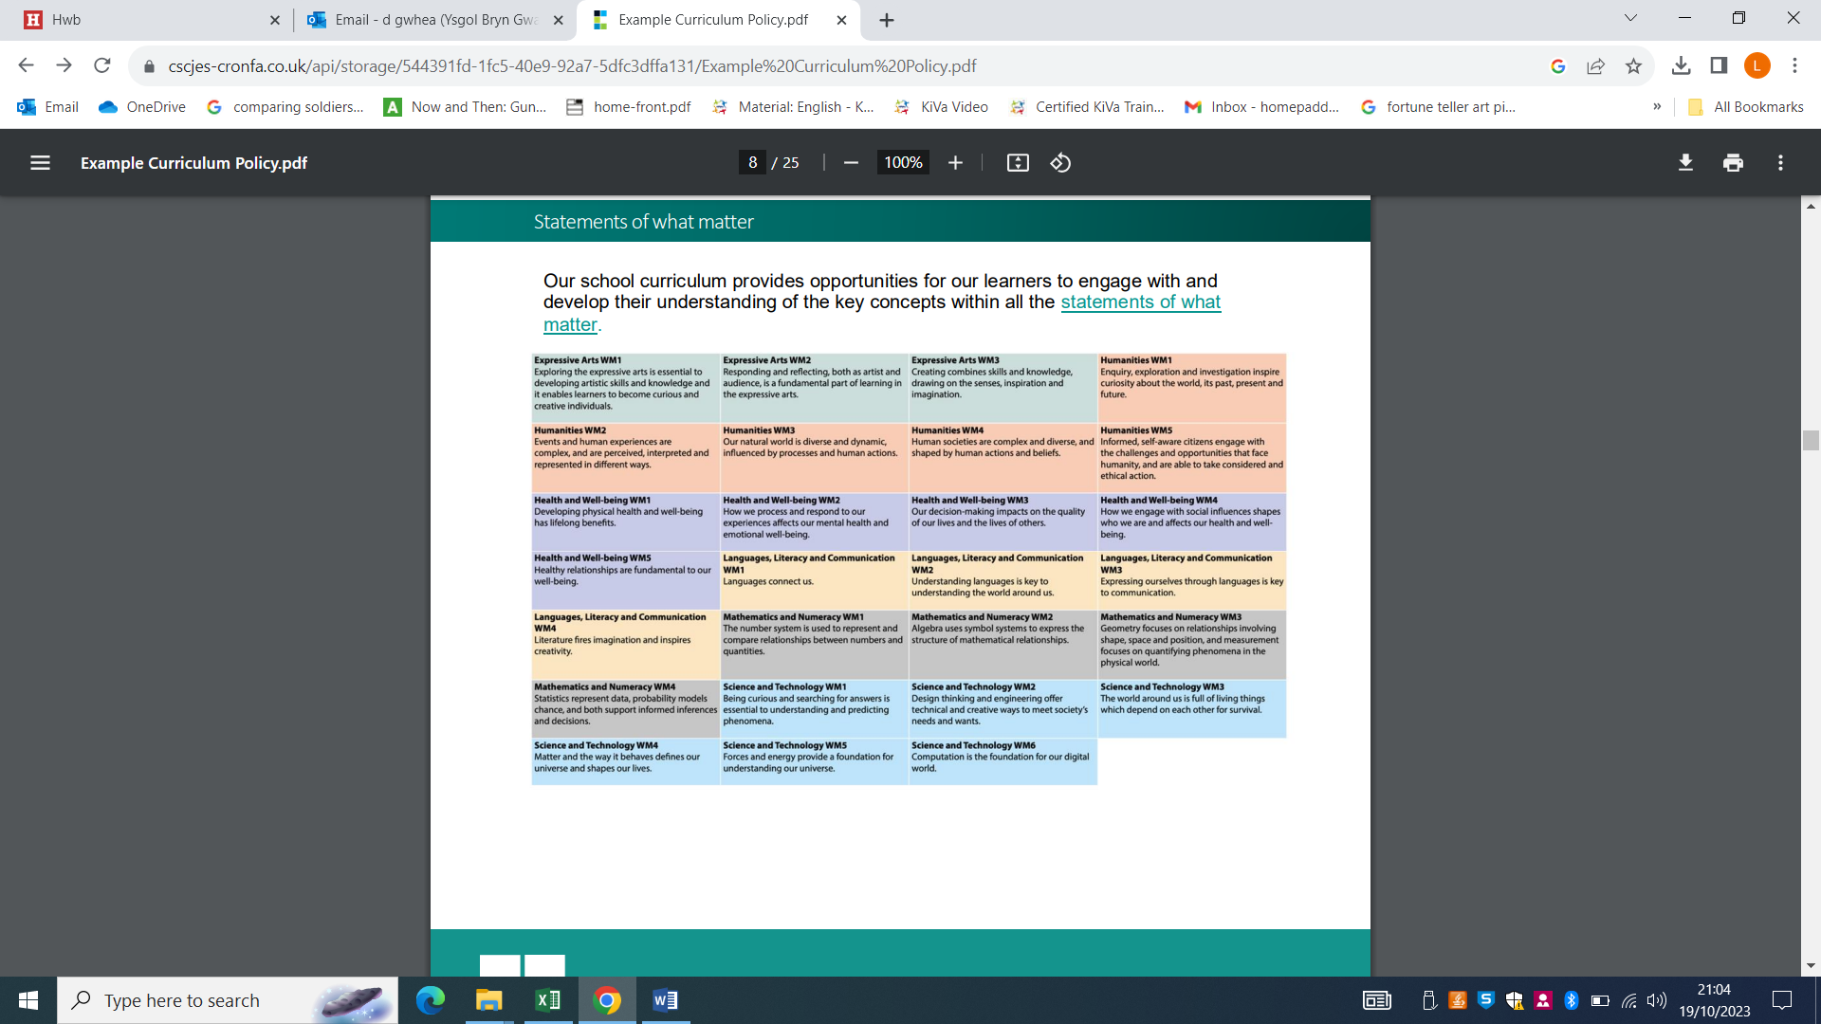

Our curriculum uses the statements of what matter to guide the selection of all curriculum content. Specifically, they are used to:
• select the range of experiences, knowledge and skills that enable our learners
to make sense of the ‘big ideas’ and key principles within each statement
• support our learners’ progression within the ‘big ideas’ and key principles and
their ability to be able to develop an increasingly sophisticated understanding
and application of the statements of what matter
• allow learners to explore topics and ideas through different lenses – the same
concept or idea will be explored through different statements of what matter
• help our learners to make sense of a range of experiences, knowledge and
skills within each Area by ensuring that content helps learners to develop a
coherent understanding of a range of information.

Descriptions of learning

At our school, we use the descriptions of learning as a planning tool to inform the wide range of knowledge, skills and experiences within our curriculum. Our curriculum also uses the descriptions of learning to inform planning for a range of contexts for learning across a progression step to create depth and breadth across our curriculum.
Our curriculum does not use the descriptions of learning to create stand-alone tasks, activities, assessment tasks or interim reports to make judgements about our learners’ outcomes at a particular point on the continuum.

Progression

Progression in learning is a process of increasing depth, sophistication, engagement and learner control, rather than of covering a body of content. Progression is not linear and different learners are likely to progress in markedly different ways. Progression is at the heart of our curriculum design. When selecting the content of our curriculum and assessment, we use the principles of progression for each Area to inform our approach to progression.

Link to supporting guidance: https://hwb.gov.wales/api/storage/fa86cf54-b75f-4807-b32a-d305218205cd/Shared%20understanding%20of%20progression.pdf?preview=true

The role of disciplines in our curriculum

As our learners progress through our curriculum, they will have greater opportunities to engage with the different disciplines within each Area and to specialise in them as they reach the later progression steps. Discipline-specific learning and teaching in our curriculum will ensure that appropriate and meaningful links to learning are made across our whole curriculum where appropriate.

Mandatory curriculum elements

Relationships and sexuality education Relationships and sexuality education (RSE) within our curriculum is planned using the RSE Code and is designed in a way that is developmentally appropriate, inclusive and pluralistic. An overview of our RSE policy can be found on our website. An overview of our RSE scheme of learning/provision map can be accessed through school.

Religion, Values and Ethics (RVE)

Religion, Values and Ethics (RVE) is mandatory for all learners aged 3 – 16 and sits within the Humanities Area of Learning and Experience. Teaching and learning in RVE reflects that the religious traditions in Wales are in the main Christian while taking account of the teaching and practices of the other principal religions represented in Wales. It also reflects the fact that a range of non-religious philosophical convictions are held in Wales. RVE is planned to meet the mandatory requirements of the Humanities AoLE, and to have regard to both the statutory RVE guidance within the Humanities Area, and the Flintshire Locally Agreed Syllabus. There is no right to withdraw from RVE

Cross-curricular skills

We believe that the mandatory cross-curricular skills of literacy, numeracy and digital competence are essential for learners to be able to access knowledge. They enable learners to access the breadth of our curriculum, equipping them with the lifelong skills to realise the four purposes. These are skills that can be transferred to the
world of work, enabling our learners to adapt and thrive in the modern world. Our curriculum is designed in a way that enables learners to develop competence and capability in the cross-curricular skills and extend and apply them across all Areas.

Across our curriculum, learners will be given a range of opportunities to:
• develop listening, reading, speaking and writing skills
• be able to use numbers and solve problems in real-life situations
• be confident users of a range of technologies to help them function and
communicate effectively and make sense of the world
We will use the Literacy, Numeracy and Digital Competency Frameworks to guide our approach to the development of the cross-curricular skills.

Cross-cutting themes

Relationships and sexuality education (RSE) Our curriculum is designed in a way that identifies and makes authentic and meaningful links between learning within a particular Area and learning within the RSE Code.

Links to supporting CSC resources for RSE can be found in the appendix below (Appendix 2)

Human Rights

We believe that learning about human rights empowers learners as rights-holders. This enables our learners to critically examine their own attitudes and behaviours and to develop skills to be ethically-informed citizens of Wales and the world, who can be advocates for their rights and the rights of others.

Our curriculum incorporates opportunities for our learners to:
• learn about human rights by developing their understanding of what human rights are and where those rights have come from including. This includes developing their understanding of the UNCRC and UNCRPD.
• learn through human rights which supports our learners to develop values, attitudes and behaviours that reflect human rights.
• learn for human rights, which motivates them to social action, empowerment of active citizenship and to advance respect for the rights for all.

Diversity

We want our curriculum to recognise and celebrate the diversity that exists within the social groups within our school community, the communities we serve and society as a whole. We want our learners to be aware of the characteristics of others and treat others with compassion, empathy, understanding and equity, regardless of those
characteristics. As our learners progress in our curriculum, they will become increasingly aware of a range of specific characteristics which can define our identity, including sex, gender, race, religion, age, disability and sexuality.

Our curriculum incorporates opportunities for our learners to:

• develop empathy and compassion for others
• celebrate diverse backgrounds, values and characteristics
• develop their own values and sense of identity
• develop understanding of people with different beliefs and perspectives
• challenge stereotypes

Links to supporting CSC resources for diversity can be found in the appendix below (Appendix 3)

Careers and work-related experiences (CWRE)

We believe that learning about CWRE is fundamental to developing skills for work and life.

Our curriculum incorporates opportunities for CWRE that inspires our learners to:

• develop an understanding of the purpose of work in life, both for themselves and for society as a whole
• become increasingly aware of the range of opportunities available to them, broadening their horizons
• develop the attitudes and behaviours required to overcome barriers to
employability, career management and lifelong learning
• appreciate the increasing range of opportunities in the workplace where an ability to communicate in Welsh is important
• explore opportunities through a variety of meaningful experiences in learning, work and entrepreneurship
• develop resilience and the ability to be adaptable in response to the
challenges, choices and responsibilities of work and life

Links to supporting CSC resources for CWRE can be found in the appendix below (Appendix 4)

Local, national and international contexts

Local, national and international contexts provide key perspectives for our learners and are important in supporting them to realise the four purposes.

Our curriculum incorporates opportunities for learners to:

• develop learning through a range of places and events of significance
• make links with the local community and organisations
• learn about the contributions and experiences of different individuals that shape each context
• learn about cultural diversity, values, histories and traditions that shape each context
• understand different identities, histories, cultures, perspectives and values that shape communities and societies
• recognise and engage with factors, influences and impacts (including
economic, social and environmental impacts) locally, nationally and
internationally
• develop an authentic sense of cynefin, building knowledge of different cultures and histories, allowing them to develop a strong sense of individual identity and understanding how this is connected to and shaped by wider influences
• draw on the stories and distinctiveness of our school’s local surroundings
• understand their role as citizens and the structures of government which affect them in each context
• explore, critically analyse and respond to contemporary issues and challenges affecting their lives and the lives of others through each context
• understand sustainable development, the challenges the environment and society face and how they can engage with and make a difference on these issues supporting sustainable citizenship
• understand contemporary Wales, providing opportunities to reflect,
understand and analyse contemporary society and their engagement with it
• recognise Wales’ diverse linguistic heritage and culture, and its connections with the rest of the world
• recognise how our languages unlock knowledge about our literature,
geography, history and their links beyond Wales
• recognise the links between local, national and international contexts,
understanding how they constantly influence each other
• use critical analysis in each context, recognising both positive and challenging aspects within each

Cynefin

Our curriculum will instil our learners with a pride and passion in themselves, our school community, the wider community and Wales. Our curriculum will allow our learners to explore and understand the different identities, landscapes and histories that all come together locally and nationally to form their cynefin. This will allow learners to develop their own sense of identity and to understand the identities of others and make connections with people, histories and landscapes elsewhere in Wales and internationally.

Learning and teaching

Information can be found in our Teaching and Learning Policy.

Assessment

The purpose and role of assessment within our curriculum

Assessment is an integral part of teaching and learning and plays a fundamental role in enabling our learners to make progress. For assessment to be effective, we recognise that partnerships between our practitioners, our learners and parents and carers are important. Progression in learning is a process of increasing depth, sophistication, engagement and learner control, rather than of covering a body of content. Progression is not linear and different learners are likely to progress in markedly different ways. Assessment planning and practice, built into the curriculum and classroom practice, should recognise this and allow for a variety of diversions, stops and variations in pace in a learner’s journey. We will assess all learners across the 3 to 16 continuum based on the progression articulated in our curriculum, against planned learning intentions.

The role of different participants in our assessment process

Leaders

Leaders at our school will establish a strong learning culture that supports and challenges our practitioners to enable them to make appropriate progress. This is achieved by:
creating a clear vision for curriculum that supports our learners’ realisation of the four purposes and supports individual learner progression;
• creating an environment that develops the necessary knowledge and skills to promote learner wellbeing;
• creating an environment based on mutual trust and respect, rather than one focused on compliance and reporting;
• enabling our practitioners to develop the knowledge and skills necessary to carry out their role in assessment effectively;
• ensuring the design, adoption, review and revision of our curriculum that affords opportunities for our practitioners to plan purposeful learning that addresses the needs of each of our learners;
• developing and embedding processes and structures that enable our
practitioners to develop a shared understanding of progression;
• ensuring there is a clear picture of learner progression within our school that is understood by all our practitioners, a process that embeds regular ongoing professional dialogue on progression into our systems to support selfreflection and inform improvement;
• ensuring there is a clear understanding of learner progression across our cluster of schools that feeds into discussions on learner progression within each school or setting
• considering how additional challenge and support for our learners can be best provided, including working with other partners
• encouraging engagement between all participants in the learning and
teaching process in order to develop effective partnerships
• ensuring that the statutory requirements have been met and that due regard has been paid to this guidance for assessment, and that practitioners are taking account of this in planning, learning and teaching and within daily practice.

Practitioners

Practitioners at our school will plan for and provide effective learning experiences that are appropriate to the age and development of our learners. They support and challenge learners effectively to ensure individuals make progress from their own starting points. This is achieved by:
• being clear about the intended learning, and planning engaging learning
experiences accordingly;
• supporting the promotion of learner well-being through assessment practice;
• sharing intended learning appropriately with learners;
• evaluating learning, including through observation, questioning and
discussion; using the information gained from ongoing assessment to reflect on their own practice to inform next steps in teaching and planning for learning;
• providing relevant and focused feedback that actively engages learners, encourages them to take responsibility for their learning, and moves their learning forward;
• encouraging learners to reflect on their progress and, where appropriate, to consider how they have developed, what learning processes they have undertaken and what they have achieved;
• providing opportunities for learners to engage in assessing their own work and that of their peers, and supporting them to develop the relevant skills to do this effectively;
• developing learners’ skills in making effective use of a range of feedback to move their learning forward;
• involving parents and carers in learner development and progression, with the learner’s involvement in this dialogue increasing over time;
• engaging in dialogue with leaders and fellow practitioners to ensure we have a clear picture of the progress being made within our school;
• identifying any additional challenge or support learners may require, engaging with external partners where necessary.

Learners

Our learners will participate in and contribute to the learning process in a way that is appropriate to their age and stage of development. This will help them develop knowledge, skills and understanding, and to apply them in different contexts. As they make progress with increasing independence, our learners will be supported and encouraged to:
• understand where they are in their learning and where they need to go next;
• develop an understanding of how they will get there;
• respond actively to feedback on their learning, and develop positive attitudes towards receiving, responding to and acting upon feedback in their learning;
• review their progression in learning and articulate this both individually and with others;
• reflect on their learning journey and develop responsibility for their own
learning over time

Parents and carers

Parents and carers have an important role to play in assessment and we will engage with them so that they can support their child’s progress in an appropriate way.

We will encourage and enable parents and carers to:
engage regularly with our school and our practitioners in order to understand and support their child’s progression in learning;
• share relevant knowledge and understanding with us which will support their child’s learning and progression;
• respond actively to information provided about their child’s learning and, in collaboration with us, plan ways of supporting that learning within and outside of school.

External partners

We will engage external partners to:
• help our practitioners assess and identify the needs of learners who may require additional support and then help them through the provision of advice and support. This includes specialist educational support and support from other agencies such as health
• provide information about learning progression that has taken place for our learners who may spend some of their time in other contexts.

Supporting each of our learners on an ongoing, day-to-day basis

To support our learners on an individual and ongoing, day-to-day basis, assessment is embedded into everyday classroom practice in a way that supports and is indistinguishable from learning.
Our assessment practices will identify each individual learner’s strengths, achievements, areas for improvement and, where relevant, barriers to learning. This understanding will be used by our practitioners, in discussion with our learners, to ascertain the next steps required to move their learning forward, including any additional challenge and support required.

Identifying, capturing and reflecting on each learner’s progress over time

Our practitioners will identify the progress being made by our learners, and record this, where appropriate, to understand each learner’s journey over different periods of time and in a variety of ways. This includes developing an understanding of how a learner has learned, as well as what they have learned and are able to demonstrate.
Reflecting on a learner’s progress over time will enable our practitioners to provide feedback and plan their future learning, including any interventions, additional support or challenge that may be required. This feedback will include both immediate next steps and longer-term objectives and goals that the learner should work towards to help keep them moving forward in their learning. This information will also
be used as a basis for communicating and engaging with our parents and carers.

Approaches that support us in identifying, capturing and reflecting on each of our learner’s progress over time

At Ysgol Bryn Gwalia our marking and feedback policy is to feedback as soon as possible to pupils, with verbal feedback being the most effective. Pupils are given time to re draft and edit their work.
Pupil progress meetings take place termly and interventions are put in place to any learner who may need support or challenge.

https://hwb.gov.wales/curriculum-for-wales/assessment-arrangements/supporting-learner-progression-assessment-guidance/

Understanding group progress in order to reflect on our practice

Assessment enables our practitioners and leaders to understand to what extent and in what ways different groups of learners are making appropriate progress. This understanding contributes to our processes of self-evaluation and continuous improvement.

Communicating with parents and carers
When communicating and engaging with parents and carers, we share information about:
• the progress their child is making
• their future progression needs
• how future progression needs can be supported at home
• their general well-being in school
We share learner information with parents and carers termly.

We provide a summary of individual learner information annually.

Our learners are provided with opportunities to contribute to the communication process with their parents and carers.

Transition

In accordance with the 2022 Transition Regulations our transition plan covers the following matters:
• proposals for managing and co-ordinating the transition of learners from feeder primary schools to the secondary school
• proposals for how continuity of learning will be achieved through curriculum design and planning for learning and teaching for learners in Year 6 transitioning to Year 7
• proposals for how each individual learner’s progression will be supported as they transition from primary school to secondary school
• proposals for how the learning needs and the well-being of each individual learner will be supported as they transition from primary school to secondary school
• proposals for reviewing and monitoring the impact of the transition plan in respect of how it has helped:
- achieve continuity of learning
- support individual learner progression
A copy of our cluster’s transition plan can be found on our website

Curriculum Summary

In line with the mandatory requirement for schools to publish a summary of their curriculum, a copy of our curriculum summary can be found here.

https://www.bryngwalia.org/curriculum-rationale/

Curriculum review, evaluation and revision

The review process It is the responsibility of the governing body and headteacher to keep the curriculum and assessment arrangements under review, revising them if they no longer comply with our curriculum policy.

Appendix
- RVE supporting materials and guidance on CSC Knowledge Bank https://www.cscjes-cronfa.co.uk/search?query=RVE&sort=relevance&strict=0
- RSE guidance and supporting materials on CSC Knowledge Bank https://www.cscjes-cronfa.co.uk/search?query=RSE&sort=relevance&strict=0
- 3. Diversity supporting materials on CSC Knowledge Bank https://www.cscjes-cronfa.co.uk/search?query=Diversity&sort=relevance&strict=0
- 4. CWRE supporting materials on CSC Knowledge Bank https://www.cscjes-cronfa.co.uk/search?query=CWRE&sort=relevance&strict=0
- 5. Assessment and progression supporting materials on CSC Knowledge
Bank https://www.cscjes-cronfa.co.uk/search?query=assessment%20and%20progression&sort=relevance&strict=0
- 6. Curriculum summary guidance on CSC Knowledge Bank https://www.cscjes-cronfa.co.uk/search?query=curriculum%20summary&sort=relevance&strict=0

