Ysgol Bryn Gwalia
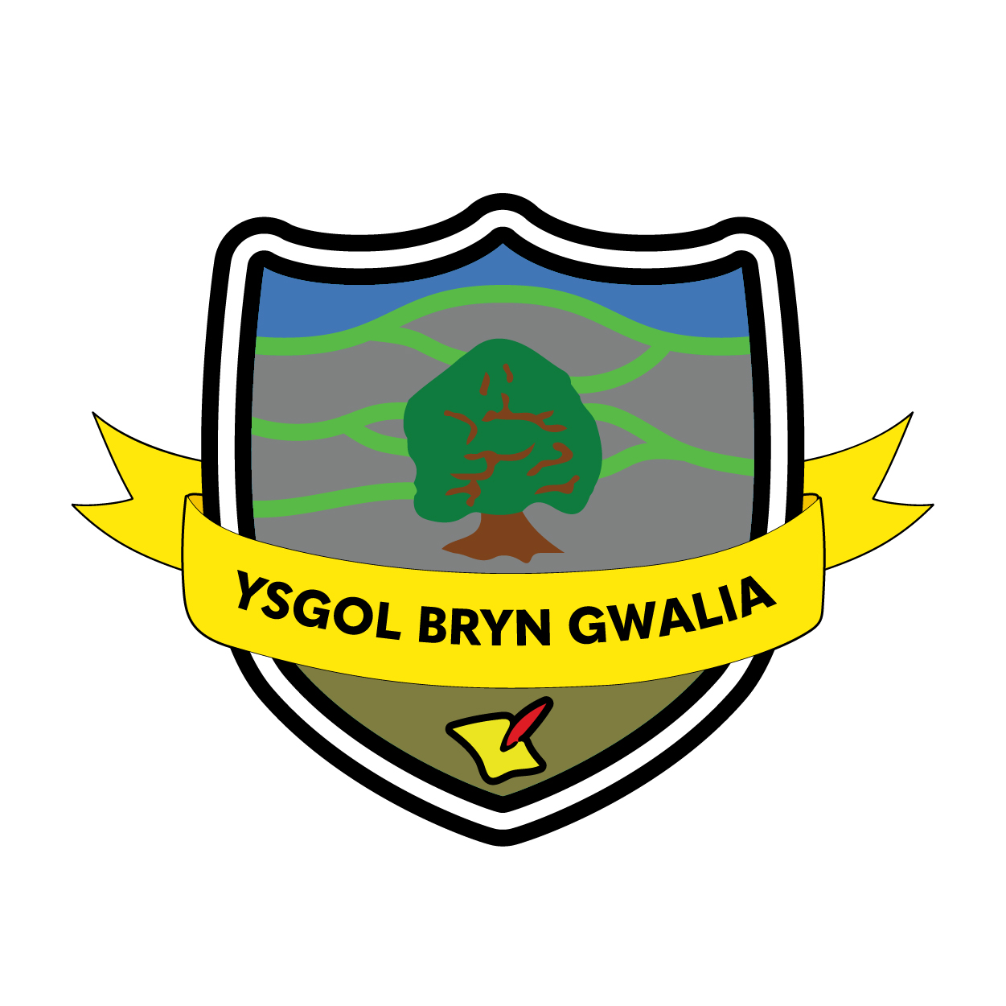

Freedom of Information Policy


Last Review Date | February 2025
Date to be reviewed by Senior Management Team | April 2028
Date Adopted by Governing Body | April 2025
Head Teacher – Mrs Lorraine Dalton | 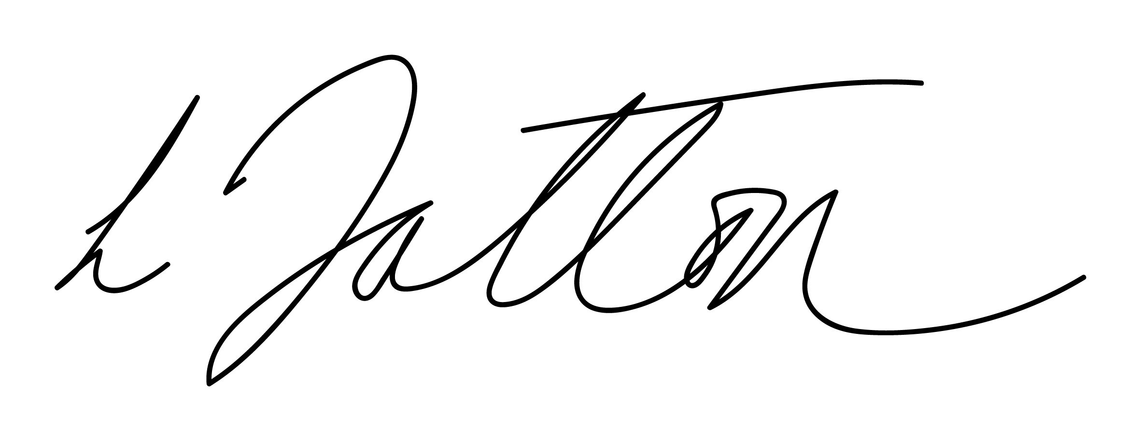
Chair of Governors – Mrs Janiene Davies | 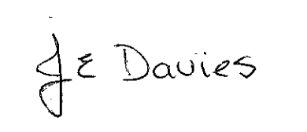

Introduction
The Freedom of Information Act 2000 (FOIA) was introduced to promote greater openness and accountability across the public sector and requires all maintained schools and Academies to be clear and proactive about the information they will make public.

As a result, Ysgol Bryn Gwalia have produced a publication scheme, setting out:
- The classes of information which we publish or intend to publish;
- The manner in which the information will be published; and
- Whether the information is available free of charge or on payment.

The scheme covers information already published and information which is to be published in the future. All information in our publication scheme is available in paper form, some is available electronically on our website for you to download and print.
Some information which we hold may not be made public, for example, personal information.

This publication scheme conforms to the model scheme for schools approved by the Information Commissioner‘s Office (ICO).

The Aims of the Policy
The school aims to:
- Enable every child to fulfil their learning potential, with education that meets the needs of each child.
- Help every child develop the skills, knowledge and personal qualities needed for life and work.

This publication scheme is a means of showing how we are pursuing these aims.

Publication Scheme - Categories of Information Published
The publication scheme guides you to information which we currently publish (or have recently published) or which we will publish in the future. This is split into categories of information known as ‘classes’. Statutory, and additional contents the school have chosen to add, can be seen in our Publication Scheme in Appendix 1.

The classes of information that we undertake to make available are organised into the following area:
- School Prospectus – information published in the school prospectus
- Governors' Documents - information published in governing body documents.
- Pupils & Curriculum – information about policies that relate to pupils and the school curriculum.
- School Policies and other information related to the school - information about policies that relate to the school in general.

How to Request Information

If you require a paper version of any of the documents within the scheme, the request must be made in writing by email, fax or letter giving clear details of the information requested.

Written notice of any fee will be provided to the enquirer before any information is supplied. Contact details are set out below:
Address: Ysgol Bryn Gwalia, Clayton Road, Mold. CH7 1SU.

Telephone: 01352 752659
Web: www.bryngwalia.org

To help us process your request quickly, please clearly mark any correspondence “PUBLICATION SCHEME REQUEST”.

If the information you are looking for is not evident via the scheme or on our website, then a Freedom of Information (FOI) request is needed. This must be in writing and must contain the requestor’s name and contact details; either postal address or email address for the response to be sent.

All FOI requests must be responded to by us within 20 working days from receipt (excluding school holidays).

Withholding Information

The FOI Act contains 23 exemptions whereby information can be withheld. There are two categories: absolute and non-absolute. We will only withhold information if it falls within the scope of one or more of these exemptions. Complete files or documents will not be withheld just because part of the information is covered by an exemption.

An exemption will only be applied where we have reason to believe that prejudice might occur to the interest protected by the exemption. In addition, wherever a “public interest” exemption is being considered, we will only withhold that information which it can demonstrate that the public interest will be best served by withholding. When considering withholding information under a non-absolute exemption we will take into account whether the release of the information would:
- promote further understanding of current issues of public debate;
- promote the accountability of decisions taken by us and the spending and allocation of public money;
- bring to light matters of public safety;
- allows the public to understand and challenge decisions made by us;
- be otherwise in the public interest.

Where information is withheld under an exemption in most cases the reason behind the decision will be made clear to the applicant, citing the exemption under which the information is being withheld.

Paying for Information
Information published on our website is free, although you may incur costs from your internet service provider. If you do not have internet access, you can access our website using either a local library or an internet café.

Single copies of information covered by this publication are provided free unless stated otherwise.

If the Publication Scheme request or FOI request means that we have to do a lot of photocopying or printing, or pay a large postage charge, or is for a priced item such as some printed publications or videos, we will let you know the cost before fulfilling your request. Payment may be requested prior to provision of the information.

Feedback and Complaints
We welcome any comments or suggestions you may have about the scheme. If you want to make any comments about this publication scheme or if you require further assistance or wish to make a complaint regarding information you have received or been refused then initially this should be addressed to the Headteacher, Ysgol Bryn Gwalia, Clayton Road. Mold. CH7 1SU.

If you are not satisfied with the assistance that you get or if we have not been able to resolve your complaint and you feel that a formal complaint needs to be made then this should be addressed to the Information Commissioner’s Office. This is the organisation that ensures compliance with the Freedom of Information Act 2000 and that deals with formal complaints. They can be contacted at:

The Case Reception Unit
Customer Service Team
Information Commissioner’s Office
Wycliffe House
Water Lane
Wilmslow
Cheshire
SK9 5AF
Enquiry/Information Line: 01625 545 700
E Mail: publications@ic-foi.demon.co.uk
Website: www.informationcommissioner.gov.uk

Policy Review
This policy will be reviewed by the Senior Management Team and Governing Body and adopted by the Governing Body as per the schedule on the front page.

