Ysgol Bryn Gwalia
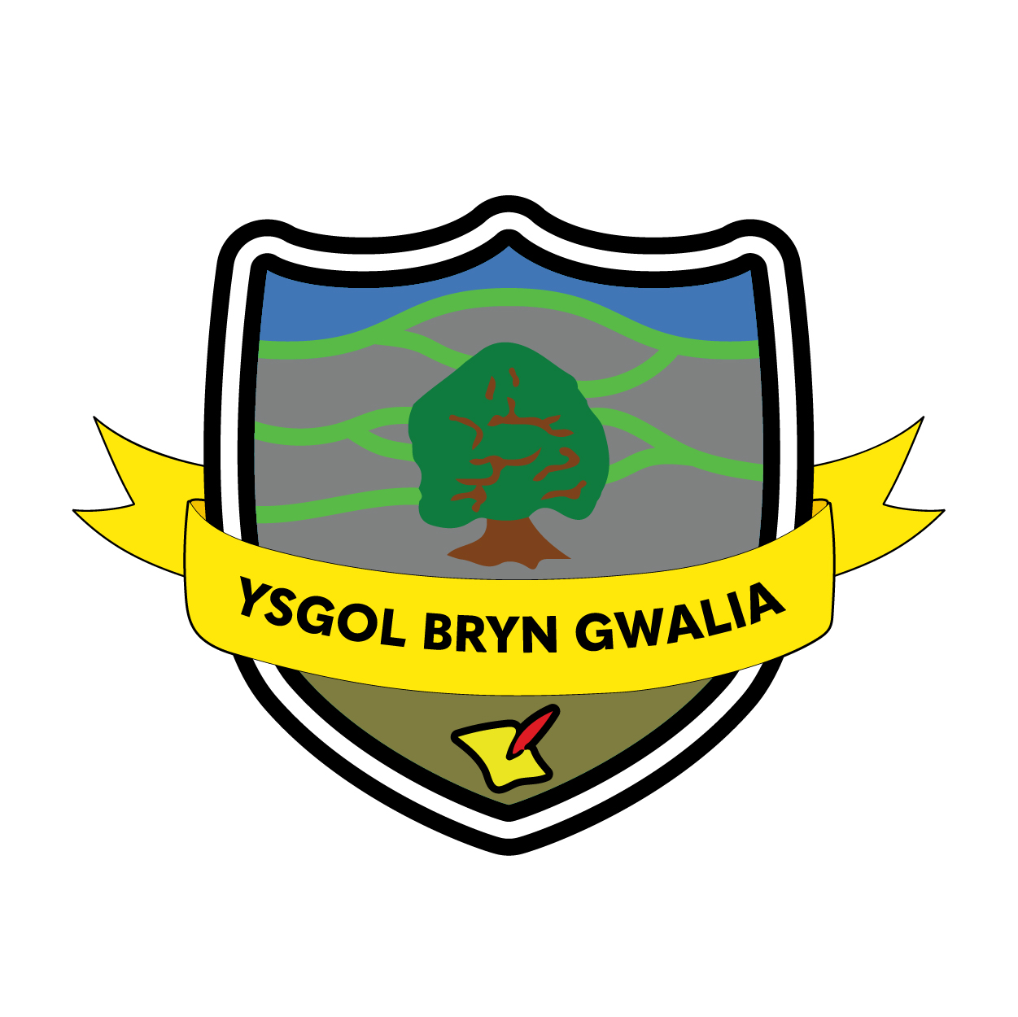

Governor Development Policy

Last Review Date | January 2025
Date to be reviewed by Senior Management Team | April 2028
Date Adopted by Governing Body | April 2025
Head Teacher – Mrs Lorraine Dalton | 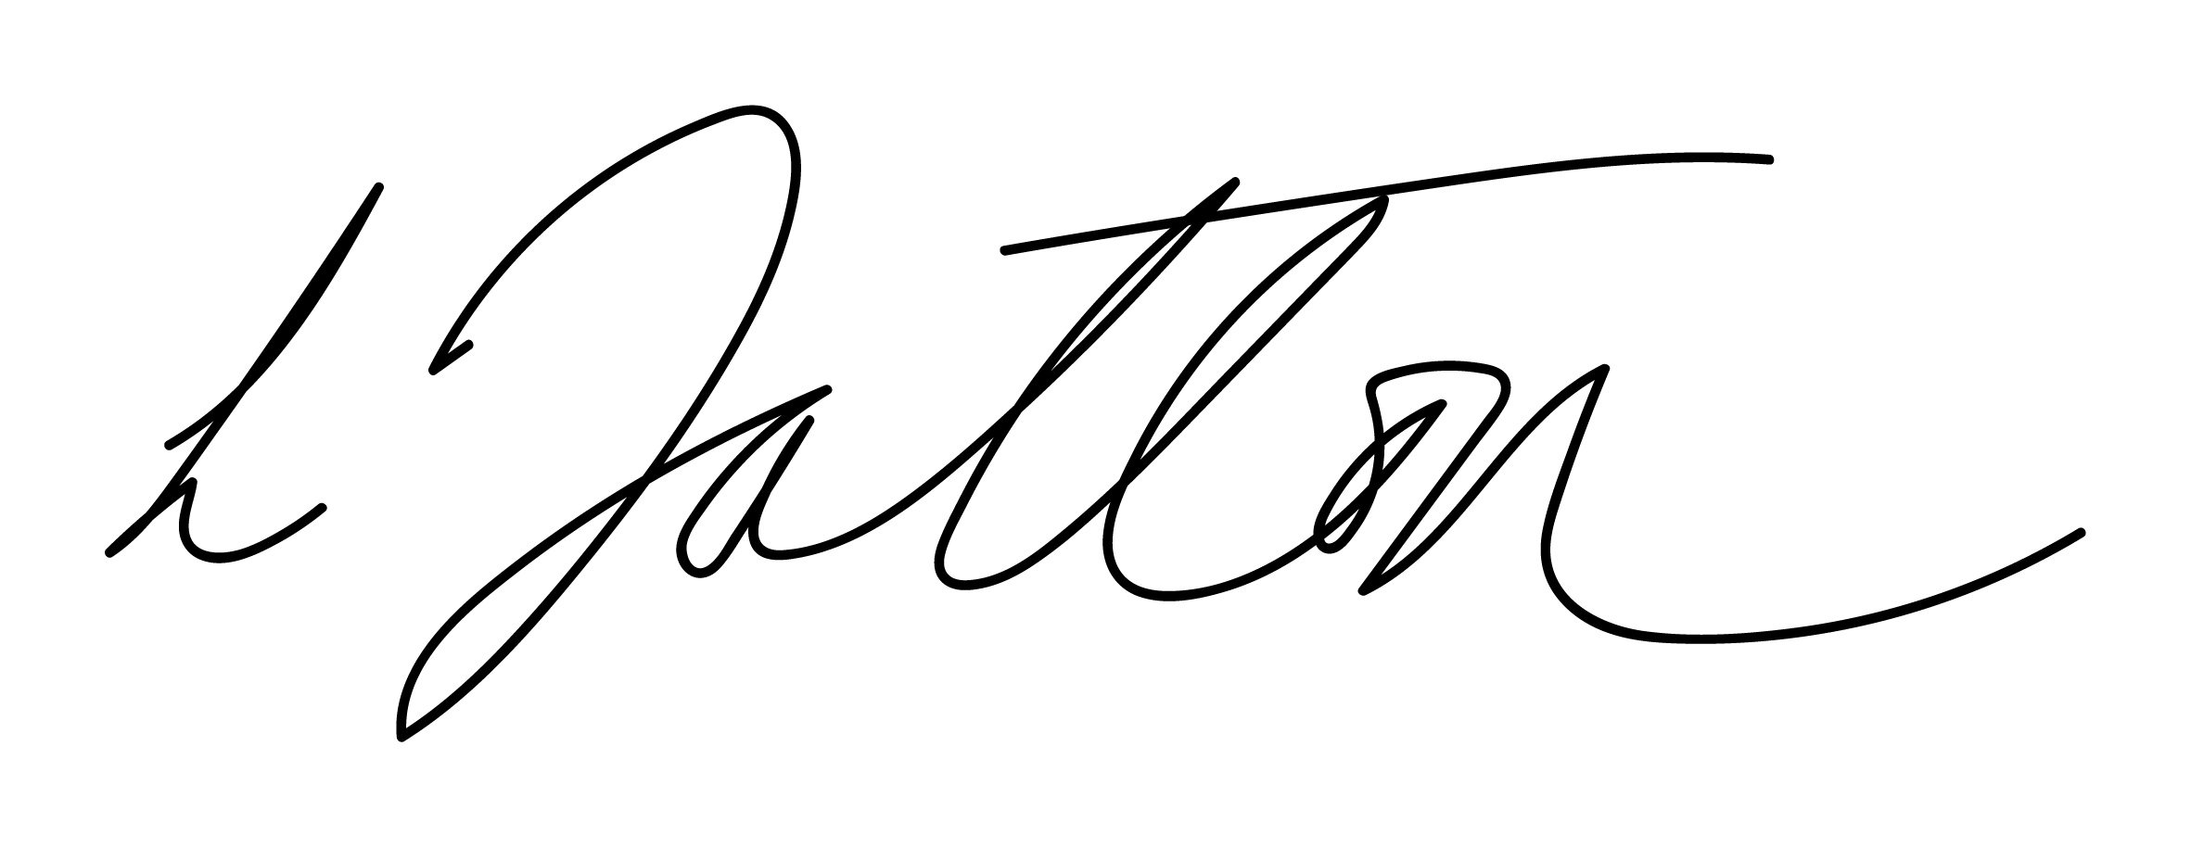
Chair of Governors – Mrs Janiene Davies | 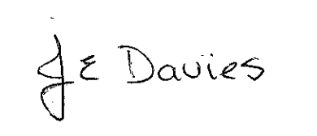


Introduction

Governing Bodies have a significant degree of responsibility in our ever changing school system. They are the vision setters and strategic decision makers for their schools and play a vital role in ensuring the best possible education that takes every child as far as possible.
Crucially, that means creating robust accountability for executive leaders by using and being familiar with objective data on the performance of pupils, teachers and finances in order to ask the right questions. It means ensuring resources are allocated to strategic priorities and safeguarding the highest standards of financial propriety – for example on pay and expenses and on related party-transactions. It also means ensuring that schools prepare pupils for life and implementing their Prevent duty and promoting fundamental Values to protect them from the risks of extremism and radicalisation.
The Governing Body should work collaboratively with the parents/carers, local community and Governing Bodies of other schools in order to promote better teaching and a broader curriculum for pupils, to enhance leadership and development opportunities for teachers and to make best use of financial and other resources. To do this the Governing Body will ensure that the skills of individual Governors will be developed and utilised in a way that is appropriate to their role.

Aims
The Governing Body will:
- Ensure clarity of vision, ethos and strategic direction;
- Hold executive leaders to account for the educational performance of the organisation and its pupils, and the performance management of staff; and
- Oversee the financial performance of the organisation and making sure its money is utilised efficiently.
The Governing Body will model the following six key features to ensure effective governance of the school:

- Strategic leadership that sets and champions vision, ethos and strategy.
- Accountability that drives up educational standards and financial performance. 9
- Appoint people with the right skills, experience, qualities and capacity.
- Promote structures that reinforce clearly defined roles and responsibilities.
- Comply with statutory and contractual requirements.
- Evaluate, monitor and improve the quality and impact of governance.

Induction and Professional Learning
The Governing Body will ensure that all new Governors undertake a comprehensive package of induction meeting requirements outlined by the Welsh Government and Local Authority. This includes mandatory professional learning for new Governors and mandatory professional learning for Governors assuming new roles, such as Chair, Clerk etc.

The induction and professional learning arrangements outlined are kept under continuous review dependent on new advice and guidance from the Welsh Government, Governors Cymru and the Local Authority.

The aims of the Governing Body in terms of Induction and Professional Learning are:

- To aid the new Governor, a Mentor will be assigned to support them in their initial
involvement with the Governing Body
- Welcome new Governors to the Governing Body and enable them to meet other members.
- Facilitate quick engagement with the working of the Governing Body.
- Encourage shared responsibility and an equitable distribution of the workload of the Governing Body.
- Encourage new Governors to visit the school to experience its atmosphere and understand its ethos.
- Meet the Headteacher, staff and students.
- Explain the partnership between the Headteacher, school community and Governing Body.
- Explain the role and responsibilities of governors.
- Give background material on the school and current issues.
- Allow new governors to ask questions about their role and/or the school.
- Explain how the Governing Body and its committees work.
- Allow new Governors to join the committee(s) of their choice.

Visiting School
Please refer to the Governor School Visits Policy.

Evaluation & Review
This policy will be reviewed by the Senior Management Team and Governing Body and adopted by the Governing Body as per the schedule on the front page.

